**Software & Hardware Requirements**

**Software Requirements:**

* HTML
* CSS
* JAVASCRIPT(JQUERY, JQUERY UI)
* OPERATING SYSTEM
* WINDOWS-7 OR WINDOWS 10

**Hardware Requirements:**

* Processor-i5
* Hard Disk-500GB
* Memory-8GB RAM

**HTML**

The **HyperText Markup Language** or **HTML** is the standard [markup language](https://en.wikipedia.org/wiki/Markup_language) for documents designed to be displayed in a [web browser](https://en.wikipedia.org/wiki/Web_browser). It can be assisted by technologies such as [Cascading Style Sheets](https://en.wikipedia.org/wiki/Cascading_Style_Sheets) (CSS) and [scripting languages](https://en.wikipedia.org/wiki/Scripting_language) such as [JavaScript](https://en.wikipedia.org/wiki/JavaScript).

[Web browsers](https://en.wikipedia.org/wiki/Web_browser) receive HTML documents from a [web server](https://en.wikipedia.org/wiki/Web_server) or from local storage and [render](https://en.wikipedia.org/wiki/Browser_engine) the documents into multimedia web pages. HTML describes the structure of a [web page](https://en.wikipedia.org/wiki/Web_page) [semantically](https://en.wikipedia.org/wiki/Semantic_Web) and originally included cues for the appearance of the document.

**Applications of HTML:**

1. Web pages development
2. Internet navigation
3. Responsive images on web pages
4. Offline capabilities usage
5. Game development usage
6. Native APIs usage to enrich a website
7. Client-side Storage
8. Cutting edge feature
9. Web document creation

10.Data entry support with HTML

**Development of HTML:**

HTML was created by **Sir Tim Berners-Lee in late 1991** but was not officially released. It was published in 1995 as HTML 2.0. HTML 4.01 was published in late 1999 and was a major version of HTML.

HTML is a very evolving markup language and has evolved with various versions updating. Long before its revised standards and specifications are carried in, each version has allowed its user to create web pages in a much easier and prettier way and make sites very efficient.

Then comes HTML 4.01, which is widely used and was a successful version of HTML before HTML 5.0, which is currently released and used worldwide. HTML 5 can be said for an extended version of HTML 4.01, which was published in the year 2012.

**CSS**

**Cascading Style Sheets** (**CSS**) is a [style sheet language](https://en.wikipedia.org/wiki/Style_sheet_language) used for describing the [presentation](https://en.wikipedia.org/wiki/Presentation_semantics) of a document written in a [markup language](https://en.wikipedia.org/wiki/Markup_language) such as [HTML](https://en.wikipedia.org/wiki/HTML). CSS is a cornerstone technology of the [World Wide Web](https://en.wikipedia.org/wiki/World_Wide_Web), alongside HTML and [JavaScript](https://en.wikipedia.org/wiki/JavaScript).

CSS is designed to enable the separation of presentation and content, including [layout](https://en.wikipedia.org/wiki/Page_layout), [colors](https://en.wikipedia.org/wiki/Color" \o "Color), and [fonts](https://en.wikipedia.org/wiki/Typeface). This separation can improve content [accessibility](https://en.wikipedia.org/wiki/Accessibility); provide more flexibility and control in the specification of presentation characteristics; enable multiple [web pages](https://en.wikipedia.org/wiki/Web_page) to share formatting by specifying the relevant CSS in a separate .css file, which reduces complexity and repetition in the structural content; and enable the .css file to be [cached](https://en.wikipedia.org/wiki/Cache_(computing)) to improve the page load speed between the pages that share the file and its formatting.

**Advantages of CSS:**

1. Better website speed
2. Easier to maintain
3. Consistent design
4. Time Saving
5. Better Device Compatibility
6. Positioning of Design Elements

**Development of CSS:**

CSS (Cascading Style Sheets) was first proposed by Håkon Wium Lie on October 10, 1994 while working with Tim Berners-Lee at CERN and the rest is history. CSS was not the only styling language in development at the time, but the very element of cascading and developing sequence is what set it apart from the rest.

CSS is a domain-specific, declarative programming language; it describes how HTML elements are to be displayed on screen, paper, or in other media; it can control the layout, colors, and fonts of multiple web pages all at once.

Cascading is the core feature of CSS since its inception, styles can cascade from one style sheet to another, enabling multiple types of CSS sources to be used on one HTML document.

Inline CSS refers to CSS found in an HTML file, found in the head of a document between style tags. Inlining CSS simply means putting your CSS into your HTML file instead of an external CSS file.

When we write CSS, we don’t tell the browser exactly how to render a page. Instead, we describe the rules for our HTML document one by one and let browsers handle the rendering.

**JAVASCRIPT**

**JavaScript** often abbreviated **JS**, is a [programming language](https://en.wikipedia.org/wiki/Programming_language) that is one of the core technologies of the [World Wide Web](https://en.wikipedia.org/wiki/World_Wide_Web), alongside [HTML](https://en.wikipedia.org/wiki/HTML) and [CSS](https://en.wikipedia.org/wiki/CSS). As of 2022, 98% of [websites](https://en.wikipedia.org/wiki/Website) use JavaScript on the [client](https://en.wikipedia.org/wiki/Client_(computing)) side for [web page](https://en.wikipedia.org/wiki/Web_page) behavior, often incorporating third-party [libraries](https://en.wikipedia.org/wiki/Library_(computing)). All major [web browsers](https://en.wikipedia.org/wiki/Web_browser) have a dedicated [JavaScript engine](https://en.wikipedia.org/wiki/JavaScript_engine) to execute the [code](https://en.wikipedia.org/wiki/Source_code) on [users](https://en.wikipedia.org/wiki/User_(computing))' devices.

JavaScript is a [high-level](https://en.wikipedia.org/wiki/High-level_programming_language), often [just-in-time compiled](https://en.wikipedia.org/wiki/Just-in-time_compilation) language that conforms to the [ECMAScript](https://en.wikipedia.org/wiki/ECMAScript) standard. It has [dynamic typing](https://en.wikipedia.org/wiki/Dynamic_typing), [prototype-based](https://en.wikipedia.org/wiki/Prototype-based_programming) [object-orientation](https://en.wikipedia.org/wiki/Object-oriented_programming), and [first-class functions](https://en.wikipedia.org/wiki/First-class_function). It is [multi-paradigm](https://en.wikipedia.org/wiki/Programming_paradigm), supporting [event-driven](https://en.wikipedia.org/wiki/Event-driven_programming), [functional](https://en.wikipedia.org/wiki/Functional_programming), and [imperative](https://en.wikipedia.org/wiki/Imperative_programming) [programming styles](https://en.wikipedia.org/wiki/Programming_paradigm). It has [application programming interfaces](https://en.wikipedia.org/wiki/Application_programming_interface) (APIs) for working with text, dates, [regular expressions](https://en.wikipedia.org/wiki/Regular_expression), standard [data structures](https://en.wikipedia.org/wiki/Data_structure), and the [Document Object Model](https://en.wikipedia.org/wiki/Document_Object_Model) (DOM).

**Advantages of Javascript:**

1. Speed
2. Popularity
3. Interoperability
4. Server Load
5. Rich Interfaces
6. Extended Functionality
7. Versatility
8. Simplicity

**Development of Javascript:**

**JavaScript** was invented by **Brendan Eich** in 1995.

It was developed for **Netscape 2**, and became the **ECMA-262** standard in 1997.

After Netscape handed JavaScript over to ECMA, the Mozilla foundation continued to develop JavaScript for the Firefox browser. Mozilla's latest version was 1.8.5. (Identical to ES5).

**Internet Explorer** (IE4) was the first browser to support ECMA-262 Edition 1 (ES1).

**JavaScrip**t is everywhere, and for the seventh year in a row, it has been ranked the most commonly used programming language, with 67.8% of developers employing it in 2019. Its ascent to the world’s most popular programming language is synonymous with the rise of the internet itself.

**jQuery**

jQuery is a fast, small, and feature-rich JavaScript library. It makes things like HTML document traversal and manipulation, event handling, animation, and Ajax much simpler with an easy-to-use API that works across a multitude of browsers.

jQuery makes a web developer's life easy. It provides many built-in functions using which you can accomplish various tasks easily and quickly.

**jQuery Features**

* DOM Selection: jQuery provides Selectors to retrieve DOM element based on different criteria like tag name, id, css class name, attribute name, value, nth child in hierarchy etc.
* DOM Manipulation: You can manipulate DOM elements using various built-in jQuery functions. For example, adding or removing elements, modifying html content, css class etc.
* Special Effects: You can apply special effects to DOM elements like show or hide elements, fade-in or fade-out of visibility, sliding effect, animation etc.
* Events: jQuery library includes functions which are equivalent to DOM events like click, dblclick, mouseenter, mouseleave, blur, keyup, keydown etc. These functions automatically handle cross-browser issues.
* Ajax: jQuery also includes easy to use AJAX functions to load data from servers without reloading whole page.
* Cross-browser support: jQuery library automatically handles cross-browser issues, so the user does not have to worry about it. jQuery supports IE 6.0+, FF 2.0+, Safari 3.0+, Chrome and Opera 9.0+.

**jQuery UI**

jQuery UI is a curated set of user interface interactions, effects, widgets, and themes built on top of the jQuery JavaScript Library. Whether you're building highly interactive web applications or you just need to add a date picker to a form control, jQuery UI is the perfect choice.

**jQuery UI Features**

1. **Collaborative design process**

The process for designing and planning the future of the jQuery UI library should be open, transparent and in the hands of the community. We welcome input from anyone interested in engaging with the team, from hard-core developers to visual and interaction designers, accessibility experts, product managers, business people, end users and more.

### Flexible styling and themes

Widgets should provide hooks to enable developers to customize both behavioral and presentational aspects. Transition animations should be optional and customizable. Class names used on internal elements should be meaningful to jQuery UI users and enable styling either through [ThemeRoller](http://jqueryui.com/themeroller/) or hand-written CSS via the [jQuery UI CSS Framework](http://learn.jquery.com/jquery-ui/theming/). As much as possible, style attributes should be separated into the plugin's CSS, not within the scripts in order to make customization simple and clear. Widgets styles should be coded with proportional (em-based or % based) sizing and should re-flow horizontally to fill the space provided.

### Elegant visual and interaction design

All widgets should be designed for simplicity, ease of use and aesthetics. We aim to synthesize best practice examples from mobile and desktop OS, web applications and a bit of common sense to create a robust and flexible set of UI widgets that is visually coherent and consistent in behavior. Features should be pared down to focus on what is practical and commonly needed with a system for extending features through customization.

### Elegant API

The jQuery UI API is designed to be as simple and intuitive as the jQuery API. You find elements using a query selector, then call a succinct method on the resultant set. There are suitable defaults to cover the most common use cases, so quite often it's not necessary to specify any non-default options. All options are optional.

**Homepage.html**

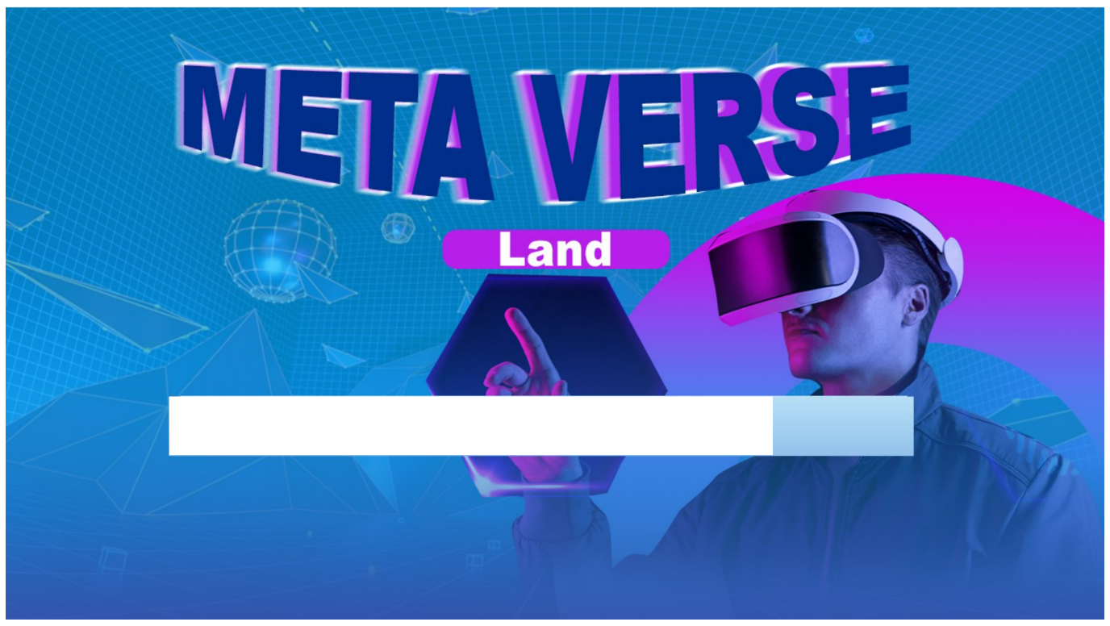

<html>

<head>

<title>Meta Home</title>

<script src="D:\metaproject\jq.js"></script>

<script>

$("document").ready(function()

{

$("#load").animate({width:'1024px'},5000);

});

const myTimeout = setTimeout(mywindow, 4900);

function mywindow()

{

window.open("D:/metaproject/Homepage2.html",'_self');

}

</script>

</head>

<body>

<div style="z-index:1;height:847;width:1520;">

<img src="D:\metaproject\images\metaverse land new background.jpg" width="1520" height="847">

</div>

<div id="load" style="z-index:3;position:absolute;top:547;left:234;height:76;border-style:solid;border-color:white;background-color: white;width:0;">

</div>

</body> </html>

**Homepage2.html**

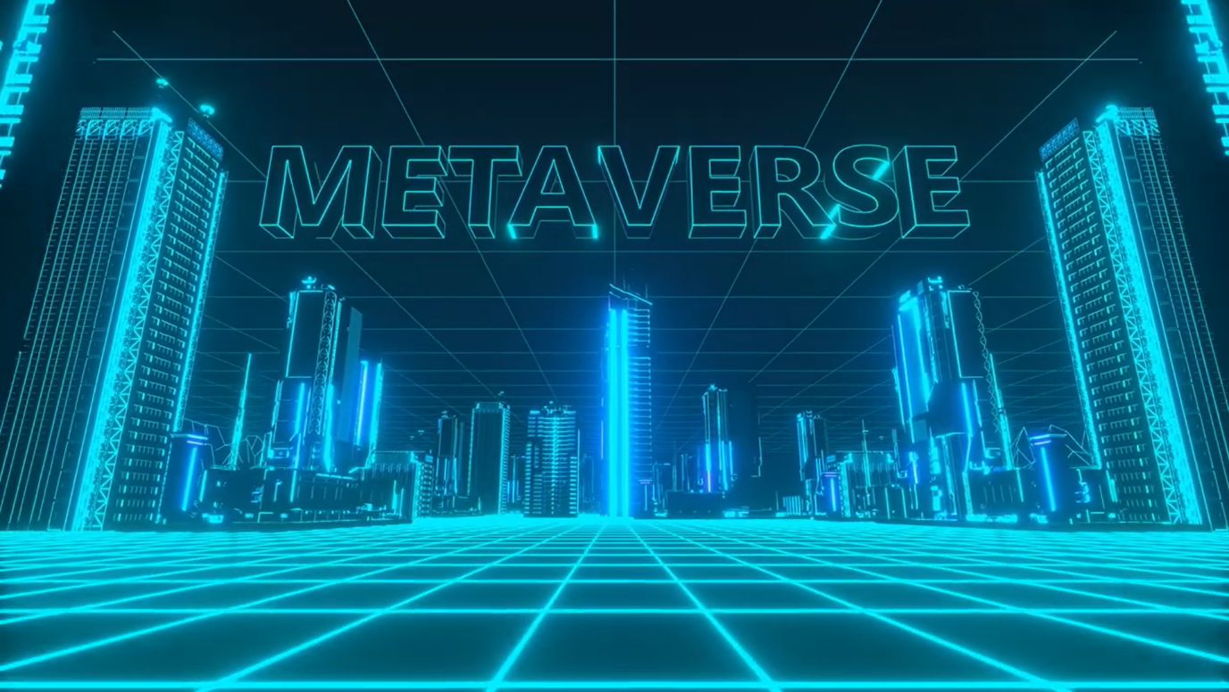

<html>

<head>

<title>homepage2.html</title>

<script language="javascript">

const myTimeOut=setTimeout(mywindow,15900)

function mywindow() {

window.open("D:/metaproject/Index.html",'_self')

}

function audioplay(){

document.getElementById("audioplay").play();

}

function playAudio(url) {

new Audio(url).play();

}

</script>

<style>

video{

position: fixed; min-height: 100%; min-width: 100%; right: 0px;

bottom: 0px; z-index: 4;}

</style>

</head>

<body onclick="playAudio('D:/metaproject/audios/Welcome to the Metaverse. Royalty Free Animation 4K ULTRA HD.wav')">

<video autoplay muted loop >

<source src="D:\metaproject\Videos\Welcome to the Metaverse. Royalty Free Animation 4K ULTRA HD.mp4"></video></html>

**Index.html**

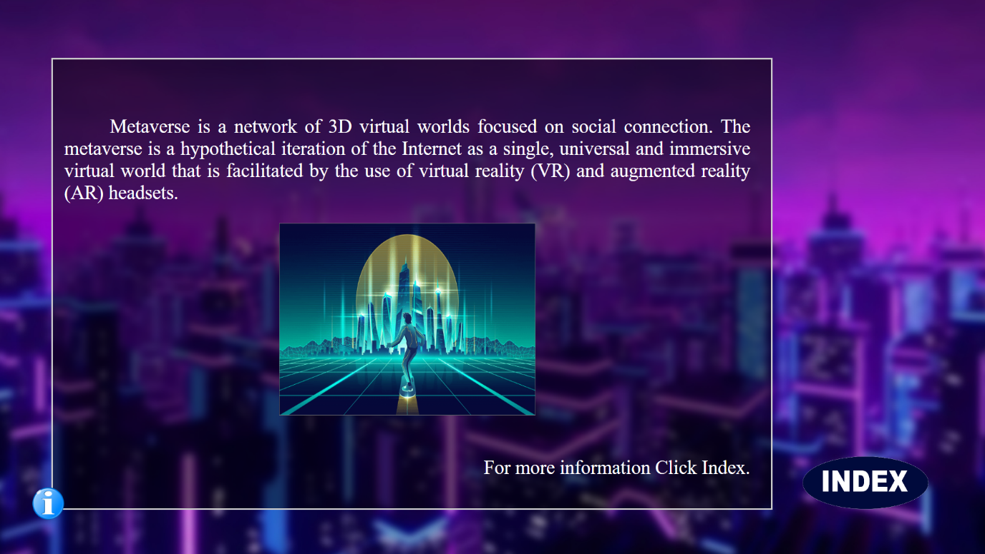

<html>

<head>

<title> index </title>

<script src="D:\metaproject\jq.js"></script>

<script>

function indexanimate()

{

$("#indexanimate").animate(

{

top:'50px',

left:'100px',

height:'700px',

width: '1240px'

},2000);

}

function ifadeinn()

{

$("#infoanim").animate({

top:'90px',

height:'700px',

width:'1120px'

},2000);

}

function ifadeinn2()

{

const myTimeOut2=setTimeout(myfade2,1800);

function myfade2()

{

$("#infofade2").fadeIn();

}

}

function myfadeout()

{

$("#infofade2").fadeOut();

}

function myfadeout2()

{

$("#infoanim").fadeOut();

}

function myfadeOuts()

{

myfadeout();

myfadeout2();

indexanimate();

fadeInn();

}

function ifadeinn3()

{

ifadeinn();

ifadeinn2();

}

function fadeInn()

{

const myTimeOut=setTimeout(myfade,1800);

function myfade()

{

$("#fadein").fadeIn();

}

}

</script>

<style>

a

{

color: white;

font-size: 40;

}

</style>

</head>

<body onload="ifadeinn3();">

<div style="z-index:0;position: absolute; height: 874;width:1546 ;top:-10; left: -10;">

<img src="D:\metaproject\images\Index2.jpg.jpg" height="874" width="1546">

</div>

<div id="index" style="z-index: 3;position: absolute;top:700;left: 1250;height: 100;width:200;">

<img id="index" src="D:\metaproject\images\indexlogo.png" height="100" width="200" onclick="myfadeOuts();">

</div>

<div id="indexanimate" style="z-index:2; position:absolute;

top:600;left:1250;height: 0;width:0;

background-image:url(D:/metaproject/indexbg2.png);">

</div>

<div id="fadein" style="display: none;z-index:4;position:absolute;top:150;left:130;height:550;width:1200;"><br>

<center><a href="D:\metaproject\index tabs\introduction tab\introduction.html">Introduction</a><br>

<a href="D:\metaproject\index tabs\history tab\history.html">History</a><br>

<a href="D:\metaproject\index tabs\companies.html">Companies</a><br>

<a href="D:\metaproject\index tabs\access\access.html">How to Access</a><br>

<a href="D:\metaproject\index tabs\Advantages of meta verse\Advantages.html">Advantages</a><br>

<a href="D:\metaproject\index tabs\disadvantages.html">Disadvantages</a><br>

<a href="D:\metaproject\Naveen\aligation and critcs.html">Supporters and Critics</a><br>

<a href="D:\metaproject\index tabs\overview.html">Overview</a><br>

<a href="D:\metaproject\index tabs\conclusion.html">Conclusion</a><br></center>

</div>

<div style="z-index:2;position:absolute;top:760;left:50;width:50;height:50;">

<img src="D:\metaproject\info symbol.png" width="50" height="50">

</div>

<div id="infoanim" style="z-index:1;position:absolute;top:760;left:80;width:0;height:0;

background-image: url(D:/metaproject/infobg.png);border-style:solid;border-color:#cccccc">

</div>

<div id="infofade2" style="z-index:5;position:absolute;top:150;left:100;width:1070;height:570;display: none;

color: white;font-size:30;text-align: justify;">

<P>&nbsp;&nbsp;&nbsp;&nbsp;&nbsp;&nbsp;Metaverse is a network of 3D virtual worlds focused on social connection.

The metaverse is

a hypothetical iteration of the Internet as a single, universal and immersive virtual world that is facilitated by the use of virtual reality (VR) and augmented reality (AR) headsets.

</P>

<center><img src="D:\metaproject\metaverse-virtual-world-1.jpg" width="400" height="300"></center><br>

<p align="right"> For more information Click Index.</p>

</div>

</body>

</html>

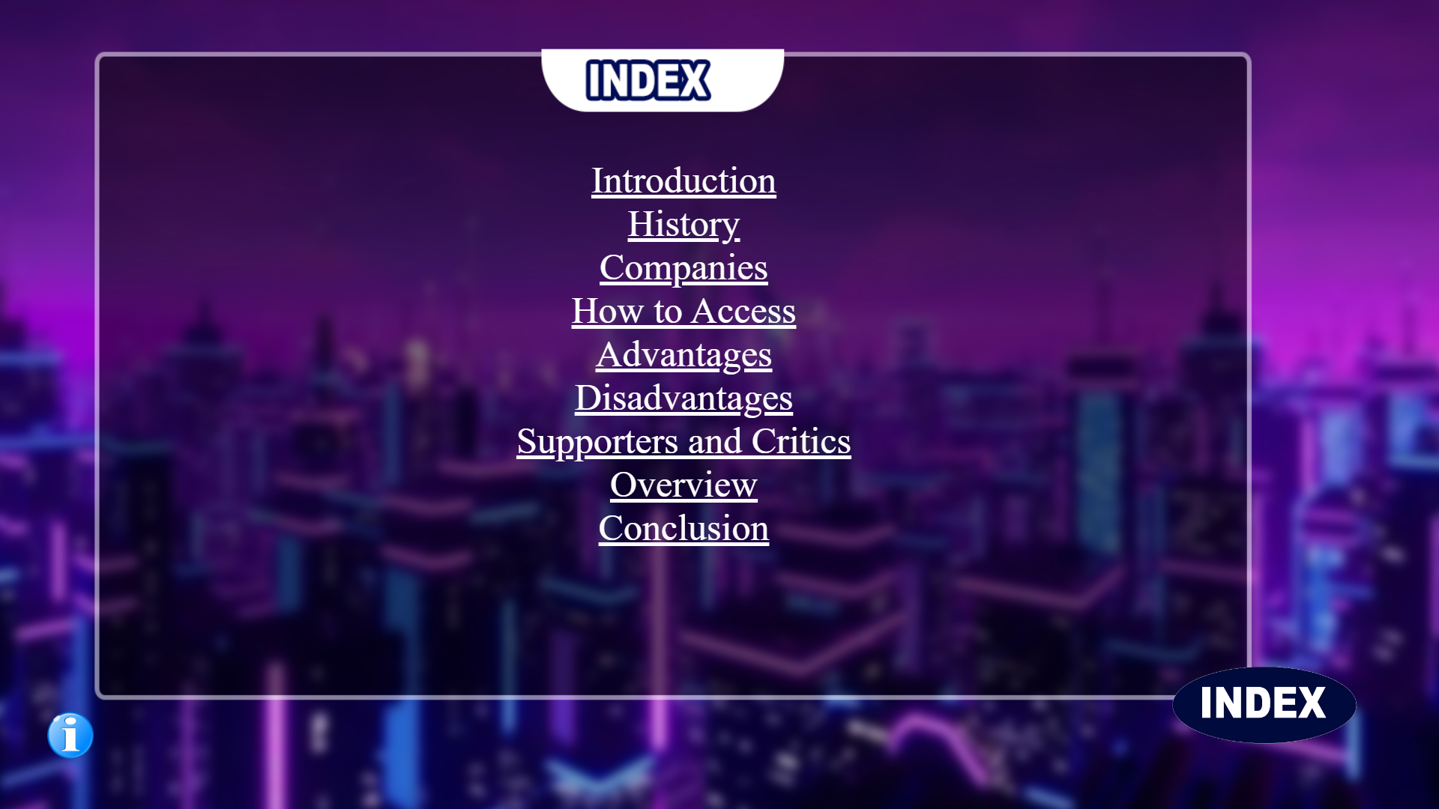

**introduction.html**

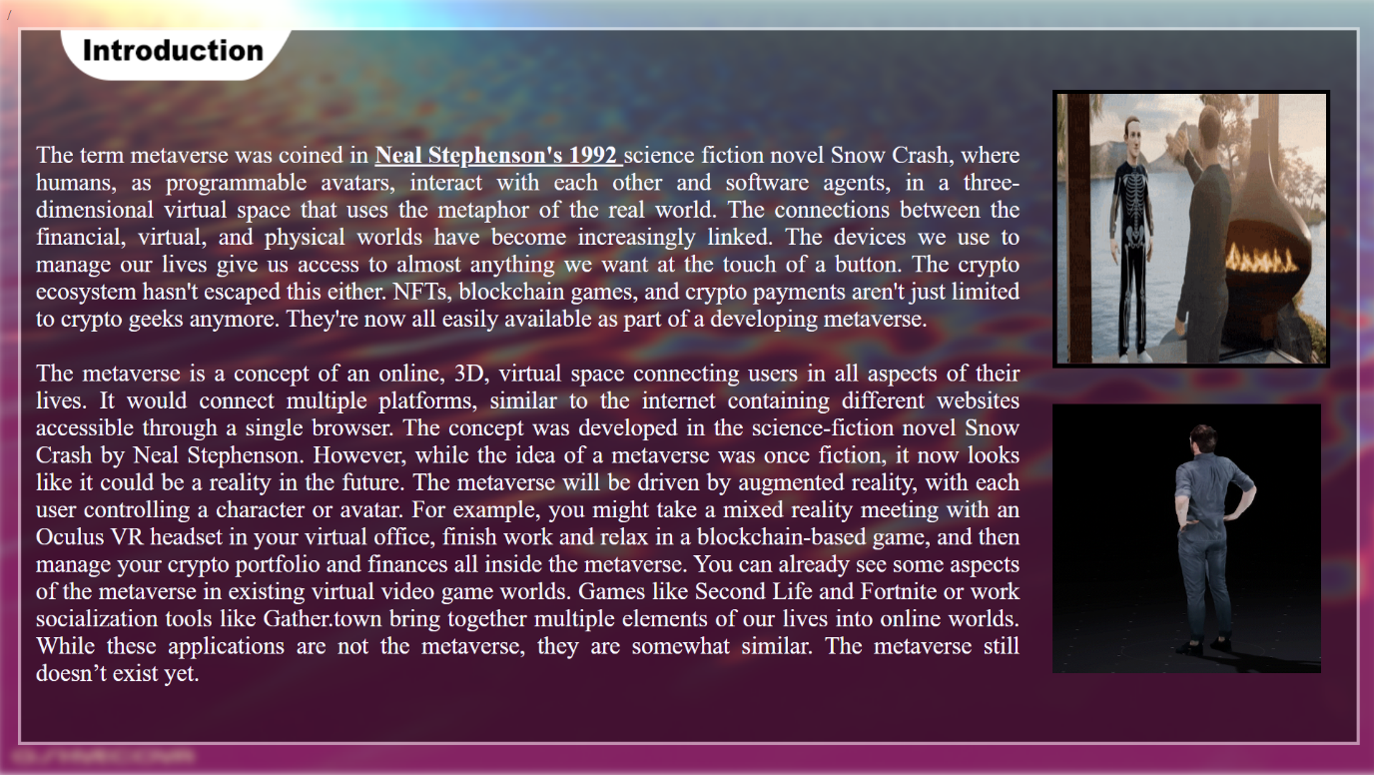

<html>

<head>

<title> introduction </title>

<style>

#img1{

filter: blur(5px);

}

</style>

</head>

<body style="overflow:hidden;">

<div style="z-index: -2;position: absolute;top:-5; left:-5;width: 1550;height: 870;">

<img id="img1" src="D:\metaproject\gifs\original.gif" height="870" width="1550">

</div>/

<div style="z-index:-1;position: absolute;top: 30;left: 20;width: 1500;

height: 800;">

<img src="D:\metaproject\introduction 1.png" height="800" width="1500">

</div>

<div style="z-index:4; position:absolute;top:70; left: 40;font-size: 27 ;width:1100;height:800;color:ghostwhite;text-align: justify;">

<br><br><p>The term metaverse was coined in <u><strong>Neal Stephenson's 1992 </strong></u>science fiction novel Snow Crash, where humans, as programmable avatars, interact with each other and software agents, in a three-dimensional virtual space that uses the metaphor of the real world.

The connections between the financial, virtual, and physical worlds have become increasingly linked. The devices we use to manage our lives give us access to almost anything we want at the touch of a button. The crypto ecosystem hasn't escaped this either. NFTs, blockchain games, and crypto payments aren't just limited to crypto geeks anymore. They're now all easily available as part of a developing metaverse.

<br>

<br>

The metaverse is a concept of an online, 3D, virtual space connecting users in all aspects of their lives. It would connect multiple platforms, similar to the internet containing different websites accessible through a single browser.

The concept was developed in the science-fiction novel Snow Crash by Neal Stephenson. However, while the idea of a metaverse was once fiction, it now looks like it could be a reality in the future.

The metaverse will be driven by augmented reality, with each user controlling a character or avatar. For example, you might take a mixed reality meeting with an Oculus VR headset in your virtual office, finish work and relax in a blockchain-based game, and then manage your crypto portfolio and finances all inside the metaverse.

You can already see some aspects of the metaverse in existing virtual video game worlds. Games like Second Life and Fortnite or work socialization tools like Gather.town bring together multiple elements of our lives into online worlds. While these applications are not the metaverse, they are somewhat similar. The metaverse still doesn’t exist yet.

</p>

</div>

<div style="z-index:5; position: absolute;top: 100;left: 1177;width: 300;height: 300;">

<img src="D:\metaproject\gifs\metaverse-zuckerberg.gif" border="5" border-color="white" width="300"height="300">

</div>

<div style="z-index:5; position: absolute;top: 450;left: 1177;width: 300;height: 300;">

<a href="D:\metaproject\index tabs\history tab\history.html"><img src="D:\metaproject\gifs\metaverseintroduction.gif" width="300"height="300"></a>

</div>

<a href="D:\metaproject\Index2.html"><div style="position:fixed;z-index:6;bottom:0;left:0;width:200;height:100;"></div></a>

<a href="D:\metaproject\Index2.html"><div style="position:fixed;z-index:6;bottom:0;left:650;width:200;height:100;"></div></a>

</body>

</html>

**history.html**

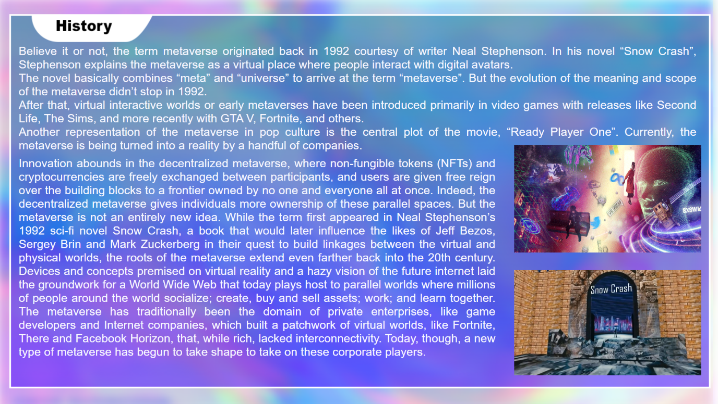

<html>

<head>

<title> history </title>

<style> #img1{ filter: blur(10px); } </style>

</head>

<body style="overflow:hidden;">

<div style="z-index: 2;position: absolute;top:-5; left:-5;width: 1530;height: 890;">

<img id="img1" src="D:\metaproject\gifs\eaa923d6c1cb0e8af1ad13b062f76bab.gif" height="890" width="1530">

</div>

<div style="z-index: 3;position: absolute;top: 30;left: 20;width: 1500;

height: 800;">

<img src="D:\metaproject\index tabs\history tab\history background.png" height="800" width="1500">

</div>

<div style="z-index:4;position: absolute;font-size: 25;color:ghostwhite;font-family:arial ; top:70; left:40;width:1450; height: 795;text-align: justify;" >

<p> Believe it or not, the term metaverse originated back in 1992 courtesy of writer Neal Stephenson. In his novel “Snow Crash”, Stephenson explains the metaverse as a virtual place where people interact with digital avatars.

<br>

The novel basically combines “meta” and “universe” to arrive at the term “metaverse”. But the evolution of the meaning and scope of the metaverse didn’t stop in 1992.

<br>

After that, virtual interactive worlds or early metaverses have been introduced primarily in video games with releases like Second Life, The Sims, and more recently with GTA V, Fortnite, and others.

<br>

Another representation of the metaverse in pop culture is the central plot of the movie, “Ready Player One”. Currently, the metaverse is being turned into a reality by a handful of companies.

</p>

</div>

<div style="z-index:4;position:absolute;left:40;top:310;width: 1020;

font-size: 25;color:ghostwhite;font-family:arial ; text-align: justify;">

<p>

Innovation abounds in the decentralized metaverse, where non-fungible tokens (NFTs) and cryptocurrencies are freely exchanged between participants, and users are given free reign over the building blocks to a frontier owned by no one and everyone all at once. Indeed, the decentralized metaverse gives individuals more ownership of these parallel spaces. But the metaverse is not an entirely new idea. While the term first appeared in Neal Stephenson’s 1992 sci-fi novel Snow Crash, a book that would later influence the likes of Jeff Bezos, Sergey Brin and Mark Zuckerberg in their quest to build linkages between the virtual and physical worlds, the roots of the metaverse extend even farther back into the 20th century. Devices and concepts premised on virtual reality and a hazy vision of the future internet laid the groundwork for a World Wide Web that today plays host to parallel worlds where millions of people around the world socialize; create, buy and sell assets; work; and learn together. The metaverse has traditionally been the domain of private enterprises, like game developers and Internet companies, which built a patchwork of virtual worlds, like Fortnite, There and Facebook Horizon, that, while rich, lacked interconnectivity. Today, though, a new type of metaverse has begun to take shape to take on these corporate players.

</p>

</div>

<div style="z-index:4;position: absolute;left: 1100;top:540; width: 400;height: 230;">

<video height="300" width="400" autoplay controls="hidden" muted loop="true" >

<source src="D:\metaproject\index tabs\history tab\Snow Crash in VR.mp4" width="100" height="80"></source>

</video>

</div>

<a href="D:\metaproject\index tabs\companies.html"><div style="z-index:5;position:absolute;left:1100;top:310;width:400; height: 230;">

<img src="D:\metaproject\index tabs\history tab\metaverse-multiverse-2022.gif" height="230" width="400">

</div></a>

<a href="D:\metaproject\index tabs\introduction tab\introduction.html"><div style="position:fixed;z-index:6;bottom:0;left:0;width:200;height:100;"></div></a>

<a href="D:\metaproject\Index2.html"><div style="position:fixed;z-index:6;bottom:0;left:650;width:200;height:100;"></div></a>

</body> </html>

**companies.html**

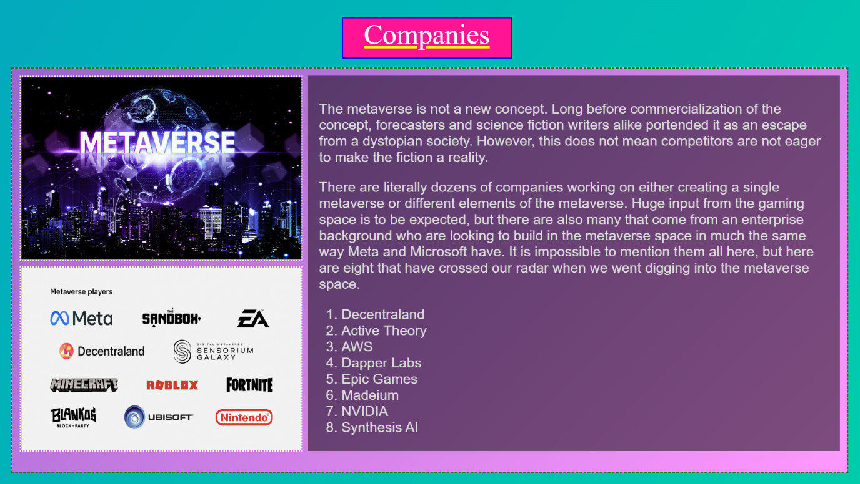

<html>

<head>

<title>companies</title>

</head>

<body style="background:linear-gradient(125deg,#02AABD, #00CDAC)">

<p style="position: fixed;top:-20;left:610;width:300;height:70;z-index:3;

font-size:50;color:white;text-decoration: underline;text-decoration-color:yellow ;border-style:solid;border-color:blue;background-color:deeppink;

text-align: center; ">Companies</p>

<div style="position: fixed;z-index: 2;left:20;top:120;height:720;width:1490;background:linear-gradient(135deg,#9966cc,#ff99ff);border-color:green;border-style:dashed;"></div>

<img style="position: fixed;z-index:3;left:35;top:135;height:325;width: 500;

border-style:dotted;border-color:floralwhite;border-width:3;"

src="D:\metaproject\images\metaversecompanies.jpg">

<a href="D:\metaproject\index tabs\access\access.html"><img style="position: fixed;z-index:3;left:35;top:475;height:325;width: 500;

border-style:dotted;border-color:floralwhite;border-width:3;"

src="D:\metaproject\images\metaverseplayers.jpg"></a>

<div style="position: fixed;z-index:3;left:550;width:950;height:670;top:135;

background-image: url(D:/metaproject/infobg.png);">

</div>

<div style="position: fixed;z-index: 4;left:570;width:910;height:630;top:155;

font-size: 25;color: #dddddd;font-family:arial;">

<p>The metaverse is not a new concept. Long before commercialization of the concept, forecasters and science fiction writers alike portended it as an escape from a dystopian society. However, this does not mean competitors are not eager to make the fiction a reality.</p>

<p>There are literally dozens of companies working on either creating a single metaverse or different elements of the metaverse. Huge input from the gaming space is to be expected, but there are also many that come from an enterprise background who are looking to build in the metaverse space in much the same way Meta and Microsoft have. It is impossible to mention them all here, but here are eight that have crossed our radar when we went digging into the metaverse space.</p>

<ol type="1">

<li>Decentraland</li>

<li>Active Theory</li>

<li>AWS</li>

<li>Dapper Labs</li>

<li>Epic Games</li>

<li>Madeium</li>

<li>NVIDIA</li>

<li>Synthesis AI</li>

</ol>

<a href="D:\metaproject\index tabs\history tab\history.html"><div style="position:fixed;z-index:6;bottom:0;left:0;width:200;height:100;"></div></a>

<a href="D:\metaproject\Index2.html"><div style="position:fixed;z-index:6;bottom:0;left:650;width:200;height:100;"></div></a>

</body></html>

**access.html**

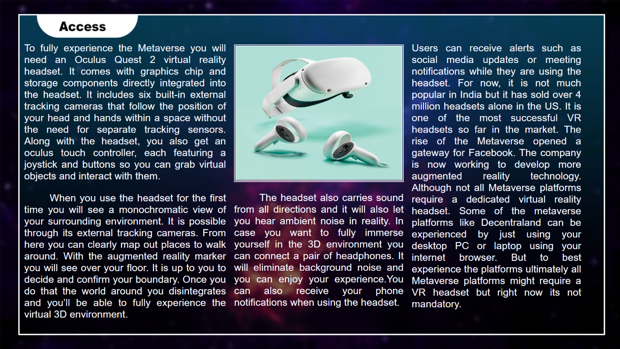

<html>

<head>

<title> Access </title>

<style>

#img1{

filter: blur(5px);

}

</style>

<script src="D:\metaproject\jq.js"></script>

<script>

var a=0;

function equipanim3()

{

if(a==0)

{

equipanim1();

a=1;

}

else

{

equipanim2();

a=0;

}

}

function equipanim1() {

$("#equipanim").animate({top:'100px',

left:'330px',

width:'850px',

height:'650px'},"slow",);

$("#equipanim").css({'border-color':'#123afd','border-style':'solid'});

}

function equipanim2() {

$("#equipanim").animate({top:'110px',

left:'580px',

width:'410px',

height:'330px'},"slow");

$("#equipanim").css({'border-color':'#123afd','border-style':'solid'});

}

</script>

</head>

<body style="overflow:hidden">

<div style="z-index: -2;position: absolute;top:-10; left:-10;width: 1591;height: 899;">

<img id="img1" src="D:\metaproject\gifs\space.gif" width="1591" height="899">

</img>

</div>

<div style="z-index: 3;position: absolute;top: 5;left: 20;width: 1500;

height: 850;">

<img src="D:\metaproject\index tabs\access\access template.png" width="1500" height="850">

</div>

<img id="equipanim" onclick="equipanim3();" style="z-index:7;position:absolute;top:110;left:580; border-style:double;border-color:ghostwhite;border-width:5;"

src="D:\metaproject\images\equipment.jpg" width="410" height="330" >

<div style="z-index:5;position: absolute;font-size: 25;color:ghostwhite;font-family:arial ; top:80; left:60;width:500; height: 795;text-align: justify;" >

<p>To fully experience the Metaverse you will need an Oculus Quest 2 virtual reality headset. It comes with graphics chip and storage components directly integrated into the headset. It includes six built-in external tracking cameras that follow the position of your head and hands within a space without the need for separate tracking sensors. Along with the headset, you also get an oculus touch controller, each featuring a joystick and buttons so you can grab virtual objects and interact with them.</p>

<p>&nbsp;&nbsp;&nbsp;&nbsp;&nbsp;&nbsp;

When you use the headset for the first time you will see a monochromatic view of your surrounding environment. It is possible through its external tracking cameras. From here you can clearly map out places to walk around. With the augmented reality marker you will see over your floor. It is up to you to decide and confirm your boundary. Once you do that the world around you disintegrates and you’ll be able to fully experience the virtual 3D environment.</p></div>

<div style="z-index:5;position: absolute;font-size: 25;color:ghostwhite;font-family:arial ; top:450; left:580;width:420; height: 795;text-align: justify">

<p>&nbsp;&nbsp;&nbsp;&nbsp;&nbsp;&nbsp;

The headset also carries sound from all directions and it will also let you hear ambient noise in reality. In case you want to fully immerse yourself in the 3D environment you can connect a pair of headphones. It will eliminate background noise and you can enjoy your experience.You can also receive your phone notifications when using the headset.

</p></div>

<div style="z-index:5;position: absolute;font-size: 25;color:ghostwhite;font-family:arial ; top:80; left:1020;width:420; height: 795;text-align: justify">

<p>Users can receive alerts such as social media updates or meeting notifications while they are using the headset. For now, it is not much popular in India but it has sold over 4 million headsets alone in the US. It is one of the most successful VR headsets so far in the market. The rise of the Metaverse opened a gateway for Facebook. The company is now working to develop more augmented reality technology.

Although not all Metaverse platforms require a dedicated virtual reality headset. Some of the metaverse platforms like Decentraland can be experienced by just using your desktop PC or laptop using your internet browser. But to best experience the platforms ultimately all Metaverse platforms might require a VR headset but right now its not mandatory.

</p>

</div>

<a href="D:\metaproject\index tabs\access\access2.html">

<div style="position: absolute;z-index:10;right: 0;bottom: 0;height:100;width:200;">

</div>

</a>

<a href="D:\metaproject\index tabs\companies.html"><div style="position:fixed;z-index:6;bottom:0;left:0;width:200;height:100;"></div></a>

<a href="D:\metaproject\Index2.html"><div style="position:fixed;z-index:6;bottom:0;left:650;width:200;height:100;"></div></a>

</body>

</html>

**access2.html**

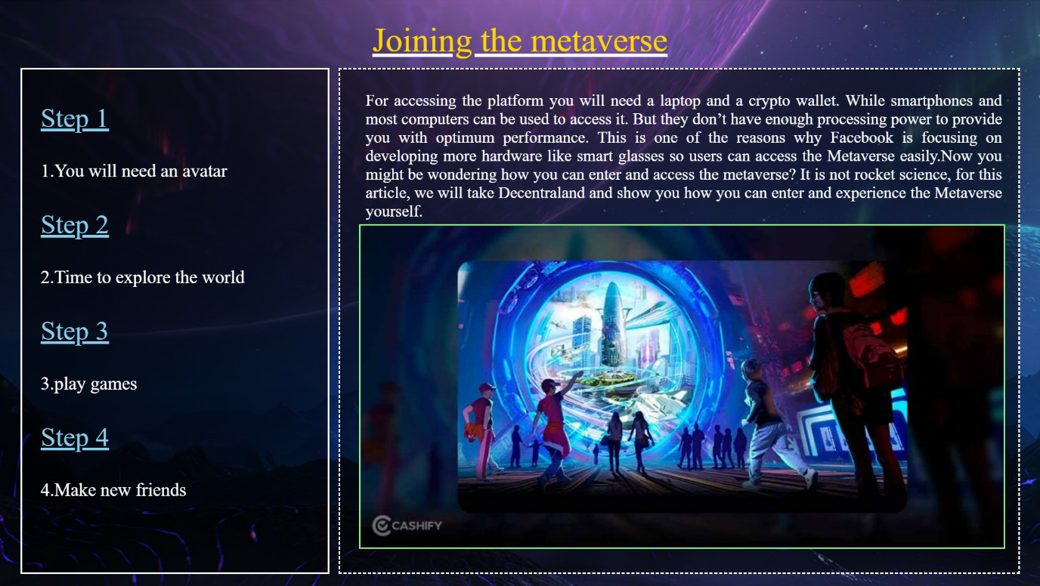

<html>

<head>

<title>acces2</title>

<script src="D:\metaproject\jq.js"></script>

<script language="javascript">

function avatar(){

$("#main,#explore,#playgames,#friends,#explore1,#friends1,#playgames1").fadeOut();

$("#avatar,#avatar1").fadeIn();}

function explore(){

$("#main,#avatar,#playgames,#friends,#playgames1,#avatar1,#friends1").fadeOut();

$("#explore,#explore1").fadeIn();}

function playgames(){

$("#main,#avatar,#explore,#friends,#friends1,#explore1,#avatar1").fadeOut();

$("#playgames,#playgames1").fadeIn();}

function friends(){

$("#main,#avatar,#explore,#playgames,#explore1,#avatar1,#playgames1").fadeOut();

$("#friends,#friends1").fadeIn();}

</script>

</head><body>

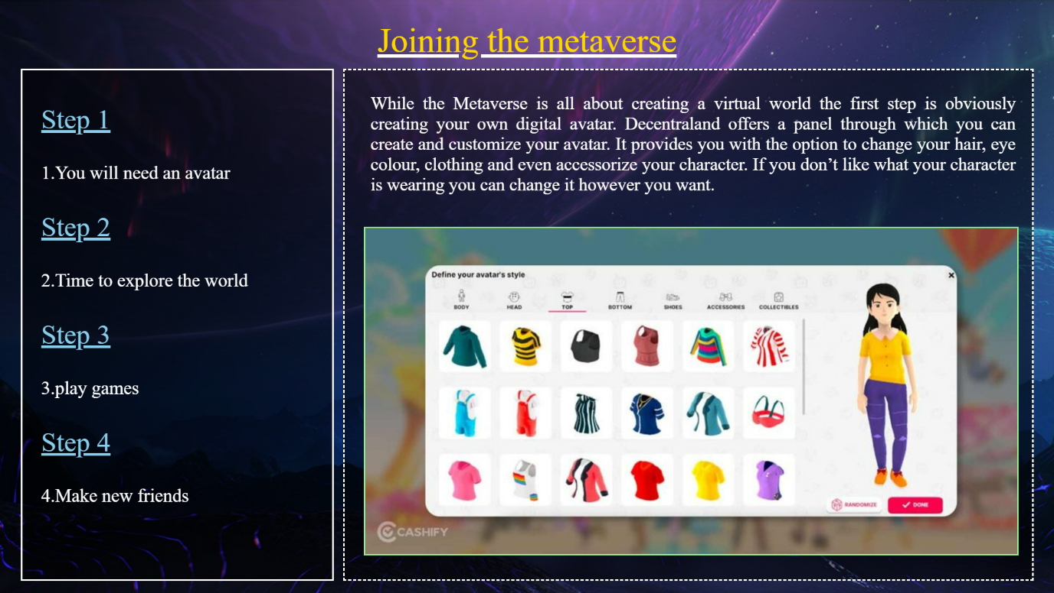

<img style="position: fixed;left:0;top:0;min-height: 100%;min-width: 100%;

z-index: -2;" src="D:\metaproject\images\accessbg.jpg">

<p style="position: fixed;top:-20;left:550;width:500;height:100;z-index:1;

font-size:50;color:gold;text-decoration: underline;text-decoration-color:white; ; ">Joining the metaverse</p>

<div style="position: fixed;top:100;left:500;width:1000;height:740;border-style:dashed;border-color:white;border-width:3;

background-image: url(D:/metaproject/infobg.png);"></div>

<div style="position: fixed;top:100;left:30;width:450;height:740;border-style:solid;border-color:white;border-width:3;background-image: url(D:/metaproject/infobg.png);"></div>

<div style="position: fixed;top:110;left:60;width:400;height:720;font-size:27;color:white;"> <span style="text-decoration: underline;font-size:40;color:skyblue;">

<p onclick="avatar()">Step 1</p></span>

1.You will need an avatar

<span style="text-decoration: underline;font-size:40;color:skyblue">

<p onclick="explore()">Step 2</p></span>

2.Time to explore the world

<span style="text-decoration: underline;font-size:40;color:skyblue">

<p onclick="playgames()">Step 3</p></span>

3.play games

<span style="text-decoration: underline;font-size:40;color:skyblue">

<p onclick="friends()">Step 4</p></span>

4.Make new friends</div>

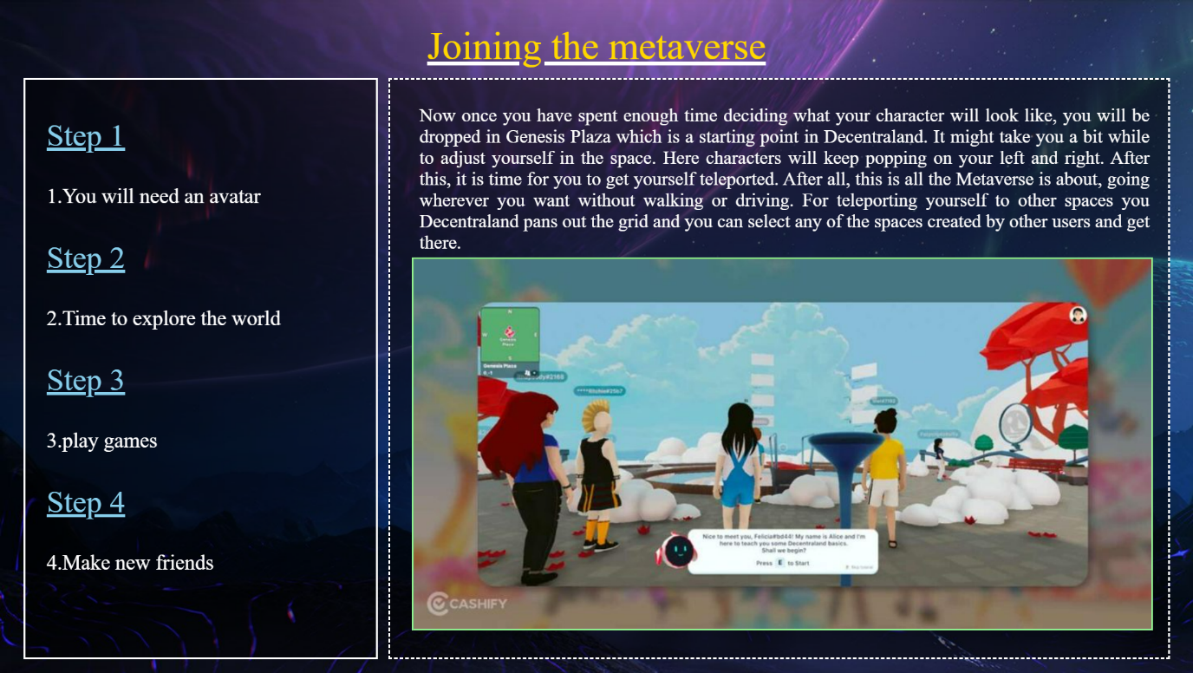

<img style="position: fixed;top:330;left:530;width:950;height:475;border-style: ridge;border-color:palegreen;" id="main"

src="D:\metaproject\images\access2.jpg">

<p style="position: fixed;top:110;left:540;width:940;height:400;text-align:justify;

font-size:24;color:white;" id="main" >

For accessing the platform you will need a laptop and a crypto wallet. While smartphones and most computers can be used to access it. But they don’t have enough processing power to provide you with optimum performance. This is one of the reasons why Facebook is focusing on developing more hardware like smart glasses so users can access the Metaverse easily.Now you might be wondering how you can enter and access the metaverse? It is not rocket science, for this article, we will take Decentraland and show you how you can enter and experience the Metaverse yourself. </p>

<img style="position: fixed;top:330;left:530;width:950;height:475;border-style: ridge;border-color:palegreen;display:none;" id="avatar"

src="D:\metaproject\images\avatar.jpg">

<p style="position: fixed;top:110;left:540;width:940;height:400;text-align:justify;

font-size:26;color:white;display:none;" id="avatar1">

While the Metaverse is all about creating a virtual world the first step is obviously creating your own digital avatar. Decentraland offers a panel through which you can create and customize your avatar. It provides you with the option to change your hair, eye colour, clothing and even accessorize your character. If you don’t like what your character is wearing you can change it however you want.</p>

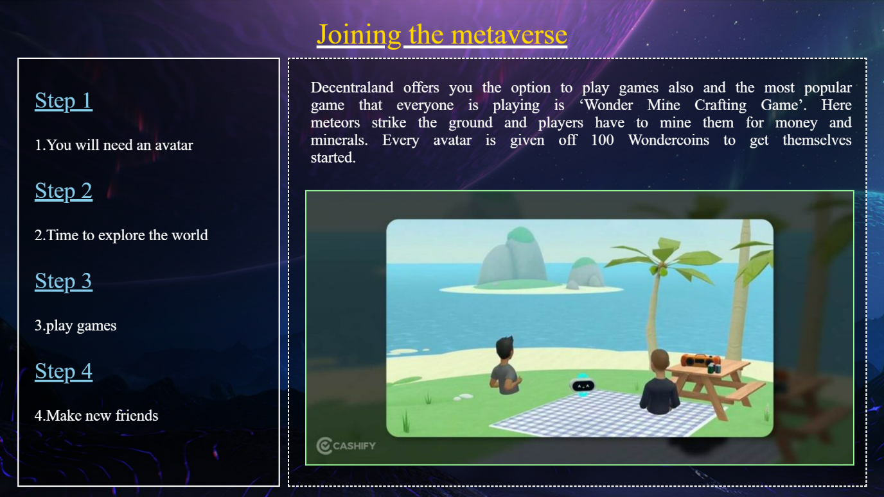

<img style="position: fixed;top:330;left:530;width:950;height:475;border-style: ridge;border-color:palegreen;display: none;" id="explore"

src="D:\metaproject\images\timetoexploreworld.jpg">

<p style="position: fixed;top:110;left:540;width:940;height:400;text-align:justify;

font-size:24;color:white;display: none;" id="explore1">

Now once you have spent enough time deciding what your character will look like, you will be dropped in Genesis Plaza which is a starting point in Decentraland. It might take you a bit while to adjust yourself in the space. Here characters will keep popping on your left and right. After this, it is time for you to get yourself teleported. After all, this is all the Metaverse is about, going wherever you want without walking or driving. For teleporting yourself to other spaces you Decentraland pans out the grid and you can select any of the spaces created by other users and get there. </p>

<img style="position: fixed;top:330;left:530;width:950;height:475;border-style: ridge;border-color:palegreen;display: none;" id="playgames"

src="D:\metaproject\images\playgames.jpg">

<p style="position: fixed;top:110;left:540;width:940;height:400;text-align:justify;

font-size:27;color:white;word-spacing: 10;display: none;" id="playgames1">

Decentraland offers you the option to play games also and the most popular game that everyone is playing is ‘Wonder Mine Crafting Game’. Here meteors strike the ground and players have to mine them for money and minerals. Every avatar is given off 100 Wondercoins to get themselves started.

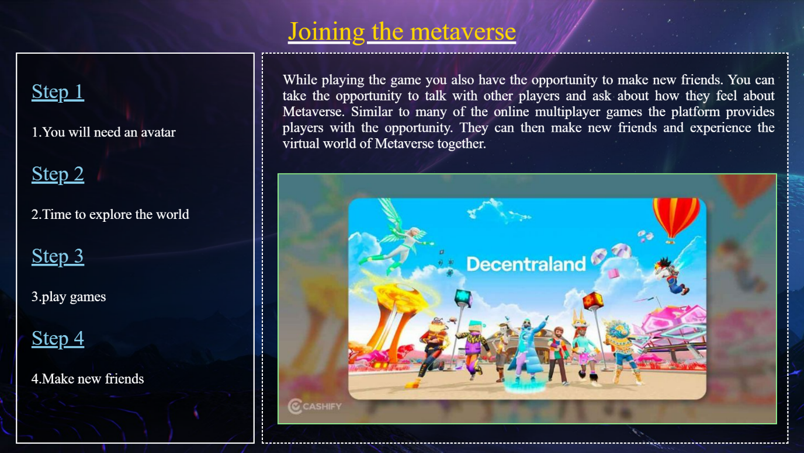

</p>

<img style="position: fixed;top:330;left:530;width:950;height:475;border-style: ridge;border-color:palegreen;display: none;" id="friends"

src="D:\metaproject\images\makenewfriends.jpg">

<p style="position: fixed;top:110;left:540;width:940;height:400;text-align:justify;

font-size:27;color:white;display: none;" id="friends1">

While playing the game you also have the opportunity to make new friends. You can take the opportunity to talk with other players and ask about how they feel about Metaverse. Similar to many of the online multiplayer games the platform provides players with the opportunity. They can then make new friends and experience the virtual world of Metaverse together. </p>

<a href="D:\metaproject\index tabs\Advantages of meta verse\Advantages.html">

<div style="position: absolute;z-index:10;right: 0;bottom: 0;height:100;width:200;">

</div>

</a>

<a href="D:\metaproject\index tabs\access\access.html"><div style="position:fixed;z-index:6;bottom:0;left:0;width:200;height:100;"></div></a>

<a href="D:\metaproject\Index2.html"><div style="position:fixed;z-index:6;bottom:0;left:650;width:200;height:100;"></div></a>

</body>

</html>

**Advantages.html**

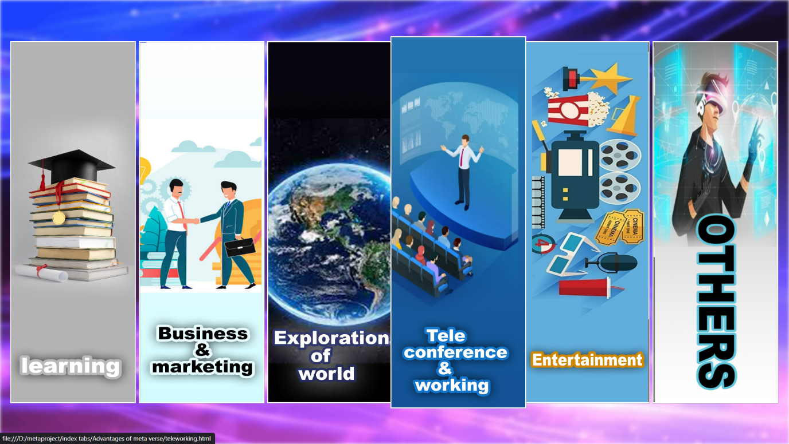

<html>

<head>

<title>Advantages of metaverse</title>

<script src="D:\metaproject\jq.js"></script>

<style>

#img1

{

filter: blur(3px);

}

</style>

<script>

function advanim1()

{

$('#advanimi').animate({left:'-=10px',

top:'-=10px',

height:'+=20px',

width:'+=20px'});

$("#advanimi").css("z-index","2");

}

function advanim1a()

{

$("#advanimi").animate({left:'+=10px',

top:'+=10px',

height:'-=20px',

width:'-=20px'});

$("#advanimi").css("z-index","1");

}

function advanim2()

{

$('#advanimi2').animate({left:'-=10px',

top:'-=10px',

height:'+=20px',

width:'+=20px'});

$("#advanimi2").css("z-index","2");

}

function advanim2a()

{

$("#advanimi2").animate({left:'+=10px',

top:'+=10px',

height:'-=20px',

width:'-=20px'});

$("#advanimi2").css("z-index","1");

}function advanim3()

{

$('#advanimi3').animate({left:'-=10px',

top:'-=10px',

height:'+=20px',

width:'+=20px'});

$("#advanimi3").css("z-index","2");

}

function advanim3a()

{

$("#advanimi3").animate({left:'+=10px',

top:'+=10px',

height:'-=20px',

width:'-=20px'});

$("#advanimi3").css("z-index","1");

}function advanim4()

{

$('#advanimi4').animate({left:'-=10px',

top:'-=10px',

height:'+=20px',

width:'+=20px'});

$("#advanimi4").css("z-index","2");

}

function advanim4a()

{

$("#advanimi4").animate({left:'+=10px',

top:'+=10px',

height:'-=20px',

width:'-=20px'});

$("#advanimi4").css("z-index","1");

}function advanim5()

{

$('#advanimi5').animate({left:'-=10px',

top:'-=10px',

height:'+=20px',

width:'+=20px'});

$("#advanimi5").css("z-index","2");

}

function advanim5a()

{

$("#advanimi5").animate({left:'+=10px',

top:'+=10px',

height:'-=20px',

width:'-=20px'});

$("#advanimi5").css("z-index","1");

}function advanim6()

{

$('#advanimi6').animate({left:'-=10px',

top:'-=10px',

height:'+=20px',

width:'+=20px'});

$("#advanimi6").css("z-index","2");

}

function advanim6a()

{

$("#advanimi6").animate({left:'+=10px',

top:'+=10px',

height:'-=20px',

width:'-=20px'});

$("#advanimi6").css("z-index","1");

}

</script>

</head>

<body>

<img id="img1" style="z-index:-1; position: absolute; top:0; left:0; height:864; width:1536;" src="D:\metaproject\gifs\advgif.gif">

</img>

<a href="D:\metaproject\index tabs\Advantages of meta verse\learning2.html"><img onmouseenter="advanim1();" id="advanimi"

onmouseleave="advanim1a();"

src="D:\metaproject\images\learning.png" width="240" height="700" style="z-index: 1;position: absolute;top:80; left:20;width: 240;height: 700;border-style:ridge;border-color:white;">

</img></a>

<a href="D:\metaproject\index tabs\Advantages of meta verse\commerce and crypto.html"><img onmouseenter="advanim2();" id="advanimi2"

onmouseleave="advanim2a();"

src="D:\metaproject\images\business and marketing .png" width="240" height="700" style="z-index: 1;position: absolute;top:80; left:270;width: 240;height: 700;border-style:ridge;border-color:white">

</img></a>

<a href="D:\metaproject\index tabs\Advantages of meta verse\exploration3.html"><img onmouseenter="advanim3();" id="advanimi3"

onmouseleave="advanim3a();"

src="D:\metaproject\images\Exploration of world.jpg" width="240" style="z-index: 1;position: absolute;top:80; left:520;width: 240;height: 700;border-style:ridge;border-color:white"

height="700">

</img></a>

<a href="D:\metaproject\index tabs\Advantages of meta verse\teleworking.html"><img onmouseenter="advanim4();" id="advanimi4"

onmouseleave="advanim4a();"

src="D:\metaproject\images\Teleconference.jpg" width="240" style="z-index: 1;position: absolute;top:80; left:770;width: 240;height: 700;border-style:ridge;border-color:white"

height="700">

</img></a>

<a href="D:\metaproject\index tabs\Advantages of meta verse\games.html"><img onmouseenter="advanim5();" id="advanimi5"

onmouseleave="advanim5a();"

src="D:\metaproject\images\Entertainment.jpg" width="240" style="z-index: 1;position: absolute;top:80; left:1020;width: 240;height: 700;border-style:ridge;border-color:white"

height="700">

</img></a>

<a href="D:\metaproject\index tabs\Advantages of meta verse\Others.html"><img onmouseenter="advanim6();" id="advanimi6"

onmouseleave="advanim6a();"

src="D:\metaproject\images\Others.jpg" width="240"height="700" style="z-index: 1;position: absolute;top:80; left:1270;width: 240;height: 700;border-style:ridge;border-color:white">

</img></a>

</body>

<a href="D:\metaproject\index tabs\access\access2.html"><div style="position:fixed;z-index:6;bottom:0;left:0;width:200;height:100;"></div></a>

<a href="D:\metaproject\Index2.html"><div style="position:fixed;z-index:6;bottom:0;left:650;width:200;height:100;"></div></a>

<a href="D:\metaproject\index tabs\disadvantages.html">

<div style="position: absolute;z-index:10;right: 0;bottom: 0;height:100;width:200;">

</div></a>

</html>

**learning2.html**

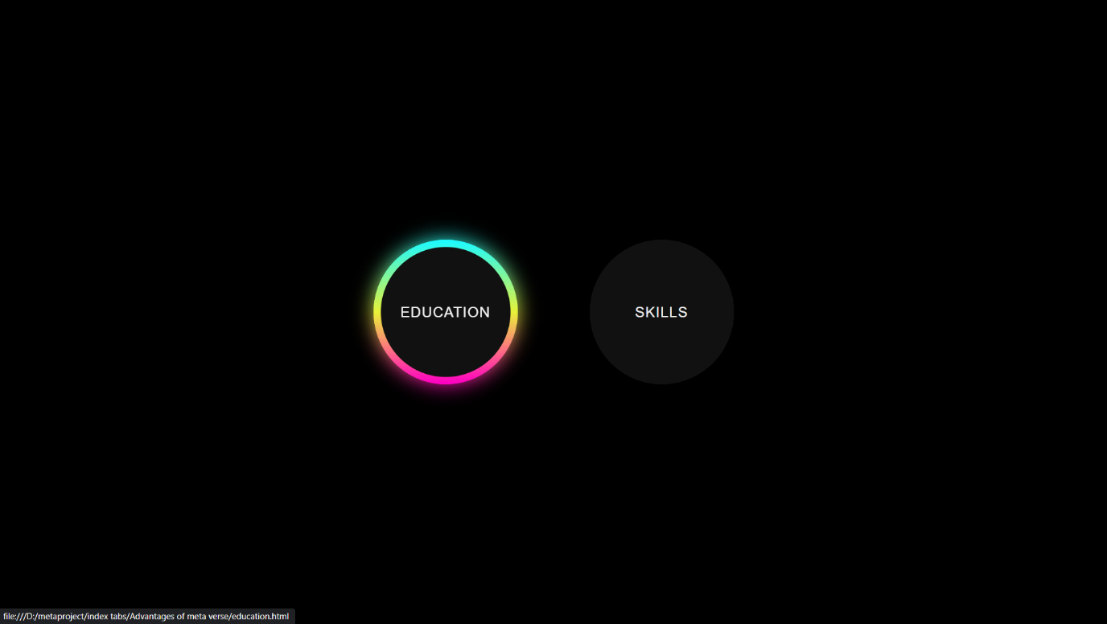

<!DOCTYPE html>

<html lang="en" dir="ltr">

<head>

<meta charset="utf-8">

<title>learning</title>

<style>

*{

margin: 0;

padding: 0;

box-sizing: border-box;

}

html,body{

display: grid;

height: 100%;

place-items: center;

background: #000;

}

.center{

display: flex;

text-align: center;

align-items: center;

justify-content: center;

}

.outer{

z-index: 2;

position: relative;

margin:0 50px;

background: #111;

}

.circle{

height: 200px;

width: 200px;

border-radius: 50%;

}

.outer button, .outer span{

position: absolute;

top: 50%;

left: 50%;

transform: translate(-50%, -50%);

}

.outer button{

background: #111;

color: #f2f2f2;

outline: none;

border: none;

font-size: 20px;

letter-spacing: 1px;

text-transform: uppercase;

z-index: 9;

cursor: pointer;

}

.circle button{

height: 180px;

width: 180px;

border-radius: 50%;

}

.outer span{

height: 100%;

width: 100%;

background: inherit;

}

.circle span{

border-radius: 50%;

}

.outer:hover span:nth-child(1){

filter: blur(7px);

}

.outer:hover span:nth-child(2){

filter: blur(14px);

}

.outer:hover {

background: linear-gradient(#14ffe9,#ffeb3b,#ff00e0);

animation: rotate 1.5s linear infinite;

}

@keyframes rotate{

0%{

filter: hue-rotate(0deg);

}

100%{

filter: hue-rotate(360deg);

}

}

@media (max-width: 640px){

.center{

flex-wrap: wrap;

flex-direction: column;

}

.outer{

margin: 50px 0px;

}

}

</style>

<meta name="viewport" content="width=device-width,initial-scale=1.0">

</head>

<body>

<div class="center">

<a href="D:\metaproject\index tabs\Advantages of meta verse\Advantages.html"><div style="opacity:0;" class="outer circle">

<button>dfasd</button>

<span></span>

<span></span>

</div></a>

<a href="D:\metaproject\index tabs\Advantages of meta verse\education.html"><div class="outer circle">

<button>Education</button>

<span></span>

<span></span>

</div></a>

<a href="D:\metaproject\index tabs\Advantages of meta verse\skills.html"><div class="outer circle">

<button>Skills</button>

<span></span>

<span></span>

</div></a>

<a href="D:\metaproject\index tabs\Advantages of meta verse\commerce and crypto.html"><div style="opacity:0;" class="outer circle">

<button>dfasd</button>

<span></span>

<span></span>

</div></a></body></html>

**education.html**

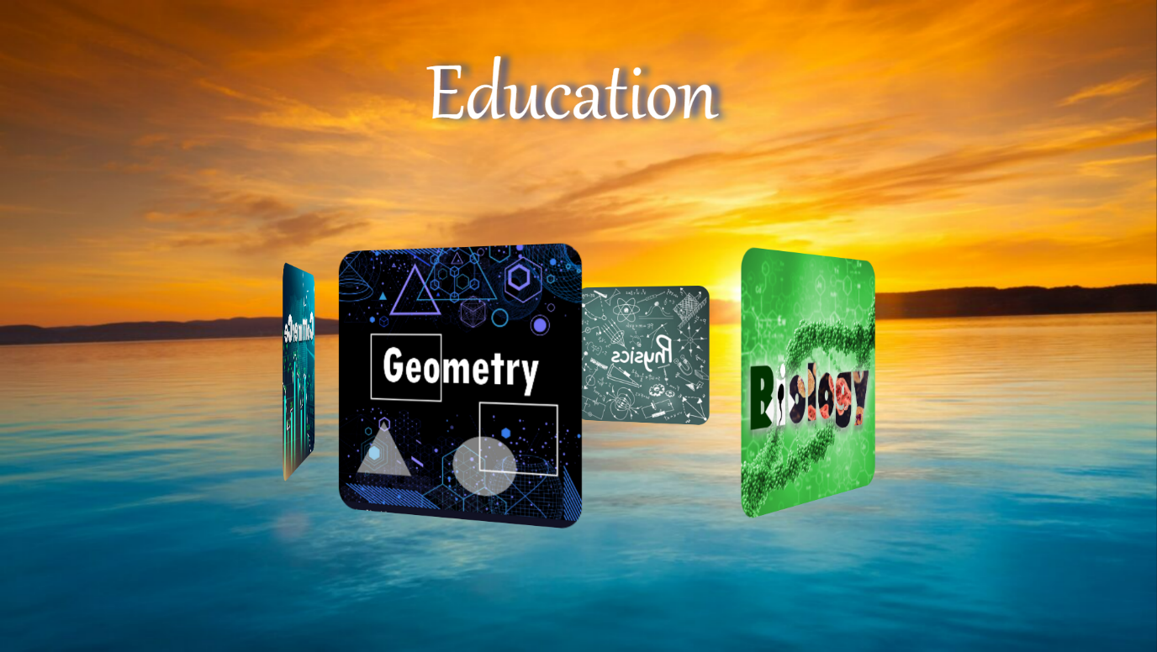

<html>

<head>

<title> Education</title>

<meta charset="UTF-8">

<script src="D:\metaproject\jq.js"></script>

<script language="javascript">

</script>

<style>

*{

margin: 0;

padding: 0;

box-sizing: border-box;

}

body{

background: linear-gradient(to right, #2c5364,#0f2027);

height: 100vh;

display: flex;

align-items: center;

justify-content: center;

overflow: hidden;

}

.slider{

position: relative;

width: 240px;

height: 240px;

transform-style: preserve-3d;

animation: rotate 25s linear infinite;

animation-direction: reverse;

animation-play-state: running;

}

@keyframes rotate{

0%{

transform: perspective(1000px) rotateY(0deg);

}

100%{

transform: perspective(1000px) rotateY(360deg);

}

}

.slider span{

position: absolute;

top: 50;

left: 0;

width: 100%;

height: 100%;

transform-origin: center;

transform-style: preserve-3d;

transform: rotateY(calc(var(--i)*60deg)) translatez(350px);

}

.slider span img{

position: absolute;

top: 0;

left: 0;

width: 100%;

height: 100%;

border-radius: 20px;

animation-timing-function: ease-in;

}

.slider:hover {

animation-play-state: paused;

}

#education2{

animation: eduzoom 2s linear infinite forwards;

}

@keyframes eduzoom

{

0%{

top:30;left:570;font-size: 120px;

}

50%{

top: 10;left: 530;font-size: 150px;

}

100%{

top:30;left:570;font-size: 120px;

}

</style>

</head>

<body>

<p style="position: fixed;z-index:8;top:30;left:570;width:400;height:100;font-size:120px;color:white;font-family:gabriola;text-shadow:10px 0px 10px #1245ab;" id="education2">Education</p>

<img style="z-index:-10;position: fixed;right:0;bottom:0;min-height: 100%;min-width: 100%;width: 100%;height: 100%" src="D:\metaproject\images\education background.jpg" >

</img>

<div class ="slider" id="slider2" >

<span style="--i:1;"><a href="D:\metaproject\Naveen\Geometry - Copy.html" ><img src="D:\metaproject\images\geometry.jpg"></a>

</span>

<span style="--i:2;"><a href="D:\metaproject\Naveen\biology.html" ><img src="D:\metaproject\images\biology.jpg"></a></span>

<span style="--i:3;"><a href="D:\metaproject\aravind\chemistry.html" ><img src="D:\metaproject\images\chemistry.jpg"></a></span>

<span style="--i:4;"><a href="D:\metaproject\Naveen\physics.html" ><img src="D:\metaproject\images\physics.jpg"></a></span>

<span style="--i:5;"><a href="D:\metaproject\Naveen\Agriculture.html" ><img src="D:\metaproject\images\agriculture.jpg"></a></span>

<span style="--i:6;"><a href="D:\metaproject\anil\commerce in metaverce.html" ><img src="D:\metaproject\images\Commerce.jpg"></a></span>

</div>

<a href="D:\metaproject\index tabs\Advantages of meta verse\skills.html">

<div style="position: absolute;z-index:10;right: 40;bottom: 30;height:100;width:100;">

</div></a>

<a href="D:\metaproject\index tabs\Advantages of meta verse\learning2.html"><div style="position:fixed;z-index:6;bottom:0;left:0;width:200;height:100;"></div></a>

<a href="D:\metaproject\index tabs\Advantages of meta verse\Advantages.html"><div style="position:fixed;z-index:6;bottom:0;left:650;width:200;height:100;"></div></a>

<a href="D:\metaproject\index tabs\Advantages of meta verse\skills.html">

<div style="position: absolute;z-index:10;right: 0;bottom: 0;height:100;width:200;">

</div></a>

</body>

</html>

**Geometry – Copy.html**

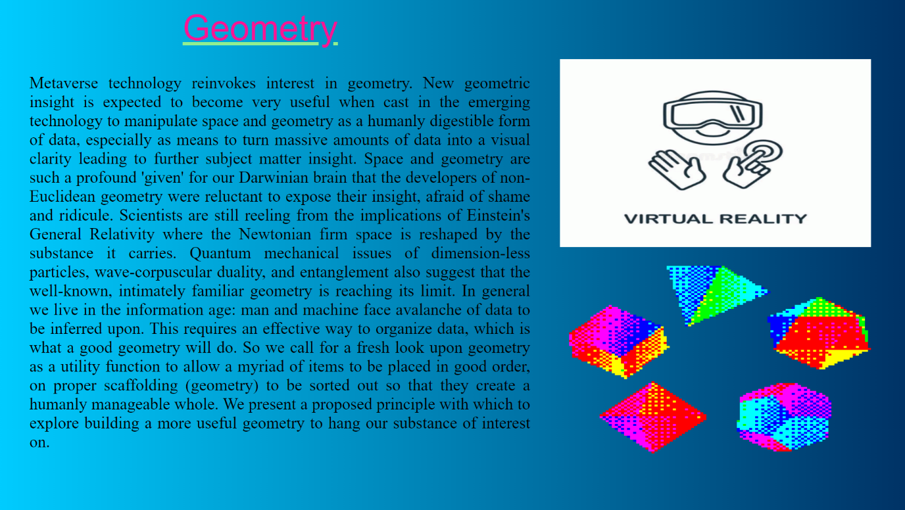

<html>

<head>

<title>open my web page to Geometry </title>

</head>

<body style="background:linear-gradient(to left, #003366 0%, #00ccff 100%);

overflow: hidden;">

<div style="z-index:1; position: absolute;top:100; left:950;width:1528;

height: 500;">

<img src ="D:\metaproject\images/metave.gif" height="318" width="528">

</div>

<div style="z-index:2; position: absolute;top:450; left:950;width:1528;

height: 500;">

<img src ="D:\metaproject\images/eesr.gif" height="318" width="528">

</div>

<div style="z-index:3;position: absolute;left:310;top:13; font-size: 60px;

color:deeppink; text-decoration:underline; text-decoration-color:lightgreen;

font-family:sans-serif;"> Geometry </div>

<div style="z-index:4;position: absolute;left:50;top:97;width:850; text-align: justify; font-size:28px; color:black;">

<p>

Metaverse technology reinvokes interest in geometry. New geometric insight is expected to become very useful when cast in the emerging technology to manipulate space and geometry as a humanly digestible form of data, especially as means to turn massive amounts of data into a visual clarity leading to further subject matter insight. Space and geometry are such a profound 'given' for our Darwinian brain that the developers of non-Euclidean geometry were reluctant to expose their insight, afraid of shame and ridicule. Scientists are still reeling from the implications of Einstein's General Relativity where the Newtonian firm space is reshaped by the substance it carries. Quantum mechanical issues of dimension-less particles, wave-corpuscular duality, and entanglement also suggest that the well-known, intimately familiar geometry is reaching its limit. In general we live in the information age: man and machine face avalanche of data to be inferred upon. This requires an effective way to organize data, which is what a good geometry will do.

So we call for a fresh look upon geometry as a utility function to allow a myriad of items to be placed in good order, on proper scaffolding (geometry) to be sorted out so that they create a humanly manageable whole. We present a proposed principle with which to explore building a more useful geometry to hang our substance of interest on.

</div>

<a href="D:\metaproject\index tabs\Advantages of meta verse\education.html"><div style="position:fixed;z-index:6;bottom:0;left:0;width:200;height:100;"></div></a>

<a href="D:\metaproject\index tabs\Advantages of meta verse\education.html"><div style="position:fixed;z-index:6;bottom:0;left:650;width:200;height:100;"></div></a>

<a href="D:\metaproject\Naveen\G1.html"> <div style="position: absolute;z-index:10;right: 0;bottom: 0;height:100;width:200;"> </div></a>

</body>

</html>

**G1.html**

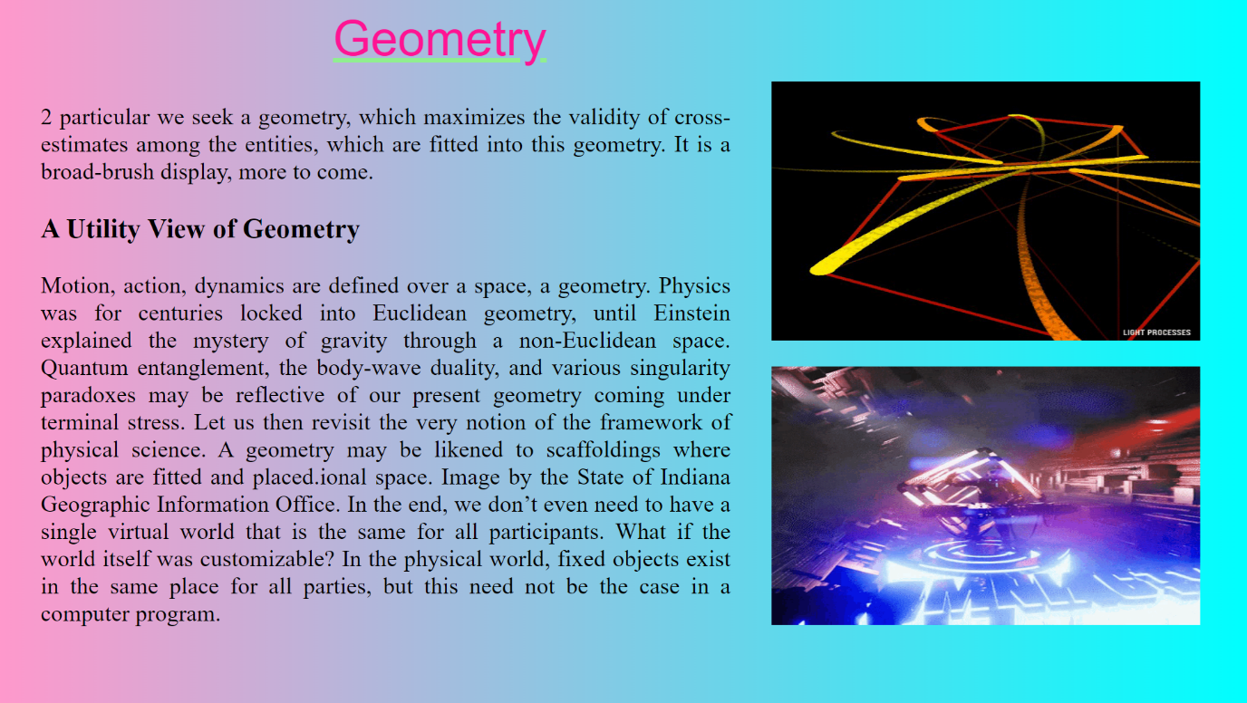

<html>

<head>

<title> open my web page to Geometry 1 </title>

</head>

<body style="background:linear-gradient(to right, #ff99cc 0%, #00ffff 100%);

overflow: hidden;">

<div style="z-index:1; position: absolute;top:100; left:950;width:1528;

height: 500;">

<img src ="D:\metaproject\images/3qMd.gif" height="318" width="528">

</div>

<div style="z-index:2; position: absolute;top:450; left:950;width:1528;

height: 500;">

<img src ="D:\metaproject\images/kryder.gif" height="318" width="528">

</div>

<div style="z-index:3;position: absolute;left:410;top:13; font-size: 60px;

color:deeppink; text-decoration:underline; text-decoration-color:lightgreen;

font-family:sans-serif;"> Geometry </div>

<div style="z-index:4;position: absolute;left:50;top:97;width:850; text-align: justify; font-size:29px; color:black;">

<p>

2 particular we seek a geometry, which maximizes the validity of cross-estimates among the entities, which are fitted into this geometry. It is a broad-brush display, more to come.<h3> A Utility View of Geometry </h3> Motion, action, dynamics are defined over a space, a geometry. Physics was for centuries locked into Euclidean geometry, until Einstein explained the mystery of gravity through a non-Euclidean space. Quantum entanglement, the body-wave duality, and various singularity paradoxes may be reflective of our present geometry coming under terminal stress. Let us then revisit the very notion of the framework of physical science. A geometry may be likened to scaffoldings where objects are fitted and placed.ional space. Image by the State of Indiana Geographic Information Office.

In the end, we don’t even need to have a single virtual world that is the same for all participants. What if the world itself was customizable? In the physical world, fixed objects exist in the same place for all parties, but this need not be the case in a computer program. </p> </div>

<a href="D:\metaproject\Naveen\Geometry - Copy.html"><div style="position:fixed;z-index:6;bottom:0;left:0;width:200;height:100;"></div></a>

<a href="D:\metaproject\index tabs\Advantages of meta verse\education.html"><div style="position:fixed;z-index:6;bottom:0;left:650;width:200;height:100;"></div></a>

<a href="D:\metaproject\Naveen\biology.html"> <div style="position: absolute;z-index:10;right: 0;bottom: 0;height:100;width:200;"> </div></a>

</body>

</html>

**biology.html**

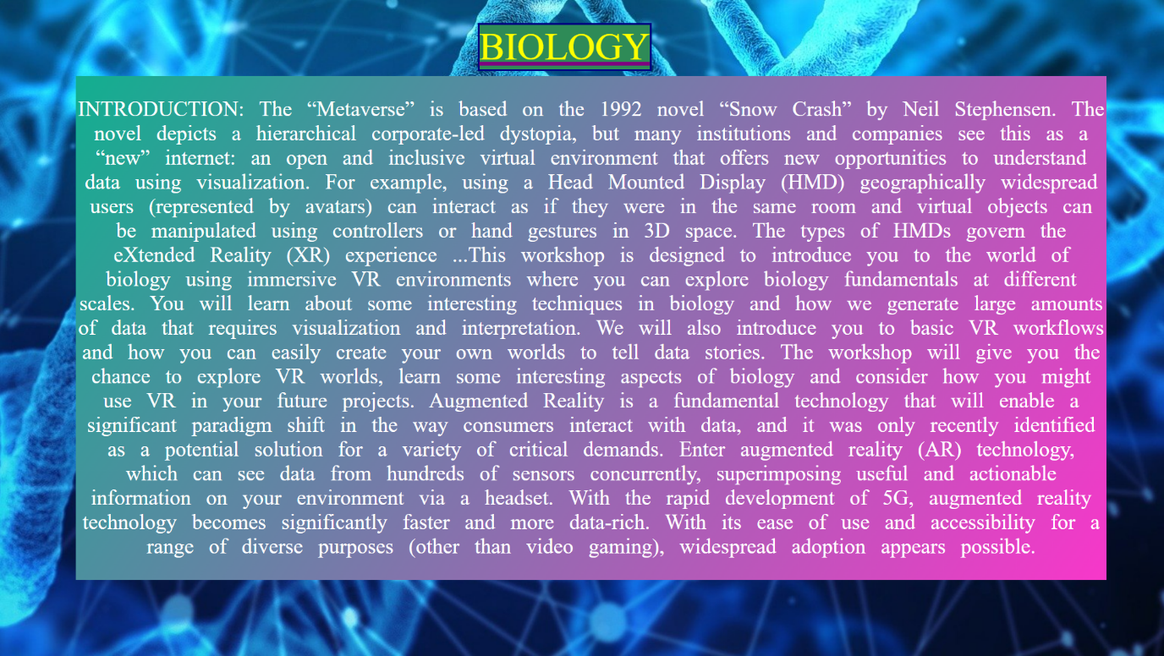

<html>

<head>

<title> open my web page to Biology </title>

<script src="D:\metaproject\jq.js"></script>

<script language="javascript">

function fadetoggle()

{

$("#fadetoggle2, .fadetoggle1").fadeToggle();

}

</script>

</head>

<body>

<img src="D:\metaproject\images\biology3.jpg" style="position: fixed;right:0;bottom:0;

min-height: 100%;min-width: 100%;" onclick="fadetoggle()">

<div class="fadetoggle1" style="z-index: 2;position: absolute;left:630;top:30; font-size: 50px;

color:yellow; text-decoration:underline; text-decoration-color:purple ;

border-style: solid; border-color: navy;background-color: seagreen;display:none;">BIOLOGY </div>

<div id="fadetoggle2" style="z-index:3 ;position: absolute;left:100;top:100;width: 1360; text-align: center; color: white; font-size:28px;word-spacing: 13;display:none;

background:linear-gradient(125deg,#12af90,#f837ca);">

<p>INTRODUCTION:

The “Metaverse” is based on the 1992 novel “Snow Crash” by Neil Stephensen. The novel depicts a

hierarchical corporate-led dystopia, but many institutions and companies see this as a “new”

internet: an open and inclusive virtual environment that offers new opportunities to understand data

using visualization. For example, using a Head Mounted Display (HMD) geographically widespread

users (represented by avatars) can interact as if they were in the same room and virtual objects can be

manipulated using controllers or hand gestures in 3D space. The types of HMDs govern the

eXtended Reality (XR) experience

...This workshop is designed to introduce you to the world of biology using immersive VR environments where you can explore biology fundamentals at different scales. You will learn about some interesting techniques in biology and how we generate large amounts of data that requires visualization and interpretation. We will also introduce you to basic VR workflows and how you can easily create your own worlds to tell data stories. The workshop will give you the chance to explore VR worlds, learn some interesting aspects of biology and consider how you might use VR in your future projects.

Augmented Reality is a fundamental technology that will enable a significant paradigm shift in the way consumers interact with data, and it was only recently identified as a potential solution for a variety of critical demands. Enter augmented reality (AR) technology, which can see data from hundreds of sensors concurrently, superimposing useful and actionable information on your environment via a headset. With the rapid development of 5G, augmented reality technology becomes significantly faster and more data-rich. With its ease of use and accessibility for a range of diverse purposes (other than video gaming), widespread adoption appears possible.</p>

</div>

<a href="D:\metaproject\Naveen\G1.html"><div style="position:fixed;z-index:6;bottom:0;left:0;width:200;height:100;"></div></a>

<a href="D:\metaproject\index tabs\Advantages of meta verse\education.html"><div style="position:fixed;z-index:6;bottom:0;left:650;width:200;height:100;"></div></a>

<a href="D:\metaproject\Naveen\biology1.html"> <div style="position: absolute;z-index:10;right: 0;bottom: 0;height:100;width:200;"> </div></a>

</body>

</html>

**biology1.html**



<html>

<head>

<title> open my web page to Biology </title>

<script src="D:\metaproject\jq.js"></script>

<script language="javascript">

function fadetoggle()

{

$("#fadetoggle2").fadeToggle();

}

</script>

</head>

<body>

<img src="D:\metaproject\images\biology4.jpg" style="position: fixed;right:0;bottom:0;

min-height: 100%;min-width: 100%;" onclick="fadetoggle()">

<div style="z-index:2 ;position: absolute;left:100;top:30;width: 1350; text-align: center; font-size: 28px; color:black;word-spacing: 14;display:none;background-image:url(D:\\metaproject\\images\\biology5bg.png" id="fadetoggle2">

<p>The Metaverse is a collectively shared virtual area that encompasses all virtual worlds including the Internet. While it may include replicas or adaptations of the real world, it is distinct from augmented reality.

Bioinformatics research generates enormous amounts of diverse data. This treasure trove of data contains information about metabolic mechanisms and pathways, as well as proteomics, transcriptomics, and metabolomics. Often, these technologies give “simple” visual help for the study, like when exploring and engaging with a protein on a 3D monitor and suitable interaction hardware. Additionally, these approaches were previously limited to expensive professional visualisation facilities. With the development of new affordable and frequently transportable technology, there is a strong case for adopting comparable tactics on a daily basis for research. Visual Analytics has been effectively utilised to evaluate complicated and heterogeneous datasets for several years. Immersive Analytics is a novel technique that blends these approaches with immersive and interactive technologies. There is significant interest in the broad application of Augmented Reality (AR) and Virtual Reality (VR) in the sciences of bioinformatics and cheminformatics for the purpose of visualising complicated biological and chemical structures.

For these reasons, virtual reality has the potential to boost abstract information visualisation, and numerous studies have demonstrated that consumers comprehend data more quickly and easily in VR environments than they do in conventional 2D and 3D desktop display.COVID-19 forced humanity to think about new ways of working globally without physically being present with other people, and eXtended Reality (XR) systems (defined as Virtual Reality, Augmented Reality and Mixed Reality) offer a potentially elegant solution. Previously seen as mainly for gaming, commercial and research institutions are investigating XR solutions to solve real world problems from training, simulation, mental health, data analysis, and studying disease progression. More recently large corporations such as Microsoft and Meta have announced they are developing the Metaverse as a new paradigm to interact with the digital world. </p>

</div>

<a href="D:\metaproject\Naveen\biology.html"><div style="position:fixed;z-index:6;bottom:0;left:0;width:200;height:100;"></div></a>

<a href="D:\metaproject\index tabs\Advantages of meta verse\education.html"><div style="position:fixed;z-index:6;bottom:0;left:650;width:200;height:100;"></div></a>

<a href="D:\metaproject\Naveen\physics.html"> <div style="position: absolute;z-index:10;right: 0;bottom: 0;height:100;width:200;"> </div></a>

</body>

</html>

**physics.html**

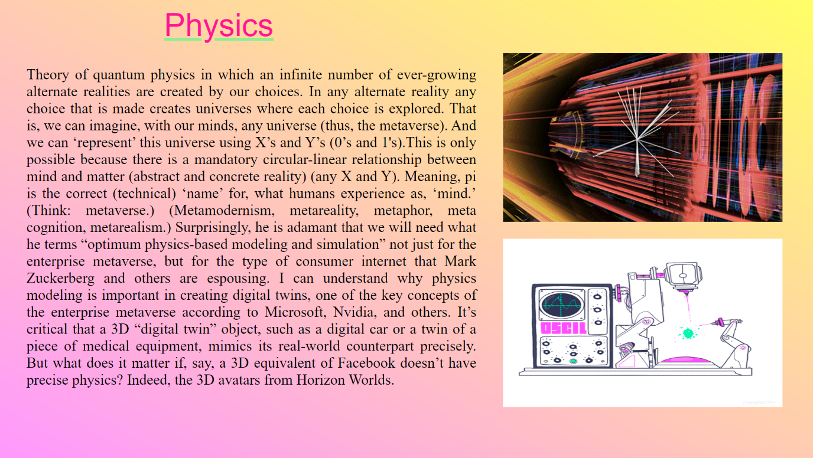

<html>

<head>

<title>physics</title>

</head>

<body style="background:linear-gradient( to bottom left, #ffff66 0%, #ff99ff 100%);

overflow: hidden;">

<div style="z-index:1; position: absolute;top:100; left:950;width:1528;

height: 500;">

<img src ="D:\metaproject\images/gip.gif" height="318" width="528">

</div>

<div style="z-index:2; position: absolute;top:450; left:950;width:1528;

height: 500;">

<img src ="D:\metaproject\images/cxnf.gif" height="318" width="528">

</div>

<div style="z-index:3;position: absolute;left:310;top:13; font-size: 60px;

color:deeppink; text-decoration:underline; text-decoration-color:lightgreen;

font-family:sans-serif;">Physics</div>

<div style="z-index:4;position: absolute;left:50;top:97;width:850; text-align: justify; font-size:28px; color:black;">

<p> Theory of quantum physics in which an infinite number of ever-growing alternate realities are created by our choices. In any alternate reality any choice that is made creates universes where each choice is explored.

That is, we can imagine, with our minds, any universe (thus, the metaverse). And we can ‘represent’ this universe using X’s and Y’s (0’s and 1's).This is only possible because there is a mandatory circular-linear relationship between mind and matter (abstract and concrete reality) (any X and Y). Meaning, pi is the correct (technical) ‘name’ for, what humans experience as, ‘mind.’ (Think: metaverse.) (Metamodernism, metareality, metaphor, meta cognition, metarealism.)

Surprisingly, he is adamant that we will need what he terms “optimum physics-based modeling and simulation” not just for the enterprise metaverse, but for the type of consumer internet that Mark Zuckerberg and others are espousing.

I can understand why physics modeling is important in creating digital twins, one of the key concepts of the enterprise metaverse according to Microsoft, Nvidia, and others. It’s critical that a 3D “digital twin” object, such as a digital car or a twin of a piece of medical equipment, mimics its real-world counterpart precisely. But what does it matter if, say, a 3D equivalent of Facebook doesn’t have precise physics? Indeed, the 3D avatars from Horizon Worlds.

</p>

</div>

<a href="D:\metaproject\Naveen\biology1.html"><div style="position:fixed;z-index:6;bottom:0;left:0;width:200;height:100;"></div></a>

<a href="D:\metaproject\index tabs\Advantages of meta verse\education.html"><div style="position:fixed;z-index:6;bottom:0;left:650;width:200;height:100;"></div></a>

<a href="D:\metaproject\aravind\chemistry.html"> <div style="position: absolute;z-index:10;right: 0;bottom: 0;height:100;width:200;"> </div></a>

</body>

</html>

**chemistry.html**

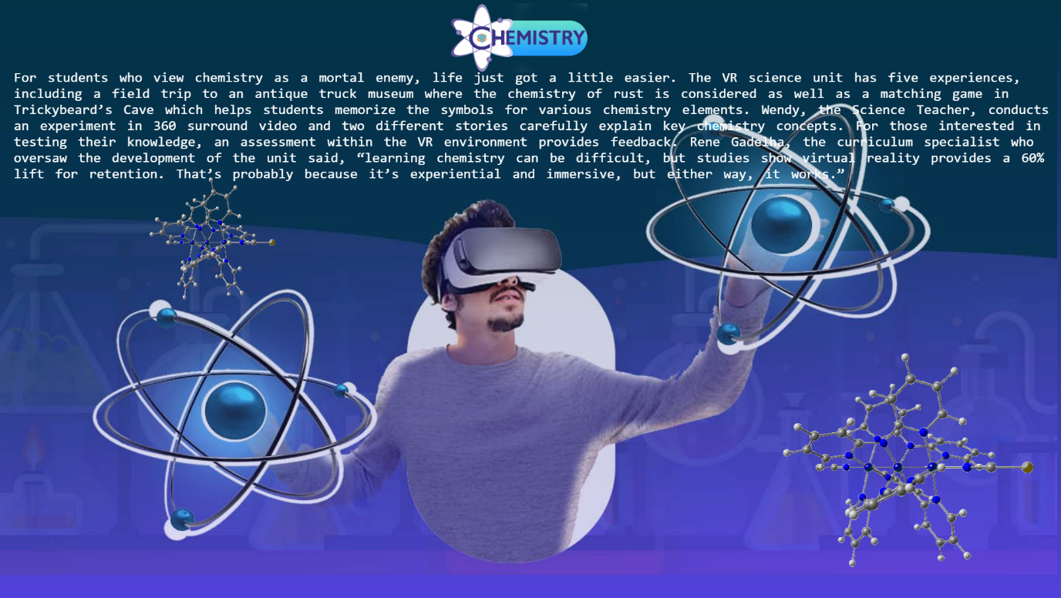

<html>

<body style="background:linear-gradient(180deg,#013246,#5342dc)">

<img style="z-index:5;top:0;left:0;position: fixed;opacity: 0.8"

src="D:\metaproject\images\CHEMISTRY 1.jpg" width="1530" height="830">

<div style="z-index:6;position: absolute;top:100;left: 20;color:white;font-family: consolas;font-size: 20;word-spacing: 5"text-align="justify">For students who view chemistry as a mortal enemy, life just got a little easier.

The VR science unit has five experiences, including a field trip to an antique truck museum where the chemistry of rust is considered as well as a matching game in Trickybeard’s Cave which helps students memorize the symbols for various chemistry elements.

Wendy, the Science Teacher, conducts an experiment in 360 surround video and two different stories carefully explain key chemistry concepts. For those interested in testing their knowledge, an assessment within the VR environment provides feedback.

Rene Gadelha, the curriculum specialist who oversaw the development of the unit said, “learning chemistry can be difficult, but studies show virtual reality provides a 60% lift for retention. That’s probably because it’s experiential and immersive, but either way, it works.”

</div>

<img style="z-index:7;position: absolute;top:500;left: 1100;width: 400;height:350"src="D:\metaproject\images\chemistry atoms.gif"> </img>

<img style="z-index:7;position: absolute;top:250;left: 200;width: 200;height:200"src="D:\metaproject\images\chemistry atoms.gif"> </img>

<img style="z-index:7;position: absolute;top:5;left: 650;width: 200;height:100"src="D:\metaproject\images\chemisrty logo.png"> </img>

<a href="D:\metaproject\Naveen\physics.html"><div style="position:fixed;z-index:6;bottom:0;left:0;width:200;height:100;"></div></a>

<a href="D:\metaproject\index tabs\Advantages of meta verse\education.html"><div style="position:fixed;z-index:6;bottom:0;left:650;width:200;height:100;"></div></a>

<a href="D:\metaproject\Naveen\Agriculture.html"> <div style="position: absolute;z-index:10;right: 0;bottom: 0;height:100;width:200;"> </div></a>

</body></html>

**Agriculture.html**

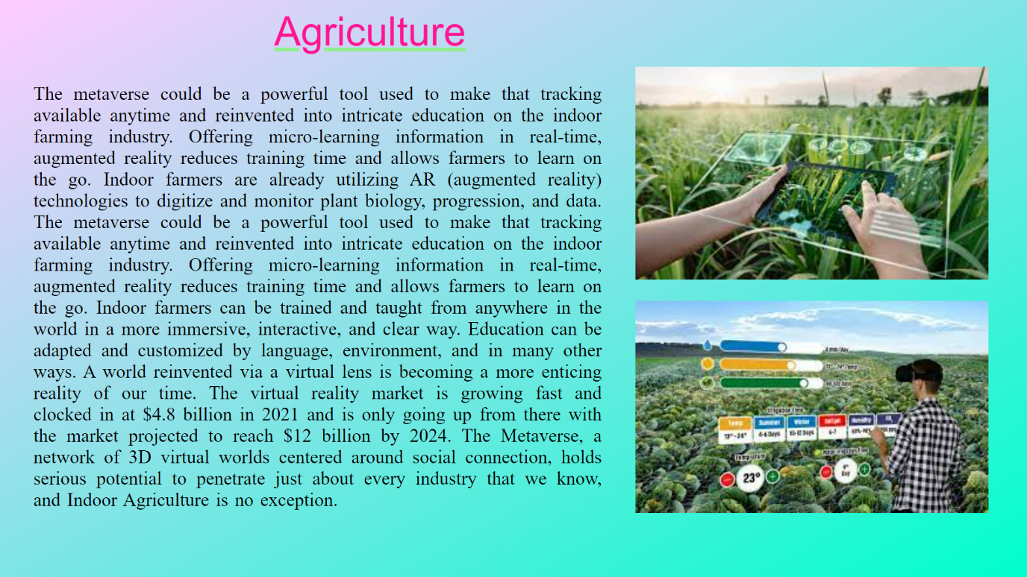

-<html>

<head>

<title> Agriculture </title>

</head>

<body style="background:linear-gradient(to top left, #00ffcc 0%, #ffccff 100%);

overflow: hidden;">

<div style="z-index:1; position: absolute; top:100; left:950;width:1528;

height: 500;">

<img src ="D:\metaproject\images/download (4).jpeg" height="318" width="528">

</div>

<div style="z-index:2; position: absolute;top:450; left:950;width:1528;

height: 500;">

<img src ="D:\metaproject\images/download (3).jpeg" height="318" width="528">

</div>

<div style="z-index:3;position: absolute;left:410;top:13; font-size: 60px;

color:deeppink; text-decoration:underline; text-decoration-color:lightgreen;

font-family:sans-serif;">Agriculture </div>

<div style="z-index:4;position: absolute;left:50;top:97;width:850; text-align: justify; font-size:28px; color:black;word-spacing: 3;">

<p>

The metaverse could be a powerful tool used to make that tracking available anytime and reinvented into intricate education on the indoor farming industry. Offering micro-learning information in real-time, augmented reality reduces training time and allows farmers to learn on the go.

Indoor farmers are already utilizing AR (augmented reality) technologies to digitize and monitor plant biology, progression, and data. The metaverse could be a powerful tool used to make that tracking available anytime and reinvented into intricate education on the indoor farming industry. Offering micro-learning information in real-time, augmented reality reduces training time and allows farmers to learn on the go.

Indoor farmers can be trained and taught from anywhere in the world in a more immersive, interactive, and clear way. Education can be adapted and customized by language, environment, and in many other ways.

A world reinvented via a virtual lens is becoming a more enticing reality of our time. The virtual reality market is growing fast and clocked in at $4.8 billion in 2021 and is only going up from there with the market projected to reach $12 billion by 2024. The Metaverse, a network of 3D virtual worlds centered around social connection, holds serious potential to penetrate just about every industry that we know, and Indoor Agriculture is no exception.

</div>

<a href="D:\metaproject\aravind\chemistry.html"><div style="position:fixed;z-index:6;bottom:0;left:0;width:200;height:100;"></div></a>

<a href="D:\metaproject\index tabs\Advantages of meta verse\education.html"><div style="position:fixed;z-index:6;bottom:0;left:650;width:200;height:100;"></div></a>

<a href="D:\metaproject\anil\commerce in metaverce.html"> <div style="position: absolute;z-index:10;right: 0;bottom: 0;height:100;width:200;"> </div></a>

</body>

</html>

**commerce in metaverse .html**

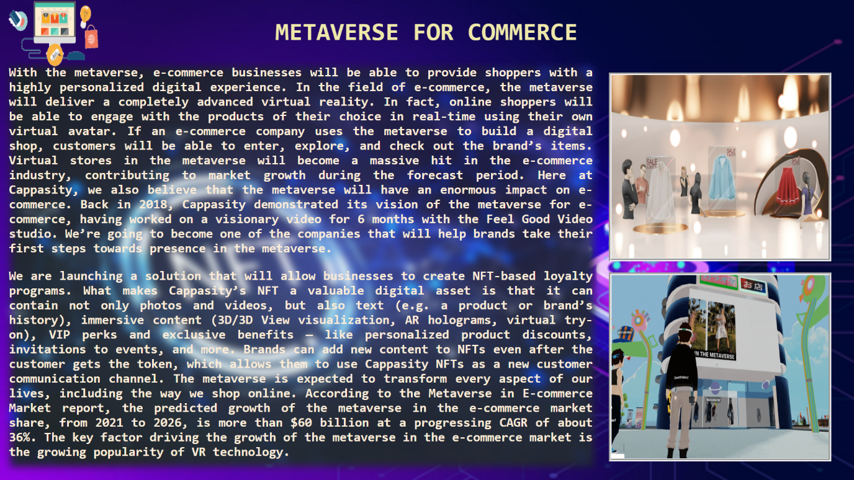

<html>

<head>

<title>Commrece in Meraverse</title>

<style>

#h2{

font-family:monospace;

color: palegoldenrod;

font-size: 45;

}

#img1{

filter: blur(7px);

}

#img3{

border: 5px;

border-style: groove;

background-color: aliceblue;

}

#h1{

font-family: sans-serif;

color: palegoldenrod;

font-size: 45;

}

</style>

</head>

<body style="overflow:hidden;">

<div style="z-index: 2;position: absolute; top:0; left:0;width: 1530;height: 990;">

<img src="D:\metaproject\images\thumbimg_25361957thumbejpg.jpg" height="870" width="1550">

<div style="z-index: 2;position: absolute; top:120; left:18;width: 1530;height: 990;">

<img id="img1" src="D:\metaproject\images\image_1338722123.webp" height="720" width="1050">

</div>

<div style="z-index: 2;position: absolute; top:0; left:495;width: 1530;height: 990;">

<h1 id="h2"><b>

METAVERSE FOR COMMERCE</b>

</h1>

</div>

<div style="z-index: 2;position: absolute; top: -20; left: 0;width: 1530;height: 990;">

<img src="D:\metaproject\images\ecommerce-development.gif" height="150" width="190">

</div>

<div style="z-index: 4;position: absolute; top:490; left: 1095;width: 1530;height: 990;">

<img id="img3" src="D:\metaproject\images\Metaverse-Shop.gif" height="330" width="390">

</div>

<div style="z-index: 4;position: absolute; top:130; left: 1095;width: 1530;height: 990;">

<img id="img3" src="D:\metaproject\images\Metaverse-in-e-commerce.jpg" height="330" width="390">

</div>

<div style="z-index:4;position:absolute;left:16;top:94; height:720; width:1050;

font-size: 23; color: antiquewhite; font-family:monospace; text-align: justify;">

<p><b>With the metaverse, e-commerce businesses will be able to provide shoppers with a highly personalized digital experience. In the field of e-commerce, the metaverse will deliver a completely advanced virtual reality. In fact, online shoppers will be able to engage with the products of their choice in real-time using their own virtual avatar. If an e-commerce company uses the metaverse to build a digital shop, customers will be able to enter, explore, and check out the brand’s items. Virtual stores in the metaverse will become a massive hit in the e-commerce industry, contributing to market growth during the forecast period.

Here at Cappasity, we also believe that the metaverse will have an enormous impact on e-commerce. Back in 2018, Cappasity demonstrated its vision of the metaverse for e-commerce, having worked on a visionary video for 6 months with the Feel Good Video studio.

We’re going to become one of the companies that will help brands take their first steps towards presence in the metaverse.<p/>

<p><b> We are launching a solution that will allow businesses to create NFT-based loyalty programs. What makes Cappasity’s NFT a valuable digital asset is that it can contain not only photos and videos, but also text (e.g. a product or brand’s history), immersive content (3D/3D View visualization, AR holograms, virtual try-on), VIP perks and exclusive benefits — like personalized product discounts, invitations to events, and more. Brands can add new content to NFTs even after the customer gets the token, which allows them to use Cappasity NFTs as a new customer communication channel.

The metaverse is expected to transform every aspect of our lives, including the way we shop online. According to the Metaverse in E-commerce Market report, the predicted growth of the metaverse in the e-commerce market share, from 2021 to 2026, is more than $60 billion at a progressing CAGR of about 36%. The key factor driving the growth of the metaverse in the e-commerce market is the growing popularity of VR technology.

</b>

</p>

</div>

<a href="D:\metaproject\Naveen\Agriculture.html"><div style="position:fixed;z-index:6;bottom:0;left:0;width:200;height:100;"></div></a>

<a href="D:\metaproject\index tabs\Advantages of meta verse\education.html"><div style="position:fixed;z-index:6;bottom:0;left:650;width:200;height:100;"></div></a>

<a href="D:\metaproject\index tabs\Advantages of meta verse\education.html"> <div style="position: fixed;z-index:10;right: 0;bottom: 0;height:100;width:200;"> </div></a>

</body>

</html>

**skills.html**

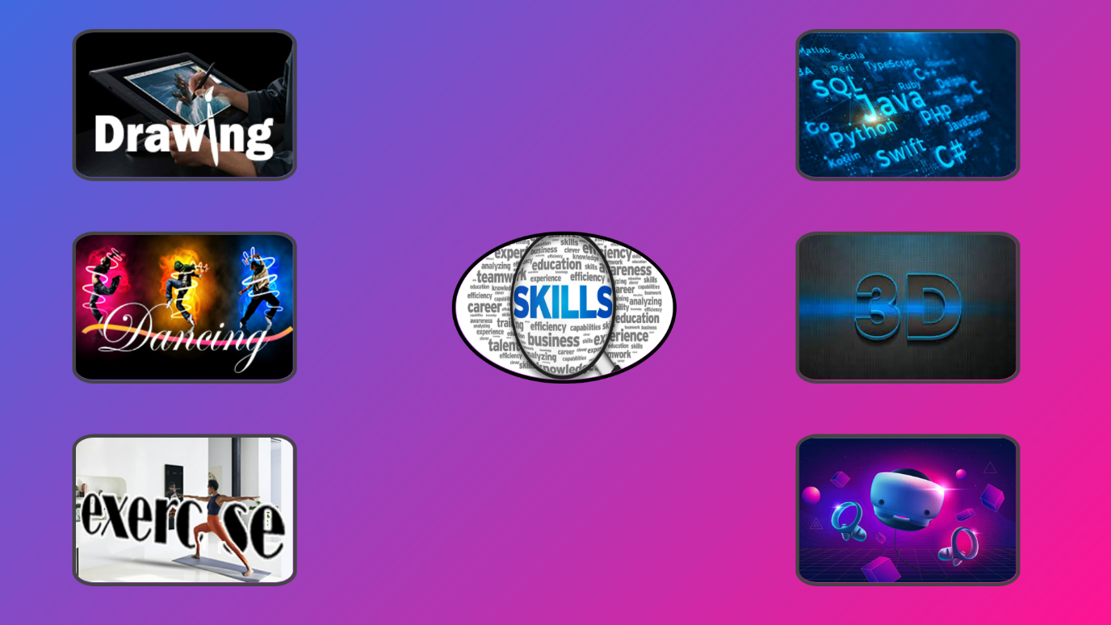

<html>

<head>

<title>Skills</title> <style>

#skills1,#skills2,#skills3,#skills4,#skills5,#skills6

{ position: absolute;

border-style:solid;

border-width:5;

border-radius:50%;

animation:border1 2s linear;

animation-fill-mode:forwards;

animation-delay: 3.5s;

border-color: #444444;

}

@keyframes border1

{

0%

{

border-radius: 50%;

}

100%

{

border-radius: 10%;

}

}

</style>

<script src="D:\metaproject\jq.js"></script>

<script language="javascript">

function skillsanim1()

{

const mytimeout=setTimeout(skillsanim,500);

function skillsanim(){

$('#skills1').animate({

left:'100px',

top:'40px',

},3000);

$('#skills2').animate({

left:'100px',

top:'320px',

},3000);

$('#skills3').animate({

left:'100px',

top:'600px',

},3000);

$('#skills4').animate({

left:'1100px',

top:'40px',

},3000);

$('#skills5').animate({

left:'1100px',

top:'320px',

},3000);

$('#skills6').animate({

left:'1100px',

top:'600px',

},3000);

}

}

</script>

</head>

<body style="background: linear-gradient(135deg,royalblue,deeppink);" onload="skillsanim1();">

<img style="z-index:8;top:320;left:625;position: absolute;border-style:solid; border-width:5; border-radius:50%;"

src="D:\metaproject\images\skills.jpg" width="300" height="200">

<a href="D:\metaproject\anil\c&d in meta.html"><img style="z-index:7;top:320;left:625;"

id="skills1" src="D:\metaproject\images\drawing.jpg" alt="" width="300" height="200"></a>

<a href="D:\metaproject\anil\drive and dance practice.html"><img style="z-index:6;top:320;left:625; " id="skills2"

src="D:\metaproject\images\dancing.jpg" width="300" height="200"></a>

<a href="D:\metaproject\anil\exersice.html"><img style="z-index:5;top:320;left:625; " id="skills3"

src="D:\metaproject\images\exercise.jpg" width="300" height="200"></a>

<a href="D:\metaproject\anil\soft & lang.html"><img style="z-index:4;top:320;left:625;" id="skills4"

src="D:\metaproject\images\softwares&languages.jpg" width="300" height="200"></a>

<a href="D:\metaproject\aravind\3d design.html"><img style="z-index:3;top:320;left:625;" id="skills5"

src="D:\metaproject\images\3ddesigning.jpg" width="300" height="200"></a>

<a href="D:\metaproject\anil\MY GAMING.html"><img style="z-index:2;top:320;left:625; " id="skills6"

src="D:\metaproject\images\games.jpg" width="300" height="200"></a>

<a href="D:\metaproject\index tabs\Advantages of meta verse\education.html"><div style="position:fixed;z-index:6;bottom:0;left:0;width:200;height:100;"></div></a>

<a href="D:\metaproject\index tabs\Advantages of meta verse\Advantages.html"><div style="position:fixed;z-index:6;bottom:0;left:650;width:200;height:100;"></div></a>

<a href="D:\metaproject\index tabs\Advantages of meta verse\learning2.html">

<div style="position: absolute;z-index:10;right: 0;bottom: 0;height:100;width:200;">

</div></a>

</body>

</html>

**c&d in meta.html**

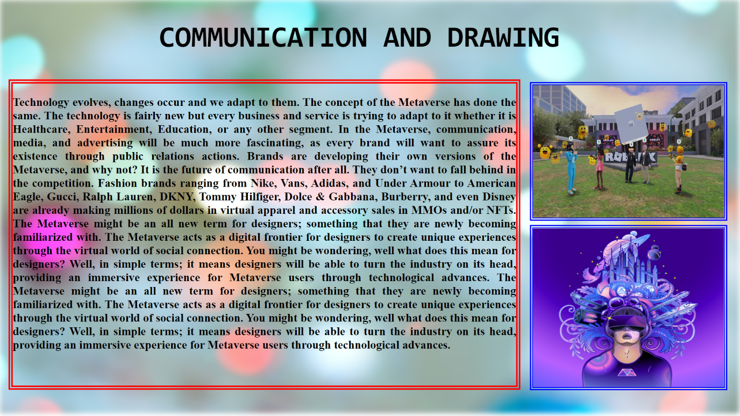

<html>

<head>

<title>communication and drawing in Metavsrse</title>

<style>

#img1{

filter: blur(5px);

}

#img2{

border: 6px;

border-style: double;

border-color: blue;

}

#h1{

font-size: 55;

font-family: monospace;

color: black;

}

#div1{

border-style: double;

border-color: red;

border-width: 8px;

}

</style>

</head>

<body style="overflow: hidden;">

<div style="z-index: 6;position: absolute; top:0; left:300;width: 1530;height: 990;"> <h1 id="h1" ><b>COMMUNICATION AND DRAWING</b></h1></div>

<div style="z-index: 4; position: absolute; height: 990; width: 1440; top:0; left:0;"><img id="img1" src="D:\metaproject\images\pexels-miguel-á-padriñán-255379.jpg" height="780" width="1395"></div>

<div style="z-index: 4;position: absolute; top:425; left:1000;width: 1510;height: 990;">

<img id="img2" src="D:\metaproject\images\metaverse-illustration-square.jpg" width="360" height="300">

</div>

<div style="z-index: 4;position: absolute; top:155; left:1000;width: 1510;height: 990;">

<img id="img2" src="D:\metaproject\images\E-SlYtNUcAIvSqY.jpg" width="360"

height="250"></div>

<div id="div1" style="z-index:4;position:absolute;left:16;top:150; height:570; width: 950;

font-size: 22; color: black; font-family:inherit; text-align: justify;">

<p><b>Technology evolves, changes occur and we adapt to them. The concept of the Metaverse has done the same. The technology is fairly new but every business and service is trying to adapt to it whether it is Healthcare, Entertainment, Education, or any other segment. In the Metaverse, communication, media, and advertising will be much more fascinating, as every brand will want to assure its existence through public relations actions. Brands are developing their own versions of the Metaverse, and why not? It is the future of communication after all. They don’t want to fall behind in the competition. Fashion brands ranging from Nike, Vans, Adidas, and Under Armour to American Eagle, Gucci, Ralph Lauren, DKNY, Tommy Hilfiger, Dolce & Gabbana, Burberry, and even Disney are already making millions of dollars in virtual apparel and accessory sales in MMOs and/or NFTs.

The Metaverse might be an all new term for designers; something that they are newly becoming familiarized with. The Metaverse acts as a digital frontier for designers to create unique experiences through the virtual world of social connection. You might be wondering, well what does this mean for designers? Well, in simple terms; it means designers will be able to turn the industry on its head, providing an immersive experience for Metaverse users through technological advances.

The Metaverse might be an all new term for designers; something that they are newly becoming familiarized with. The Metaverse acts as a digital frontier for designers to create unique experiences through the virtual world of social connection. You might be wondering, well what does this mean for designers? Well, in simple terms; it means designers will be able to turn the industry on its head, providing an immersive experience for Metaverse users through technological advances.

</b></p> </div>

<a href="D:\metaproject\index tabs\Advantages of meta verse\skills.html"><div style="position:fixed;z-index:6;bottom:0;left:0;width:200;height:100;"></div></a>

<a href="D:\metaproject\index tabs\Advantages of meta verse\skills.html"><div style="position:fixed;z-index:6;bottom:0;left:650;width:200;height:100;"></div></a>

<a href="D:\metaproject\anil\drive and dance practice.html">

<div style="position: absolute;z-index:10;right: 0;bottom: 0;height:100;width:200;">

</div></a>

</body></html>

**drive and dance.html**

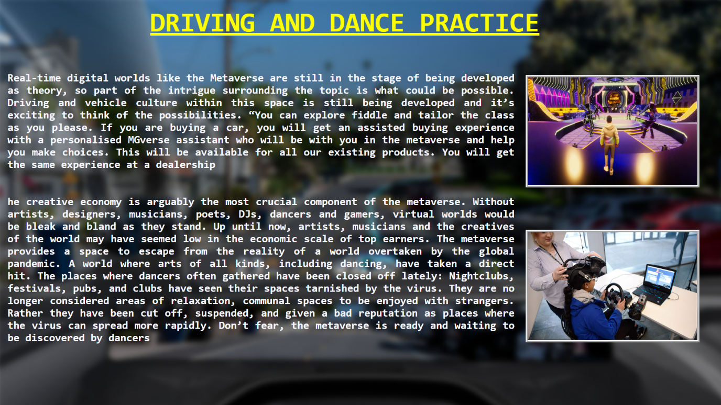

<html>

<head>

<title>Driving and Dance practice</title>

<style>

#img1{ filter: blur(6px);}

#img2{border: 5px;

border-style: ridge;

border-color: whitesmoke;}

#h1{ font-size: 58;

font-family: monospace;

color: yellow;}

#img2{ border: 6px;

border-style: solid;

border-color: whitesmoke;}

</style>

</head>

<body style="overflow: hidden;">

<div style="z-index: 3; position: absolute; height: 900; width: 1500; top:-10; left:-10;"><img id="img1" src="D:\metaproject\images\VRRC_AR_3976f17b5c.jpg" height="890" width="1570">

</div>

<div style="z-index: 6;position: absolute; top:-25; left: 320;width: 1530;height: 990;">

<h1 id="h1" ><u><b>DRIVING AND DANCE PRACTICE</u></b></h1>

</div>

<div style="z-index: 4;position: absolute; top:160; left:1120;width: 1530;height: 990;">

<img id="img2" src="D:\metaproject\images\COLORS-Dance-Deewane-Juniors-Metaverse-2.png" width="360"

height="230">

</div>

<div style="z-index: 4;position: absolute; top:490; left:1120;width: 1530;height: 990;">

<img id="img2" src="D:\metaproject\images\vrdrivinglessons.jpg" width="360"

height="230">

</div>

<div id="div1" style="z-index:4;position:absolute;left:16;top:130; height:570; width: 1080;font-size: 23; color: ghostwhite; font-family:monospace; text-align: justify;">

<p>

<b>

Real-time digital worlds like the Metaverse are still in the stage of being developed as theory, so part of the intrigue surrounding the topic is what could be possible. Driving and vehicle culture within this space is still being developed and it’s exciting to think of the possibilities.

“You can explore fiddle and tailor the class as you please. If you are buying a car, you will get an assisted buying experience with a personalised MGverse assistant who will be with you in the metaverse and help you make choices. This will be available for all our existing products. You will get the same experience at a dealership

<br><br><br>

he creative economy is arguably the most crucial component of the metaverse. Without artists, designers, musicians, poets, DJs, dancers and gamers, virtual worlds would be bleak and bland as they stand. Up until now, artists, musicians and the creatives of the world may have seemed low in the economic scale of top earners.

The metaverse provides a space to escape from the reality of a world overtaken by the global pandemic. A world where arts of all kinds, including dancing, have taken a direct hit. The places where dancers often gathered have been closed off lately: Nightclubs, festivals, pubs, and clubs have seen their spaces tarnished by the virus.

They are no longer considered areas of relaxation, communal spaces to be enjoyed with strangers. Rather they have been cut off, suspended, and given a bad reputation as places where the virus can spread more rapidly. Don’t fear, the metaverse is ready and waiting to be discovered by dancers

</b></p>

</div>

<a href="D:\metaproject\anil\c&d in meta.html"><div style="position:fixed;z-index:6;bottom:0;left:0;width:200;height:100;"></div></a>

<a href="D:\metaproject\index tabs\Advantages of meta verse\skills.html"><div style="position:fixed;z-index:6;bottom:0;left:650;width:200;height:100;"></div></a>

<a href="D:\metaproject\anil\exersice.html">

<div style="position: absolute;z-index:10;right: 0;bottom: 0;height:100;width:200;">

</div></a></body></html>

**exercise.html**

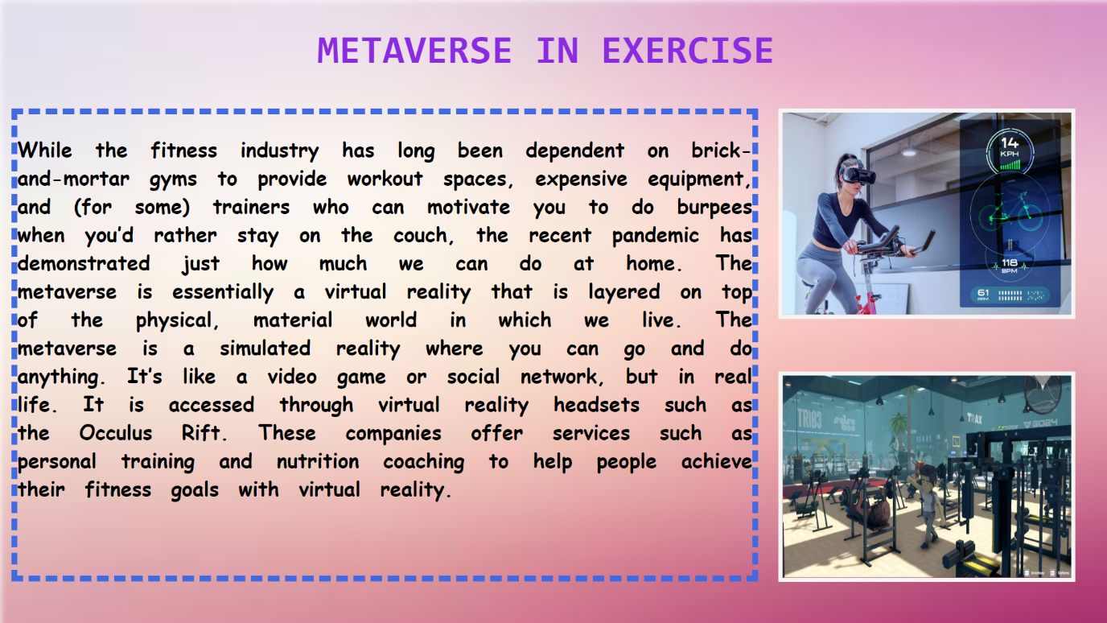

<html>

<head>

<title>Metavsrse in Exercise</title>

<style>

#img1{

filter: blur(5px);

}

#img2{

border: 6px;

border-style: ridge;

border-color: whitesmoke;

}

#h1{

font-size: 55;

font-family: monospace;

color: blueviolet;

}

#div1{

border-style: dashed;

border-color: royalblue;

border-width: 8px;

}

#img2{

border: 6px;

border-style: solid;

border-color: whitesmoke;

}

</style>

</head>

<body style="overflow: hidden;">

<div style="z-index: 4; position: absolute; height: 990; width: 1440; top:0; left:0;">

<img id="img1" src="D:\metaproject\images\images.jpg" height="880" width="1575">

</div>

<div style="z-index: 6;position: absolute; top:0; left:440;width: 1530;height: 990;">

<h1 id="h1" ><b>METAVERSE IN EXERCISE</b></h1>

</div>

<div style="z-index: 4;position: absolute; top:150; left:1080;width: 1530;height: 990;">

<img id="img2" src="D:\metaproject\images\0x0.jpg" width="400" height="280">

</div>

<div style="z-index: 4;position: absolute; top:515; left:1080;width: 1530;height: 990;">

<img id="img2" src="D:\metaproject\images\1 0rqGQpxf8HDjLIihy6ukpA.png" width="400"

height="280">

</div>

<div id="div1" style="z-index:4;position:absolute;left:16;top:150; height:640; width: 1020;font-size: 28;word-spacing: 15; color: black; font-family:cursive; text-align: justify;">

<p><b>While the fitness industry has long been dependent on brick-and-mortar gyms to provide workout spaces, expensive equipment, and (for some) trainers who can motivate you to do burpees when you’d rather stay on the couch, the recent pandemic has demonstrated just how much we can do at home.

The metaverse is essentially a virtual reality that is layered on top of the physical, material world in which we live.

The metaverse is a simulated reality where you can go and do anything. It’s like a video game or social network, but in real life.

It is accessed through virtual reality headsets such as the Occulus Rift.

These companies offer services such as personal training and nutrition coaching to help people achieve their fitness goals with virtual reality.

</b></p>

</div>

<a href="D:\metaproject\anil\drive and dance practice.html"><div style="position:fixed;z-index:6;bottom:0;left:0;width:200;height:100;"></div></a>

<a href="D:\metaproject\index tabs\Advantages of meta verse\skills.html"><div style="position:fixed;z-index:6;bottom:0;left:650;width:200;height:100;"></div></a>

<a href="D:\metaproject\anil\soft & lang.html">

<div style="position: absolute;z-index:10;right: 0;bottom: 0;height:100;width:200;">

</div></a>

</body>

</html>

**soft & lang.html**



<html>

<head>

<title>softwares and languages</title>

<style>

#img1{

filter: blur(6px);

}

#img2{

border: 5px;

border-style: dotted;

border-color: paleturquoise;

}

#h1{

font-size: 55;

font-family: fantasy;

color:gold;

}

</style>

</head>

<body style="overflow: hidden;">

<div style="z-index: 3; position: absolute; height: 900; width: 1500; top:-10; left:-10;">

<img id="img1" src="D:\metaproject\images\background_11_nQJIc9J.normal.jpeg" height="880" width="1570">

</div>

<div style="z-index: 6;position: absolute; top:; left:430;width: 1530;height: 990;">

<h1 id="h1" ><u><b>SOFTWARES AND LANGUAGES</b></u></h1>

</div>

<div style="z-index: 4;position: absolute; top:180; left:1130;width: 1530;height: 990;">

<img id="img2" src="D:\metaproject\images\Popular-Programmig-Languages.png"

width="340" height="630">

</div>

<div style="z-index:4;position:absolute;left:16;top:150; height:570; width: 1070;

font-size: 28; color: coral; font-family: monospace; text-align: justify;word-spacing:6">

<p>

<b>With the help of the metaverse we can learn any language of software like Python, JavaScript , Java ,C C++ , Go,R,Swift,PHP through great vr technology.

Some programmers are able to build a career out of being an expert in one language, but many programmers learn new languages frequently, Gorton says. It’s not uncommon for a professional programmer to be fluent in three or four different languages, he adds.

The type of software you want to develop is one consideration for which programming languages to learn. While there are no concrete rules for what language is used to write what software, a few trends offer some guidance:

Web-based startups are more likely to be programming in Python and JavaScript.

Larger companies tend to develop their internal software applications using C# or Java and their Web applications using PHP.

Programs for data analytics typically use the R and MATLAB programming languages.

Embedded devices, such as those in the automotive and healthcare industries, run software written in C, C++, or Rust.

</b></p>

</div>

<a href="D:\metaproject\anil\exersice.html"><div style="position:fixed;z-index:6;bottom:0;left:0;width:200;height:100;"></div></a>

<a href="D:\metaproject\index tabs\Advantages of meta verse\skills.html"><div style="position:fixed;z-index:6;bottom:0;left:650;width:200;height:100;"></div></a>

<a href="D:\metaproject\aravind\3d design.html">

<div style="position: absolute;z-index:10;right: 0;bottom: 0;height:100;width:200;">

</div></a>

</body></html>

**3d design.html**

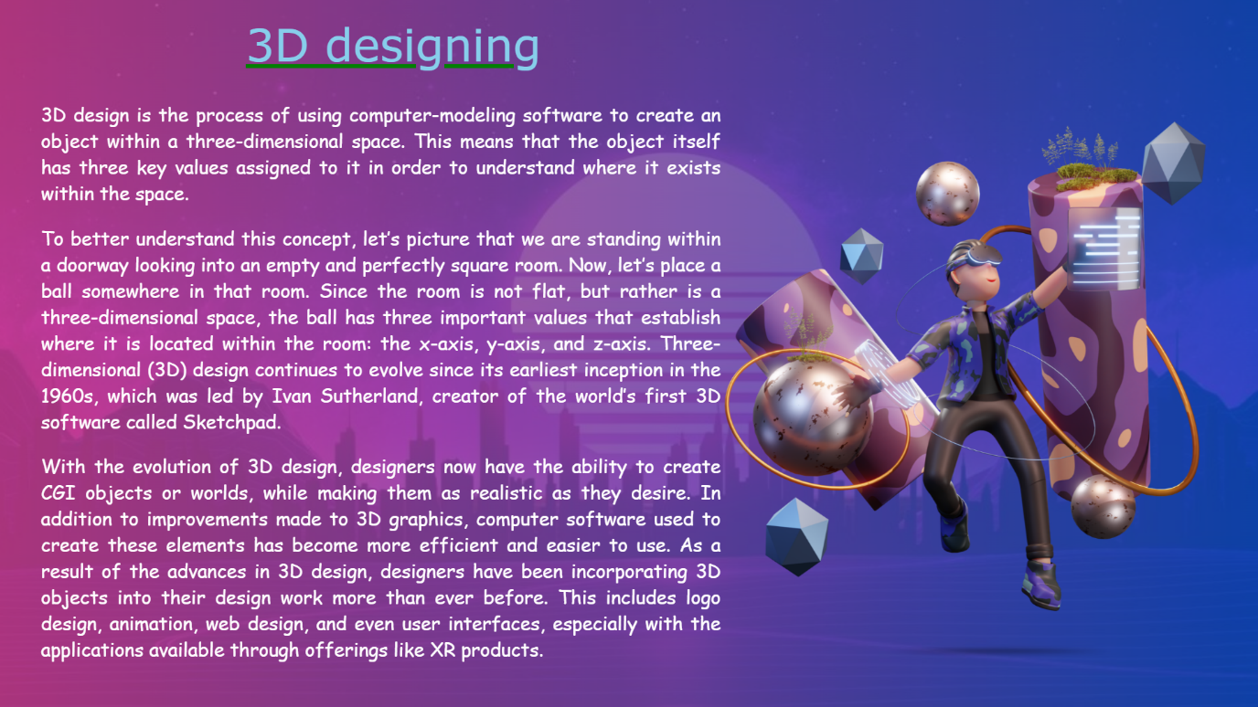

<html>

<head>

</head>

<body style="background:linear-gradient(to right,#cd408f,#094fc3)">

<img style="z-index:5;top:100;left:850;position: fixed;"

src="D:\metaproject\images\3d design.jpg.png" width="700" height="700">

<img style="z-index:1;position: fixed;min-height: 100%;min-width: 100%;width:110%;

height:110%;top:-10;left:-10;opacity: 0.2" src="D:\metaproject\images\metaverse.jpg">

<img style="z-index:6;position:fixed;top:750;left:1070;width:300;height:50;filter:blur(3px);"

src="D:\metaproject\images\shadow.png">

<div style="z-index:5;position: fixed;top:20;left:300;width:1000;height:800;color: skyblue;font-family: Verdana;font-size:55px;text-decoration: underline;text-decoration-color:green;">3D designing</div>

<div style="z-index:6;position:fixed;top:100;left:50;width:830;height:800;font-size:23px;font-family:cursive;text-align:justify;color:white;"><p>3D design is the process of using computer-modeling software to create an object within a three-dimensional space. This means that the object itself has three key values assigned to it in order to understand where it exists within the space.</p><p>

To better understand this concept, let’s picture that we are standing within a doorway looking into an empty and perfectly square room. Now, let’s place a ball somewhere in that room.

Since the room is not flat, but rather is a three-dimensional space, the ball has three important values that establish where it is located within the room: the x-axis, y-axis, and z-axis.

Three-dimensional (3D) design continues to evolve since its earliest inception in the 1960s, which was led by Ivan Sutherland, creator of the world’s first 3D software called Sketchpad.</p><p>

With the evolution of 3D design, designers now have the ability to create CGI objects or worlds, while making them as realistic as they desire. In addition to improvements made to 3D graphics, computer software used to create these elements has become more efficient and easier to use.

As a result of the advances in 3D design, designers have been incorporating 3D objects into their design work more than ever before. This includes logo design, animation, web design, and even user interfaces, especially with the applications available through offerings like XR products.

</p>

</div>

<a href="D:\metaproject\anil\soft & lang.html"><div style="position:fixed;z-index:6;bottom:0;left:0;width:200;height:100;"></div></a>

<a href="D:\metaproject\index tabs\Advantages of meta verse\skills.html"><div style="position:fixed;z-index:6;bottom:0;left:650;width:200;height:1

00;"></div></a>

<a href="D:\metaproject\anil\MY GAMING.html">

<div style="position: absolute;z-index:10;right: 0;bottom: 0;height:100;width:200;">

</div></a>

</body>

</html>

**MY GAMING.html**

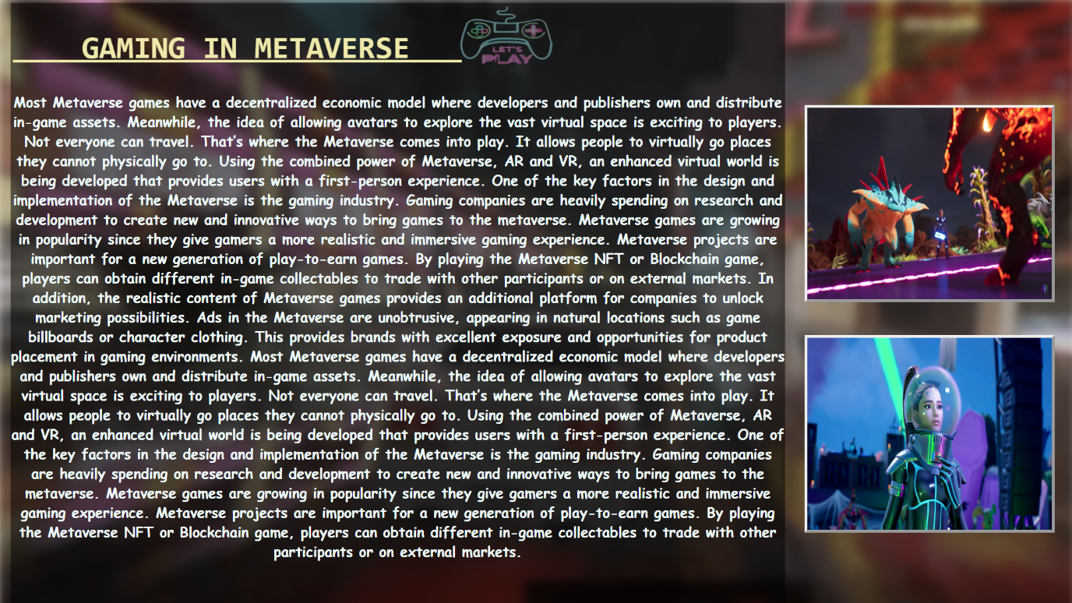

<html><head>

<title>Gaming in Meraverse</title>

<style>

#img1{

filter: blur(7px);

}

#h2{

position: relative;

top: 0;left:-230;

font-family:monospace;

color: palegoldenrod;

font-size: 45;

text-decoration: underline;

}

#img2{

border: 4px;

border-style: outset;

color: ghostwhite;

}

</style>

</head>

<body style="overflow:hidden;">

<div style="z-index: 4;position: absolute; top:-5; left:-5;width: 1430;height: 990;">

<img id="img1" src="D:\metaproject\images\AdorableGlitteringGangesdolphin-size_restricted.gif" height="990" width="1550">

</div>

<div style="z-index: 4;position: absolute; top:0; left:650;width: 1530;height: 990;">

<img src="D:\metaproject\images\pngtree-let-s-play-vector-realistic-neon-sign-of-video-vr-games-png-image_5991994.png" width="150"

height="100">

</div>

<div style="z-index: 4;position: absolute; top:150; left:1153;width: 1530;height: 990;">

<img id="img2" src="D:\metaproject\images\1730-illuvium_ss_01.jpg" width="350"

height="275">

</div>

<div style="z-index: 4;position: absolute; top:480; left:1153;width: 1530;height: 990;">

<img id="img2" src="D:\metaproject\images\1728-fortnite-ariana-grande-punchcard.jpg"height="275" width="350">

</div>

<div style="z-index:4;position:absolute;left:15;top:4; height: 900; width: 1110;background-image: url(D:/metaproject/infobg.png);

font-size: 20; color:azure; font-family:cursive ; text-align: center;">

<h2 id="h2">&nbsp;&nbsp;&nbsp;

GAMING IN METAVERSE&nbsp;&nbsp;&nbsp;

</h2>

<p> <b>

Most Metaverse games have a decentralized economic model where developers and publishers own and distribute in-game assets. Meanwhile, the idea of allowing avatars to explore the vast virtual space is exciting to players.

Not everyone can travel. That’s where the Metaverse comes into play. It allows people to virtually go places they cannot physically go to. Using the combined power of Metaverse, AR and VR, an enhanced virtual world is being developed that provides users with a first-person experience.

One of the key factors in the design and implementation of the Metaverse is the gaming industry. Gaming companies are heavily spending on research and development to create new and innovative ways to bring games to the metaverse.

Metaverse games are growing in popularity since they give gamers a more realistic and immersive gaming experience. Metaverse projects are important for a new generation of play-to-earn games. By playing the Metaverse NFT or Blockchain game, players can obtain different in-game collectables to trade with other participants or on external markets.

In addition, the realistic content of Metaverse games provides an additional platform for companies to unlock marketing possibilities. Ads in the Metaverse are unobtrusive, appearing in natural locations such as game billboards or character clothing. This provides brands with excellent exposure and opportunities for product placement in gaming environments.

Most Metaverse games have a decentralized economic model where developers and publishers own and distribute in-game assets. Meanwhile, the idea of allowing avatars to explore the vast virtual space is exciting to players.

Not everyone can travel. That’s where the Metaverse comes into play. It allows people to virtually go places they cannot physically go to. Using the combined power of Metaverse, AR and VR, an enhanced virtual world is being developed that provides users with a first-person experience.

One of the key factors in the design and implementation of the Metaverse is the gaming industry. Gaming companies are heavily spending on research and development to create new and innovative ways to bring games to the metaverse.

Metaverse games are growing in popularity since they give gamers a more realistic and immersive gaming experience. Metaverse projects are important for a new generation of play-to-earn games. By playing the Metaverse NFT or Blockchain game, players can obtain different in-game collectables to trade with other participants or on external markets.

</b></p>

</div>

<a href="D:\metaproject\aravind\3d design.html"><div style="position:fixed;z-index:6;bottom:0;left:0;width:200;height:100;"></div></a>

<a href="D:\metaproject\index tabs\Advantages of meta verse\skills.html"><div style="position:fixed;z-index:6;bottom:0;left:650;width:200;height:100;"></div></a>

<a href="D:\metaproject\index tabs\Advantages of meta verse\skills.html">

<div style="position: absolute;z-index:10;right: 0;bottom: 0;height:100;width:200;">

</div></a>

</body>

</html>

**commerce and crypto.html**

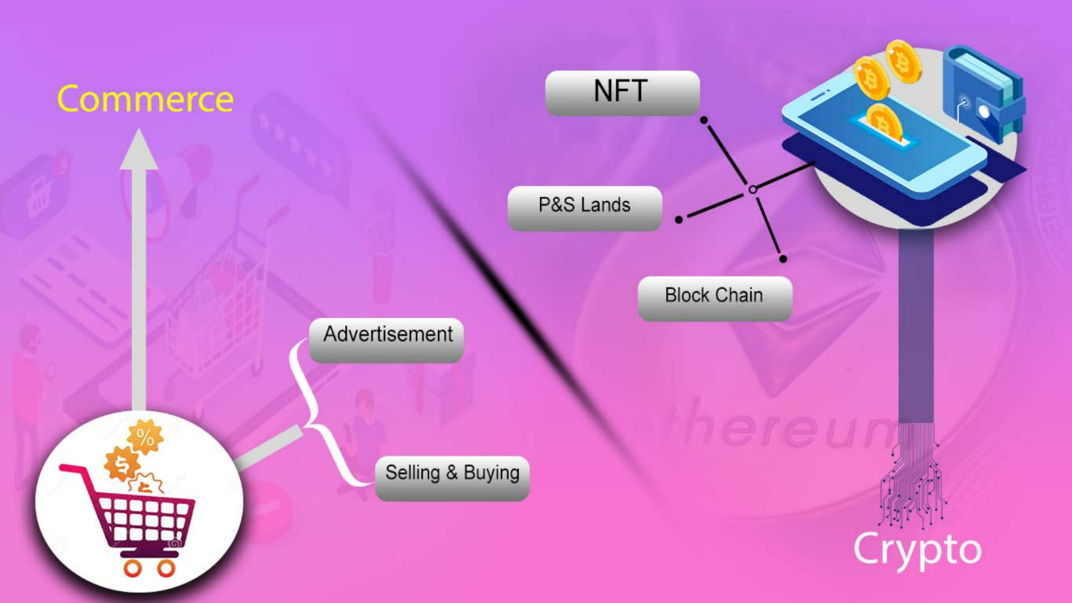

<html><head>

<title>commerce and crypto</title>

</head><body>

<img style="position: fixed;z-index: -1;min-height: 100%;min-width:100%;top: 0;left:0"

src="D:\metaproject\images\commerce and crypto.jpg">

<a href="D:\metaproject\Naveen\adversiment.html"><div style="position:fixed;z-index:1;top:430;left:440;width:230;height:70;"></div></a>

<a href="D:\metaproject\Naveen\buy and sell.html"><div style="position:fixed;z-index:1;top:630;left:535;width:230;height:70;"></div></a>

<a href="D:\metaproject\anil\Nft.html"><div style="position:fixed;z-index:1;top:75;left:780;width:230;height:70;"></div></a>

<a href="D:\metaproject\anil\p&S lands.html"><div style="position:fixed;z-index:1;top:245;left:720;width:230;height:70;"></div></a>

<a href="D:\metaproject\anil\block chain.html"><div style="position:fixed;z-index:1;top:370;left:910;width:230;height:70;"></div></a>

<a href="D:\metaproject\index tabs\Advantages of meta verse\learning2.html"><div style="position:fixed;z-index:6;bottom:0;left:0;width:200;height:100;"></div></a>

<a href="D:\metaproject\index tabs\Advantages of meta verse\Advantages.html"><div style="position:fixed;z-index:6;bottom:0;left:650;width:200;height:100;"></div></a>

<a href="D:\metaproject\index tabs\Advantages of meta verse\exploration3.html"> <div style="position: absolute;z-index:10;right: 0;bottom: 0;height:100;width:200;"> </div></a>

</body>

</html>

**advertisement.html**

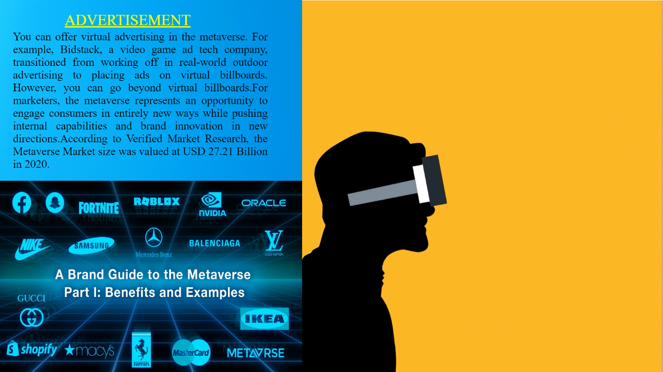

<html>

<head>

<title> advertisement </title>

</head>

<body style="overflow:hidden">

<div style="z-index:1;position: absolute;left:335;top:0; ">

<video height="900" width="1200" autoplay muted loop=" true" >

<source src="D:\metaproject\images\Metaverse5.mp4"></source>

</video>

</div>

<div style = "z-index:3;position:absolute;left: 0;top: 0; width:1528; height:900 ;">

<img src="D:\metaproject\images\color.jpg" width="700" height="600">

<div style="z-index:4 ;position: absolute;left:150;top:26 ;width: 990; text-align: justify; font-size: 35px; color:yellow; text-decoration: underline; text-decoration-color:yellow;">ADVERTISEMENT

</div>

<div style = "z-index:5;position:absolute;left:0;top:420; width:1528; height:900 ;">

<img src="D:\metaproject\images\Brand-Guide-Hero.jpeg" width="700" height="450">

</div>

<div style="z-index:5;position: absolute;left:30;top:44;width:590; text-align: justify; font-size:26px; color:lightpink;color:black">

<p>You can offer virtual advertising in the metaverse. For example, Bidstack, a video game ad tech company, transitioned from working off in real-world outdoor advertising to placing ads on virtual billboards. However, you can go beyond virtual billboards.For marketers, the metaverse represents an opportunity to engage consumers in entirely new ways while pushing internal capabilities and brand innovation in new directions.According to Verified Market Research, the Metaverse Market size was valued at USD 27.21 Billion in 2020.

</p>

</div>

<a href="D:\metaproject\index tabs\Advantages of meta verse\commerce and crypto.html"><div style="position:fixed;z-index:6;bottom:0;left:0;width:200;height:100;">

</div>

</a>

<a href="D:\metaproject\index tabs\Advantages of meta verse\commerce and crypto.html"><div style="position:fixed;z-index:6;bottom:0;left:650;width:200;height:100;">

</div>

</a>

<a href="D:\metaproject\Naveen\buy and sell.html"> <div style="position: absolute;z-index:10;right: 0;bottom: 0;height:100;width:200;">

</div>

</a>

</body>

</html>

**buy and sell.html**

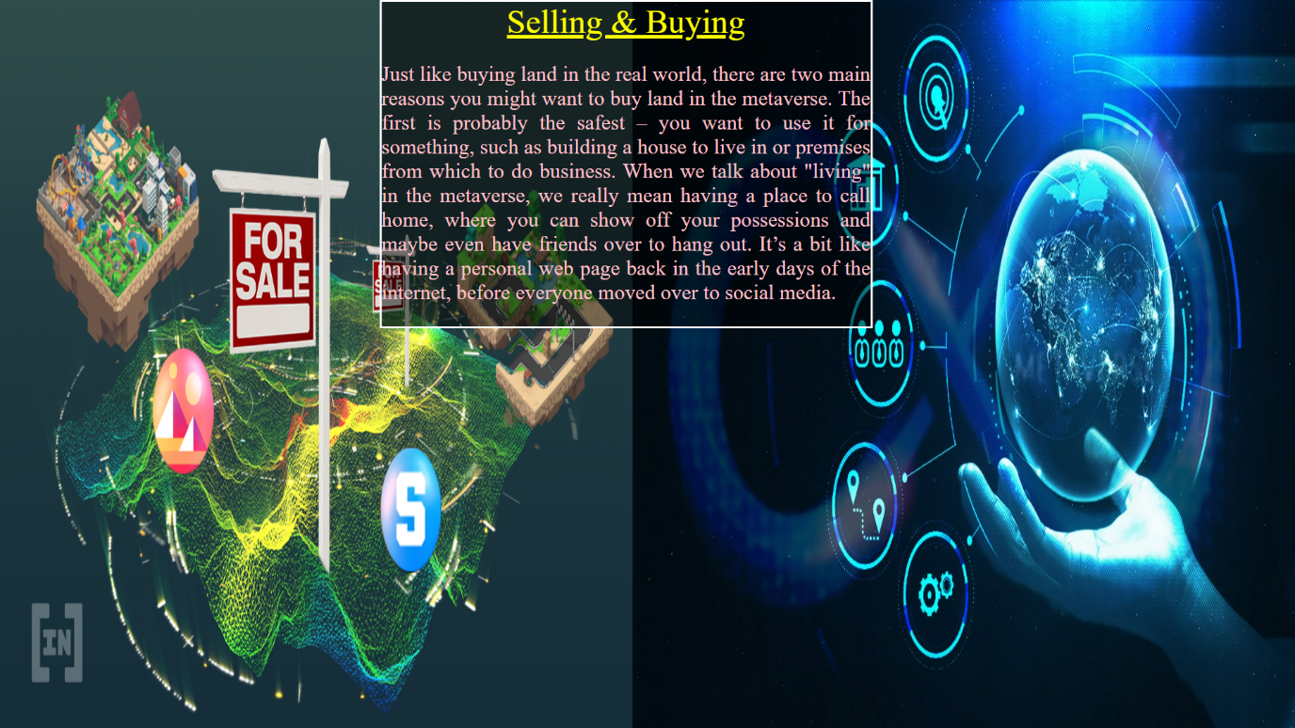

<html>

<head>

<title> open my web page to Advertisement </title>

</head>

<body style="overflow: hidden;">

<div style="z-index:1;position: absolute;left:0;top:0; width:1528;height: 900;">

<img src="D:\metaproject\images\buyland.png" width="750" height="870">

<div style="z-index:2;position: absolute;left:750;top:0; width:1528;height: 900;">

<img src="D:\metaproject\images\metaverso.jpg" width="790" height="870"></div>

<div style="z-index:5;position: absolute;left:450;top:0;width:580; text-align: justify; font-size:25px; color:pink;background-image: url(D:/metaproject/infobg.png);

border-style:solid;border-color:white">

<div style=" text-align: center; font-size: 40px; color:yellow; text-decoration: underline; text-decoration-color:yellow;"> Selling & Buying </div>

<p>Just like buying land in the real world, there are two main reasons you might want to buy land in the metaverse. The first is probably the safest – you want to use it for something, such as building a house to live in or premises from which to do business. When we talk about "living" in the metaverse, we really mean having a place to call home, where you can show off your possessions and maybe even have friends over to hang out. It’s a bit like having a personal web page back in the early days of the internet, before everyone moved over to social media. </p>

</div>

</div>

<a href="D:\metaproject\Naveen\adversiment.html"><div style="position:fixed;z-index:6;bottom:0;left:0;width:200;height:100;"></div></a>

<a href="D:\metaproject\index tabs\Advantages of meta verse\commerce and crypto.html"><div style="position:fixed;z-index:6;bottom:0;left:650;width:200;height:100;"></div></a>

<a href="D:\metaproject\anil\Nft.html"> <div style="position: absolute;z-index:10;right: 0;bottom: 0;height:100;width:200;"> </div></a></body></html>

**Nft.html**

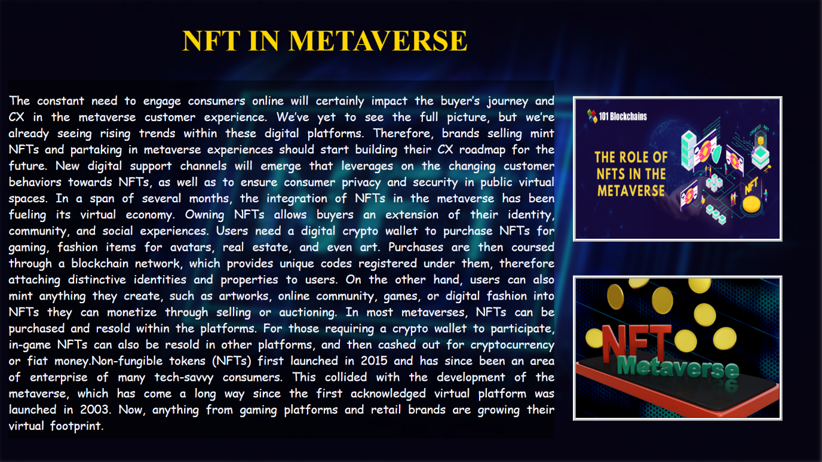

<html>

<head>

<title>NFT in Exercise</title>

<style>

#img1{

filter: blur(5px);

}

#img2{

border: 6px;

border-style: ridge;

border-color: whitesmoke;

}

#h1{

font-size: 55;

font-family: serif;

color: gold;

}

#img2{

border: 6px;

border-style: solid;

border-color: whitesmoke;

}

</style>

</head>

<body style="overflow: hidden;">

<div style="z-index: 3; position: absolute; height: 900; width: 1500; top:-10; left:-10;">

<img id="img1" src="D:\metaproject\images\Why-NFTs-Are-The-Key-To-The-Metaverse.jpg" height="880" width="1550">

</div>

<div style="z-index: 6;position: absolute; top:; left:340;width: 1530;height: 990;">

<h1 id="h1" ><b>NFT IN METAVERSE</b></h1>

</div>

<div style="z-index: 4;position: absolute; top:180; left:1070;width: 1530;height: 990;">

<img id="img2" src="D:\metaproject\images\the-role-of-nfts-in-the-metaverse.webp" width="380" height="260">

</div>

<div style="z-index: 4;position: absolute; top:515; left:1070;width: 1530;height: 990;">

<img id="img2" src="D:\metaproject\images\metaverse-and-nfts-are-cool-but-theyre-way-too-overhyped-1-1200x720.jpg" width="380" height="260">

</div>

<div id="div1" style="z-index:4;position:absolute;left:16;top:150; height:670; width: 1020;font-size: 22; color: ghostwhite; font-family:cursive; text-align: justify;background-image: url(D:/metaproject/infobg.png);

word-spacing: 4;">

<p>The constant need to engage consumers online will certainly impact the buyer’s journey and CX in the metaverse customer experience. We’ve yet to see the full picture, but we’re already seeing rising trends within these digital platforms. Therefore, brands selling mint NFTs and partaking in metaverse experiences should start building their CX roadmap for the future. New digital support channels will emerge that leverages on the changing customer behaviors towards NFTs, as well as to ensure consumer privacy and security in public virtual spaces.

In a span of several months, the integration of NFTs in the metaverse has been fueling its virtual economy. Owning NFTs allows buyers an extension of their identity, community, and social experiences. Users need a digital crypto wallet to purchase NFTs for gaming, fashion items for avatars, real estate, and even art. Purchases are then coursed through a blockchain network, which provides unique codes registered under them, therefore attaching distinctive identities and properties to users. On the other hand, users can also mint anything they create, such as artworks, online community, games, or digital fashion into NFTs they can monetize through selling or auctioning.

In most metaverses, NFTs can be purchased and resold within the platforms. For those requiring a crypto wallet to participate, in-game NFTs can also be resold in other platforms, and then cashed out for cryptocurrency or fiat money.Non-fungible tokens (NFTs) first launched in 2015 and has since been an area of enterprise of many tech-savvy consumers. This collided with the development of the metaverse, which has come a long way since the first acknowledged virtual platform was launched in 2003. Now, anything from gaming platforms and retail brands are growing their virtual footprint.

<b>

</b></p>

</div>

<a href="D:\metaproject\Naveen\buy and sell.html"><div style="position:fixed;z-index:6;bottom:0;left:0;width:200;height:100;"></div></a>

<a href="D:\metaproject\index tabs\Advantages of meta verse\commerce and crypto.html"><div style="position:fixed;z-index:6;bottom:0;left:650;width:200;height:100;"></div></a>

<a href="D:\metaproject\anil\p&S lands.html"> <div style="position: absolute;z-index:10;right: 0;bottom: 0;height:100;width:200;"> </div></a>

</body>

</html>

**p&S lands.html**

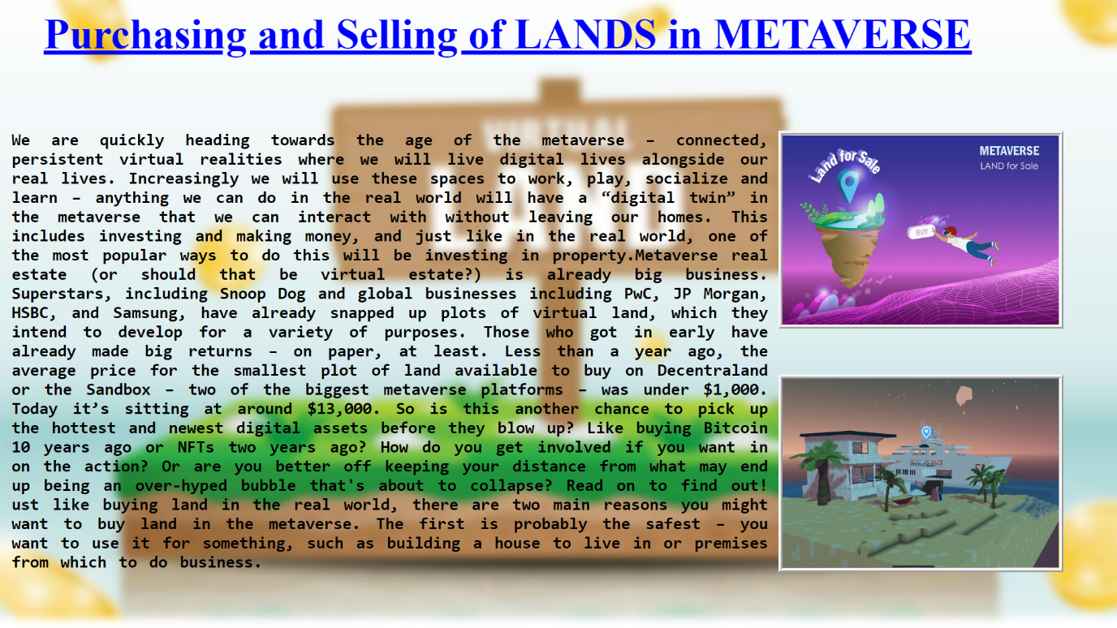

<html>

<head>

<title>NFT in Exercise</title>

<style>

#img1{filter: blur(6px);}

#img2{ border: 6px;

border-style: ridge;

border-color: whitesmoke;

#h1{ font-size: 58;

font-family: serif;

color: blue;}

#img2{ border: 6px;

border-style: solid;

border-color: whitesmoke;}

</style>

</head>

<body style="overflow: hidden;">

<div style="z-index: 3; position: absolute; height: 900; width: 1500; top:-10; left:-10;">

<img id="img1" src="D:\metaproject\images\land.jpg" height="860" width="1560">

</div>

<div style="z-index: 6;position: absolute; top:-25; left:60;width: 1530;height: 990;">

<h1 id="h1" ><u>Purchasing and Selling of LANDS in METAVERSE</u></h1>

</div>

<div style="z-index: 4;position: absolute; top:180; left:1070;width: 1530;height: 990;">

<img id="img2" src="D:\metaproject\images\Metaverse-virtual-land-featured.webp" width="380" height="260">

</div>

<div style="z-index: 4;position: absolute; top:515; left:1070;width: 1530;height: 990;">

<img id="img2" src="D:\metaproject\images\white_yacht_behind_villa.webp" width="380" height="260">

</div>

<div id="div1" style="z-index:4;position:absolute;left:16;top:130; height:670; width: 1040; font-size: 23; color: black; font-family:monospace; text-align: justify;

word-spacing:4"><p>

<b><br>

We are quickly heading towards the age of the metaverse – connected, persistent virtual realities where we will live digital lives alongside our real lives. Increasingly we will use these spaces to work, play, socialize and learn – anything we can do in the real world will have a “digital twin” in the metaverse that we can interact with without leaving our homes. This includes investing and making money, and just like in the real world, one of the most popular ways to do this will be investing in property.Metaverse real estate (or should that be virtual estate?) is already big business. Superstars, including Snoop Dog and global businesses including PwC, JP Morgan, HSBC, and Samsung, have already snapped up plots of virtual land, which they intend to develop for a variety of purposes. Those who got in early have already made big returns – on paper, at least. Less than a year ago, the average price for the smallest plot of land available to buy on Decentraland or the Sandbox – two of the biggest metaverse platforms – was under $1,000. Today it’s sitting at around $13,000. So is this another chance to pick up the hottest and newest digital assets before they blow up? Like buying Bitcoin 10 years ago or NFTs two years ago? How do you get involved if you want in on the action? Or are you better off keeping your distance from what may end up being an over-hyped bubble that's about to collapse? Read on to find out!

ust like buying land in the real world, there are two main reasons you might want to buy land in the metaverse. The first is probably the safest – you want to use it for something, such as building a house to live in or premises from which to do business.

</b></p>

</div>

<a href="D:\metaproject\anil\Nft.html"><div style="position:fixed;z-index:6;bottom:0;left:0;width:200;height:100;"></div></a>

<a href="D:\metaproject\index tabs\Advantages of meta verse\commerce and crypto.html"><div style="position:fixed;z-index:6;bottom:0;left:650;width:200;height:100;"></div></a>

<a href="D:\metaproject\anil\block chain.html"> <div style="position: absolute;z-index:10;right: 0;bottom: 0;height:100;width:200;"> </div></a>

</body>

</html>

**block chain.html**

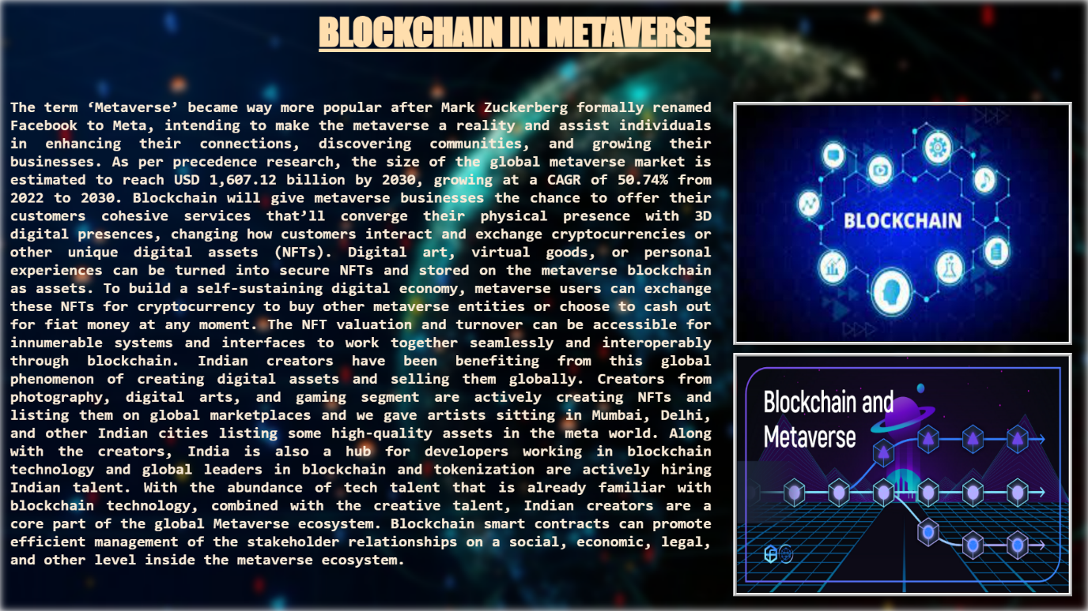

<html>

<head>

<title>Block Chain</title>

<style>

#img1{

filter: blur(6px);

}

#img2{

border: 6px;

border-style: ridge;

border-color: whitesmoke;

}

#h1{

font-size: 58;

font-family: fantasy;

color: navajowhite;

}

}

#img2{

border: 6px;

border-style: inset;

border-color: whitesmoke;

}

</style>

</head>

<body style="overflow: hidden;">

<img style="z-index: 3; position: fixed; min-height: 100%; min-width: 100%; right:0; bottom:0;" id="img1" src="D:\metaproject\images\Coinzilla-5tiny-750x375.jpg"

height="780" width="1430" >

<div style="z-index: 6;position: absolute; top:-25; left:500;width: 1530;height: 990;">

<h1 id="h1" ><u>BLOCKCHAIN IN METAVERSE</u></h1>

</div>

<div style="z-index: 4;position: absolute; top:160; left:1150;width: 1530;height: 990;">

<img id="img2" src="D:\metaproject\images\blk.jpg" width="520" height="370">

</div>

<div style="z-index: 4;position: absolute; top:555; left:1150;width: 1530;height: 990;">

<img id="img2" src="D:\metaproject\images\0 1j4j4LIHQQWVrKqs.png" width="520"

height="370">

</div>

<div id="div1" style="z-index:4;position:absolute;left:16;top:130; height:570; width: 1100;font-size: 24; color: antiquewhite; font-family:monospace; text-align: justify;">

<p>

<b>

The term ‘Metaverse’ became way more popular after Mark Zuckerberg formally renamed Facebook to Meta, intending to make the metaverse a reality and assist individuals in enhancing their connections, discovering communities, and growing their businesses.

As per precedence research, the size of the global metaverse market is estimated to reach USD 1,607.12 billion by 2030, growing at a CAGR of 50.74% from 2022 to 2030. Blockchain will give metaverse businesses the chance to offer their customers cohesive services that’ll converge their physical presence with 3D digital presences, changing how customers interact and exchange cryptocurrencies or other unique digital assets (NFTs).

Digital art, virtual goods, or personal experiences can be turned into secure NFTs and stored on the metaverse blockchain as assets. To build a self-sustaining digital economy, metaverse users can exchange these NFTs for cryptocurrency to buy other metaverse entities or choose to cash out for fiat money at any moment. The NFT valuation and turnover can be accessible for innumerable systems and interfaces to work together seamlessly and interoperably through blockchain.

Indian creators have been benefiting from this global phenomenon of creating digital assets and selling them globally. Creators from photography, digital arts, and gaming segment are actively creating NFTs and listing them on global marketplaces and we gave artists sitting in Mumbai, Delhi, and other Indian cities listing some high-quality assets in the meta world. Along with the creators, India is also a hub for developers working in blockchain technology and global leaders in blockchain and tokenization are actively hiring Indian talent. With the abundance of tech talent that is already familiar with blockchain technology, combined with the creative talent, Indian creators are a core part of the global Metaverse ecosystem.

Blockchain smart contracts can promote efficient management of the stakeholder relationships on a social, economic, legal, and other level inside the metaverse ecosystem.

</b></p>

</div>

<a href="D:\metaproject\anil\p&S lands.html"><div style="position:fixed;z-index:6;bottom:0;left:0;width:200;height:100;"></div></a>

<a href="D:\metaproject\index tabs\Advantages of meta verse\commerce and crypto.html"><div style="position:fixed;z-index:6;bottom:0;left:650;width:200;height:100;"></div></a>

<a href="D:\metaproject\index tabs\Advantages of meta verse\commerce and crypto.html"> <div style="position: absolute;z-index:10;right: 0;bottom: 0;height:100;width:200;"> </div></a>

</body></html>

**exploration3.html**

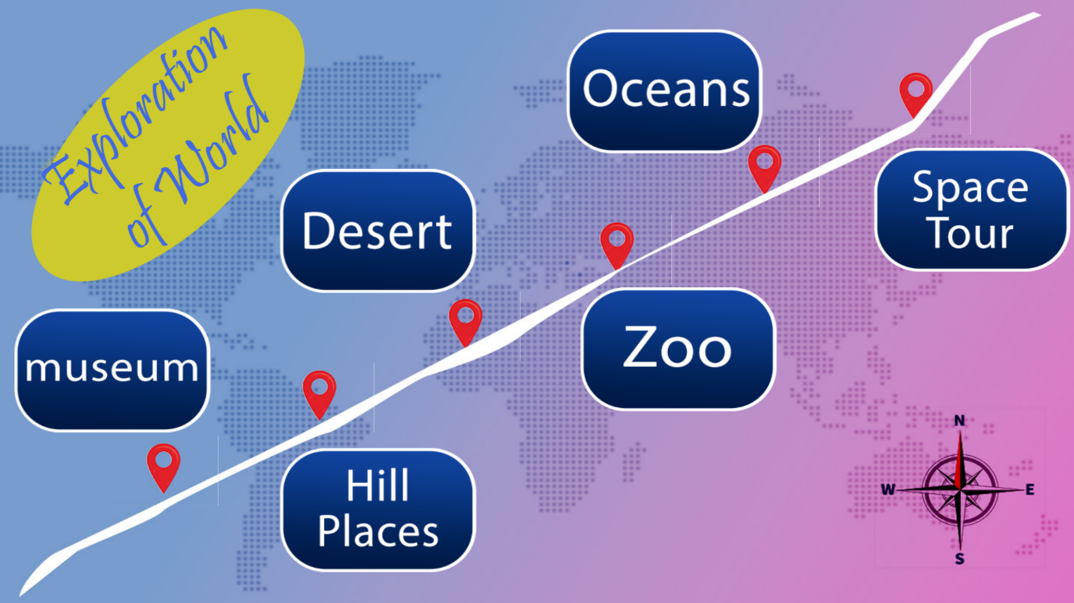

<html>

<head>

<title>Exploration</title>

<script src="D:\metaproject\jq.js"></script>

<script language="javascript">

function spacetourfun(){ $("#spacetourid").fadeIn();}

function spacetourfun2(){ $("#spacetourid").fadeOut();}

function museumfun(){ $("#museumid").fadeIn();}

function museumfun2(){ $("#museumid").fadeOut();}

function hillplacesfun(){ $("#hillplacesid").fadeIn();}

function hillplacesfun2(){ $("#hillplacesid").fadeOut();}

function desertfun(){ $("#desertid").fadeIn();}

function desertfun2(){ $("#desertid").fadeOut();}

function zoofun(){ $("#zooid").fadeIn();}

function zoofun2(){ $("#zooid").fadeOut();}

function oceansfun(){ $("#oceansid").fadeIn();}

function oceansfun2(){ $("#oceansid").fadeOut();}

</script>

</head>

<body>

<p style="z-index:2;position:fixed;top:00;left:-10;width:500;text-align: center;

text-shadow: 10px 0px 10px #CCCA2D;font-family:pristina;font-size:90;color:royalblue;transform:rotateZ(-45deg);text-decoration: blink;background-color:#CCCA2D;border-radius:50%">Exploration<br>of World</p>

<img style="position:fixed;right:0;bottom:0;min-width: 100%;min-height:100%;

z-index:1;" src="D:\metaproject\images\expbackground3.jpg" >

<img style="position:fixed;left:10;top:430;width:300;height:200;z-index:2;"

src="D:\metaproject\images\museum3.png">

<img style="position:fixed;left:390;top:630;width:300;height:200;z-index:2;"

src="D:\metaproject\images\hillplaces3.png">

<img style="position:fixed;left:390;top:230;width:300;height:200;z-index:2;"

src="D:\metaproject\images\desert3.png">

<img style="position:fixed;left:820;top:400;width:300;height:200;z-index:2;"

src="D:\metaproject\images\zoo3.png">

<img style="position:fixed;left:800;top:30;width:300;height:200;z-index:2;"

src="D:\metaproject\images\oceans3.png">

<img style="position:fixed;left:1240;top:200;width:300;height:200;z-index:2;"

src="D:\metaproject\images\spacetour3.png">

<img style="position:fixed;left:10;top:430;width:300;height:200;z-index:3;

display:none;" src="D:\metaproject\images\museum2.png" id="museumid">

<img style="position:fixed;left:390;top:630;width:300;height:200;z-index:3;

display:none;" src="D:\metaproject\images\hillplaces2.png" id="hillplacesid">

<img style="position:fixed;left:390;top:230;width:300;height:200;z-index:3;

display:none;" src="D:\metaproject\images\desert2.png" id="desertid">

<img style="position:fixed;left:820;top:400;width:300;height:200;z-index:3;

display:none;" src="D:\metaproject\images\Zoo.png" id="zooid">

<img style="position:fixed;left:800;top:30;width:300;height:200;z-index:3;

display:none;" src="D:\metaproject\images\oceans2.png" id="oceansid">

<img style="position:fixed;left:1240;top:200;width:300;height:200;z-index:3;

display:none;" src="D:\metaproject\images\spacetour2.png" id="spacetourid">

<a href="D:\metaproject\anil\Mueseum.html">

<img style="position:fixed;left:210;top:630;width:50;height:80;z-index:4;

opacity:0;" onmouseover="museumfun()" onmouseout="museumfun2()"></a>

<a href="D:\metaproject\aravind\hill places.html">

<img style="position:fixed;left:430;top:530;width:50;height:80;z-index:4;

opacity:0;" onmouseover="hillplacesfun()" onmouseout="hillplacesfun2()"></a>

<a href="D:\metaproject\aravind\hill places.html">

<img style="position:fixed;left:640;top:420;width:50;height:80;z-index:4;

opacity:0;" onmouseover="desertfun()" onmouseout="desertfun2()"></a>

<a href="D:\metaproject\index tabs\zoo.html">

<img style="position:fixed;left:860;top:310;width:50;height:80;z-index:4;

opacity:0;" onmouseover="zoofun()" onmouseout="zoofun2()"></a>

<a href="D:\metaproject\aravind\oceans.html">

<img style="position:fixed;left:1070;top:210;width:50;height:80;z-index:4;

opacity:0;" onmouseover="oceansfun()" onmouseout="oceansfun2()"></a>

<a href="D:\metaproject\anil\space.html">

<img style="position:fixed;left:1290;top:100;width:50;height:80;z-index:4;

opacity:0;" onmouseover="spacetourfun()" onmouseout="spacetourfun2()"></a>

<a href="D:\metaproject\index tabs\Advantages of meta verse\commerce and crypto.html"><div style="position:fixed;z-index:6;bottom:0;left:0;width:200;height:100;"></div></a>

<a href="D:\metaproject\index tabs\Advantages of meta verse\Advantages.html"><div style="position:fixed;z-index:6;bottom:0;left:650;width:200;height:100;"></div></a>

<a href="D:\metaproject\index tabs\Advantages of meta verse\teleworking.html"> <div style="position: absolute;z-index:10;right: 0;bottom: 0;height:100;width:200;">

</div></a>

</body>

</html>

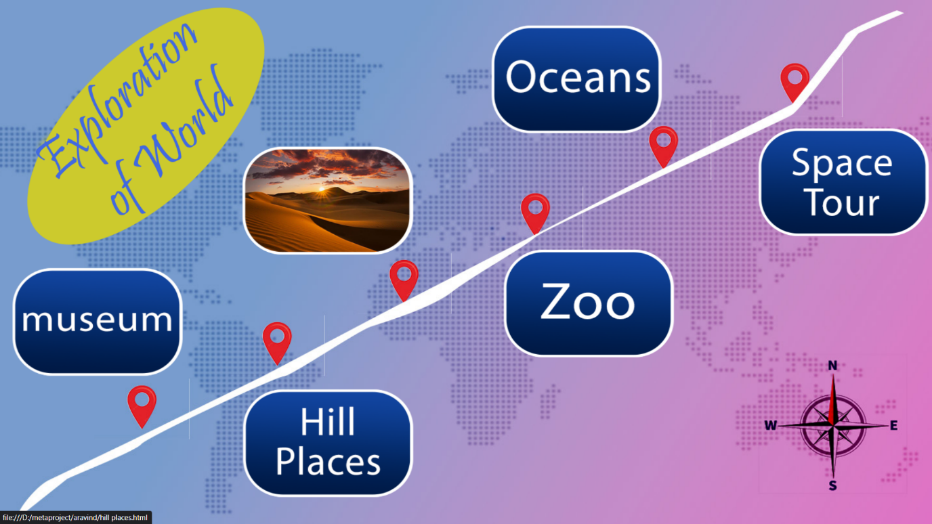

**Mueseum.html**

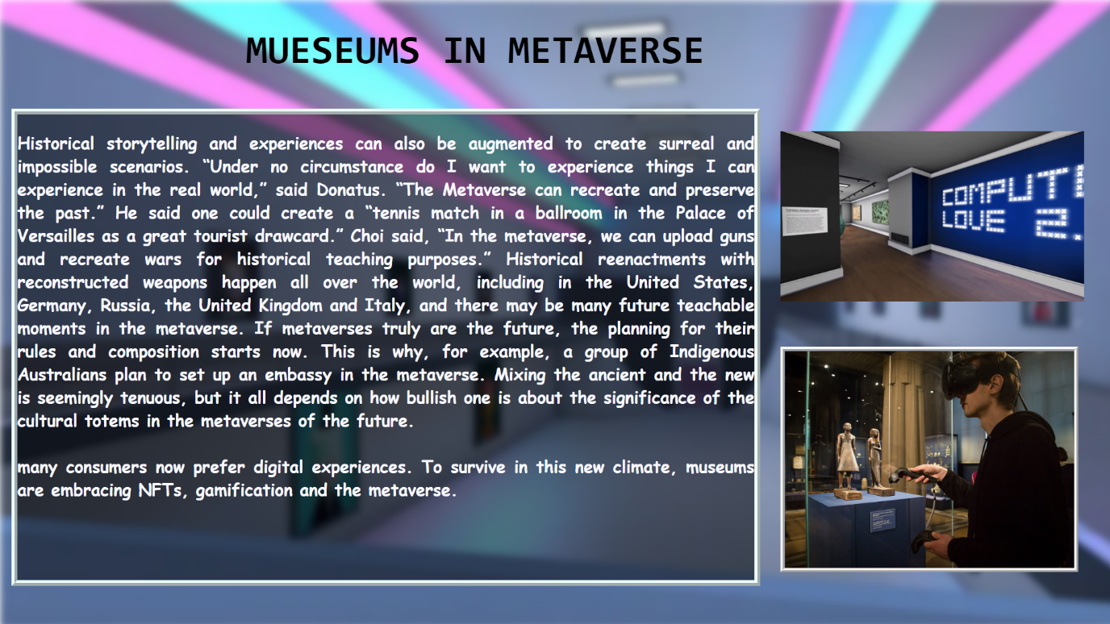

<html>

<head>

<title>Museum in Metavsrse</title>

<style>

#img1{filter: blur(5px);}

#img2{ border: 6px;

border-style: ridge;

border-color: whitesmoke;}

#h1{ font-size: 55;

font-family: monospace;

color: black;}

#div1{ border-style: ridge;

border-color: azure;

border-width: 8px;}

</style>

</head>

<body style="overflow: hidden;">

<div style="z-index: 6;position: absolute; top:0; left:340;width: 1530;height: 990;">

<h1 id="h1" ><b>MUESEUMS IN METAVERSE</b></h1>

</div>

<div style="z-index: 4; position: absolute; height: 990; width: 1440; top:0; left:0;">

<img id="img1" src="D:\metaproject\images\FWvmIoOCecX-9FpXYlPpCPbO0cq8GAfXILgYwTwpG2A.webp" height="870" width="1575">

</div>

<div style="z-index: 4;position: absolute; top:480; left:1080;width: 1530;height: 990;">

<img id="img2" src="D:\metaproject\images\79081c75553139.5c50254e51870.jpg" width="400" height="300">

</div>

<div style="z-index:5; position: absolute;left: 1080;top: 160; width: 1530;height: 990;">

<video height="280" width="420" autoplay muted loop="true" >

<source src="D:\metaproject\images\Virtual Reality Museum Fly-Through.mp4" width="100" height="140"></source>

</video>

</div>

<div id="div1" style="z-index:4;position:absolute;left:16;top:150; height:645; width: 1020;

font-size: 23; color: ghostwhite; font-family:cursive; text-align: justify;background-image:url(D:/metaproject/infobg.png)">

<p><b><b>Historical storytelling and experiences can also be augmented to create surreal and impossible scenarios.

“Under no circumstance do I want to experience things I can experience in the real world,” said Donatus. “The Metaverse can recreate and preserve the past.” He said one could create a “tennis match in a ballroom in the Palace of Versailles as a great tourist drawcard.”

Choi said, “In the metaverse, we can upload guns and recreate wars for historical teaching purposes.” Historical reenactments with reconstructed weapons happen all over the world, including in the United States, Germany, Russia, the United Kingdom and Italy, and there may be many future teachable moments in the metaverse.

If metaverses truly are the future, the planning for their rules and composition starts now. This is why, for example, a group of Indigenous Australians plan to set up an embassy in the metaverse. Mixing the ancient and the new is seemingly tenuous, but it all depends on how bullish one is about the significance of the cultural totems in the metaverses of the future.

<br><br>

many consumers now prefer digital experiences. To survive in this new climate, museums are embracing NFTs, gamification and the metaverse.

</b></b></p>

</div>

<a href="D:\metaproject\index tabs\Advantages of meta verse\exploration3.html"><div style="position:fixed;z-index:6;bottom:0;left:0;width:200;height:100;"></div></a>

<a href="D:\metaproject\index tabs\Advantages of meta verse\exploration3.html"><div style="position:fixed;z-index:6;bottom:0;left:650;width:200;height:100;"></div></a>

<a href="D:\metaproject\aravind\hill places.html"> <div style="position: absolute;z-index:10;right: 0;bottom: 0;height:100;width:200;">

</div></a>

</body>

</html>

**hill places.html**

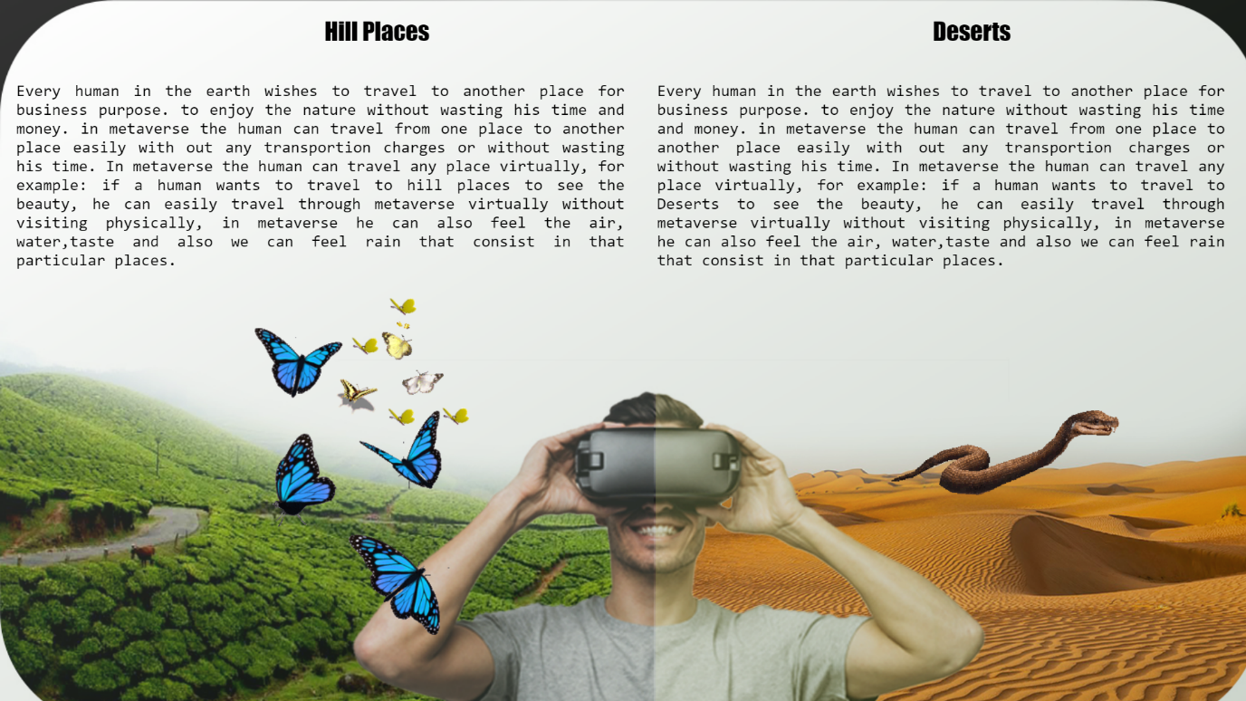

<html>

<body style="background: linear-gradient(150deg,#FFFFFF,#032A00)">

<img style="z-index:5;top:0;left:0;position: fixed;opacity: 0.8"

src="D:\metaproject\images\desert2.jpg" width="1550" height="900">

<div style="z-index:6;position: absolute;top:20;left: 400;color:black;font-family: impact;font-size: 30">Hill Places </div>

</div>

<div style="z-index:6;position: absolute;top:100;left: 20;width:750;color:black;font-family: consolas;font-size:20"text align="justify">Every human in the earth wishes to travel to another place for business purpose.

to enjoy the nature without wasting his time and money. in metaverse the human can travel from one place to another place easily with out any transportion charges or without wasting his time. In metaverse the human can travel any place virtually,

for example: if a human wants to travel to hill places to see the beauty, he can easily travel through metaverse virtually without visiting physically, in metaverse he can also feel the air, water,taste and also we can feel rain that consist in that particular places.

</div>

<div style="z-index:6;position: absolute;top:20;left: 1150;color:black;font-family: impact;font-size: 30">Deserts </div>

<div style="z-index:6;position: absolute;top:100;left: 810;width:700;color:black;font-family: consolas;font-size:20"text align="justify">Every human in the earth wishes to travel to another place for business purpose.

to enjoy the nature without wasting his time and money. in metaverse the human can travel from one place to another place easily with out any transportion charges or without wasting his time. In metaverse the human can travel any place virtually,

for example: if a human wants to travel to Deserts to see the beauty, he can easily travel through metaverse virtually without visiting physically, in metaverse he can also feel the air, water,taste and also we can feel rain that consist in that particular places.

</div>

<img style="z-index:7;position: absolute;top:350;left: 400;"src="D:\metaproject\images\butterfly 2.gif"> </img>

<img style="z-index:7;position: absolute;top:350;left: 200;"src="D:\metaproject\images\butterfly.gif"> </img>

<img style="z-index:7;position: absolute;top:350;left: 1000;width:500"

src="D:\metaproject\images\snake.gif"> </img>

<a href="D:\metaproject\anil\Mueseum.html"><div style="position:fixed;z-index:6;bottom:0;left:0;width:200;height:100;"></div></a>

<a href="D:\metaproject\index tabs\Advantages of meta verse\exploration3.html"><div style="position:fixed;z-index:6;bottom:0;left:650;width:200;height:100;"></div></a>

<a href="D:\metaproject\index tabs\zoo.html"> <div style="position: absolute;z-index:10;right: 0;bottom: 0;height:100;width:200;">

</div></a>

</body>

</html>

**zoo.html**

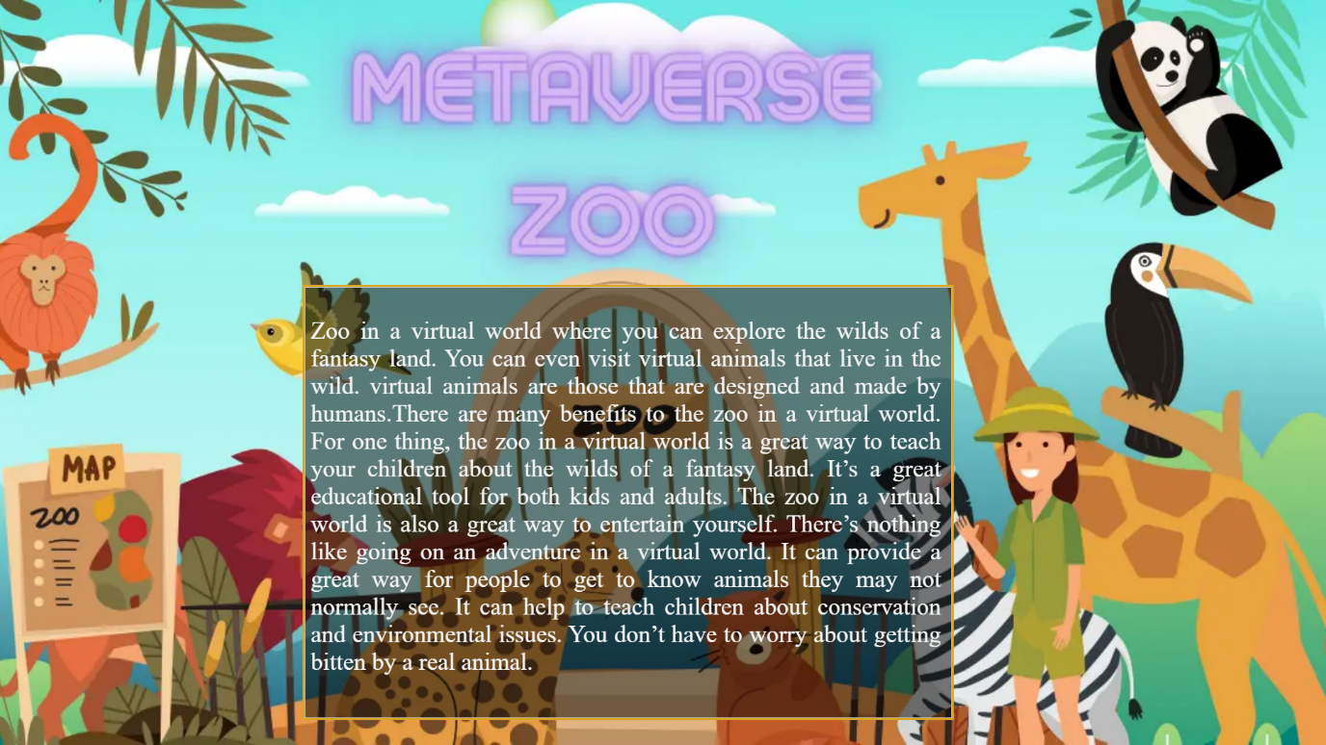

<html>

<head><title>Zoo</title></head>

<body>

<img style="z-index:0;position: fixed;right: 0;bottom:0;min-height: 100%;

min-width:100%" src="D:\metaproject\images\zoobg.jpg">

<img style="z-index:1;position:fixed;left:350;top:330;width:750;height:500;background-image:url(D:/metaproject/infobg.png);border-style:solid;border-color:goldenrod;">

<div style="z-index:2;position:fixed;left:360;top:340;width:730;height:490;font-size:28;color:whitesmoke;text-align:justify;"><p>Zoo in a virtual world where you can explore the wilds of a fantasy land. You can even visit virtual animals that live in the wild. virtual animals are those that are designed and made by humans.There are many benefits to the zoo in a virtual world. For one thing, the zoo in a virtual world is a great way to teach your children about the wilds of a fantasy land. It’s a great educational tool for both kids and adults. The zoo in a virtual world is also a great way to entertain yourself. There’s nothing like going on an adventure in a virtual world. It can provide a great way for people to get to know animals they may not normally see. It can help to teach children about conservation and environmental issues. You don’t have to worry about getting bitten by a real animal.</p></div>

<a href="D:\metaproject\aravind\hill places.html"><div style="position:fixed;z-index:6;bottom:0;left:0;width:200;height:100;"></div></a>

<a href="D:\metaproject\index tabs\Advantages of meta verse\exploration3.html"><div style="position:fixed;z-index:6;bottom:0;left:650;width:200;height:100;"></div></a>

<a href="D:\metaproject\aravind\oceans.html"> <div style="position: absolute;z-index:10;right: 0;bottom: 0;height:100;width:200;">

</div></a></body></html>

**oceans.html**

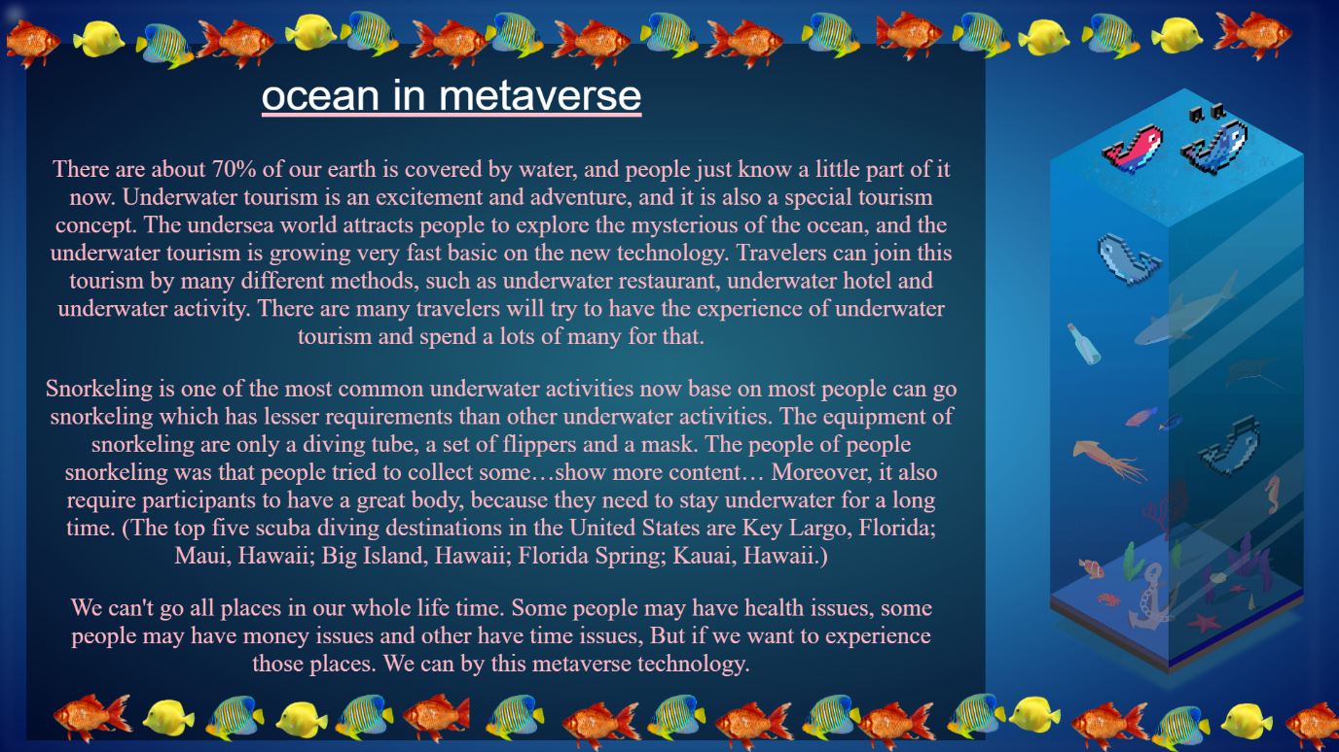

<html>

<head>

</head>

<body style="background:radial-gradient(#42D0FF,#000F4F)">

<div style="z-index:4;position: absolute; top:80; left:300; font-size: 50; font-family:arial; color:white;text-shadow:0px 0px 100px 10px black;text-decoration: underline;

text-decoration-color: pink">ocean in metaverse</div>

<img style="z-index:1;position: absolute; opacity: 0.6; filter:blur(6px);"src="D:\metaproject\icegif-526.gif" width="1500" height="850">

<img style="z-index:3;position: absolute;top:100; left:1200;"src="D:\metaproject\images\oceans.png" width="300" height="700">

<img style="z-index:3;position: absolute;top:50; left:30;"src="D:\metaproject\infobg.png" width="1100" height="800">

<div style="z-index:5;position: absolute;top:784; left:-;">

<marquee direction="left">

<img style="transform: rotateY(180deg);" src="D:\metaproject\images\ALL FISHES.png" width="1530" height="80"></img>

</marquee>

</div>

<div style="z-index:5;position: absolute;top:0; left:-;">

<marquee direction="right">

<img src="D:\metaproject\images\ALL FISHES 2.png" width="1530" height="80"></img>

</marquee>

</div>

<div style="z-index:7;top:150;left:50;width:1050;height:760;position: fixed;

text-align:center;font-size:28px;color:lightpink;"><p>

There are about 70% of our earth is covered by water, and people just know a little part of it now. Underwater tourism is an excitement and adventure, and it is also a special tourism concept. The undersea world attracts people to explore the mysterious of the ocean, and the underwater tourism is growing very fast basic on the new technology. Travelers can join this tourism by many different methods, such as underwater restaurant, underwater hotel and underwater activity. There are many travelers will try to have the experience of underwater tourism and spend a lots of many for that. </p>

<p>

Snorkeling is one of the most common underwater activities now base on most people can go snorkeling which has lesser requirements than other underwater activities. The equipment of snorkeling are only a diving tube, a set of flippers and a mask. The people of people snorkeling was that people tried to collect some…show more content…

Moreover, it also require participants to have a great body, because they need to stay underwater for a long time. (The top five scuba diving destinations in the United States are Key Largo, Florida; Maui, Hawaii; Big Island, Hawaii; Florida Spring; Kauai, Hawaii.)</p><p>

We can't go all places in our whole life time. Some people may have health issues, some people may have money issues and other have time issues, But if we want to experience those places. We can by this metaverse technology.</p>

</div>

<a href="D:\metaproject\index tabs\zoo.html"><div style="position:fixed;z-index:6;bottom:0;left:0;width:200;height:100;"></div></a>

<a href="D:\metaproject\index tabs\Advantages of meta verse\exploration3.html"><div style="position:fixed;z-index:6;bottom:0;left:650;width:200;height:100;"></div></a>

<a href="D:\metaproject\anil\space.html"> <div style="position: absolute;z-index:10;right: 0;bottom: 0;height:100;width:200;">

</div></a>

</body>

</html>

**space.html**

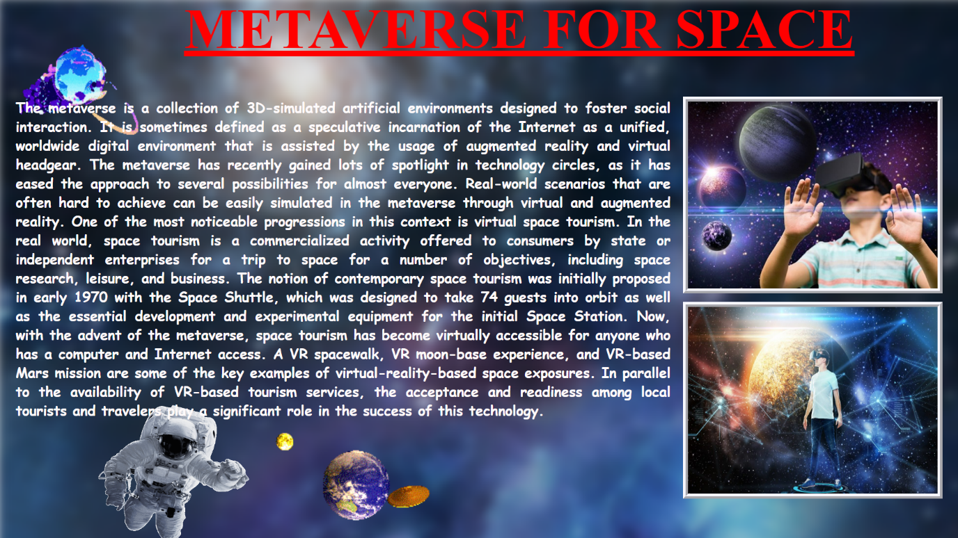

<html>

<head>

<title>Metaverse for space</title>

<style>

#img1{ filter: blur(8px);}

#img2{ border: 8px;

border-style: ridge;

border-color: ghostwhite;}

</style>

</head>

<body style="overflow:hidden;">

<div style="z-index: 4;position: absolute; top:-5; left:-5;width: 1430;height: 990;">

<img id="img1" src="D:\metaproject\images\space.jpg" height="1030" width="1830">

<div style="z-index: 4;position: absolute; top:0; left:5;width: 1430;height: 990;">

<img src="D:\metaproject\images\200w-unscreen.gif" height="250" width="250">

</div>

<div style="z-index: 4;position: absolute; top:160; left:1100;width: 1430;height: 990;">

<img id="img2" src="D:\metaproject\images\24_1_720x540.jpg" height="300" width="400">

</div>

<div style="z-index: 4;position: absolute; top:490; left:1100;width: 1430;height: 990;">

<img id="img2" src="D:\metaproject\images\resized-Experience-Space-as-a-Virtual-Reality-Astronaut-e1531317001372.jpg" height="300" width="400">

</div>

<div style="z-index: 4;position: absolute; top:640; left: 140;width: 1430;height: 990;">

<img src="D:\metaproject\images\giphy.gif" height="250" width="280">

</div>

<div style="z-index: 4;position: absolute; top:610; left: 350;width: 1430;height: 990;">

<img src="D:\metaproject\images\BackRevolvingEgg-max-1mb.gif" height="350" width="450">

</div>

<div style="z-index:4;position:absolute;left:300;top:-60; height: 1090; width: 1200;

font-size: 45; color: red; text-align: justify;">

<h1><u>

METAVERSE FOR SPACE

</u></h1>

</div>

<div style="z-index:4;position:absolute;left:30;top:140; height: 700; width: 1050;

font-size: 22; color: snow; font-family: cursive; text-align: justify;">

<p><b>

The metaverse is a collection of 3D-simulated artificial environments designed to foster social interaction. It is sometimes defined as a speculative incarnation of the Internet as a unified, worldwide digital environment that is assisted by the usage of augmented reality and virtual headgear. The metaverse has recently gained lots of spotlight in technology circles, as it has eased the approach to several possibilities for almost everyone. Real-world scenarios that are often hard to achieve can be easily simulated in the metaverse through virtual and augmented reality. One of the most noticeable progressions in this context is virtual space tourism. In the real world, space tourism is a commercialized activity offered to consumers by state or independent enterprises for a trip to space for a number of objectives, including space research, leisure, and business. The notion of contemporary space tourism was initially proposed in early 1970 with the Space Shuttle, which was designed to take 74 guests into orbit as well as the essential development and experimental equipment for the initial Space Station. Now, with the advent of the metaverse, space tourism has become virtually accessible for anyone who has a computer and Internet access. A VR spacewalk, VR moon-base experience, and VR-based Mars mission are some of the key examples of virtual-reality-based space exposures.

In parallel to the availability of VR-based tourism services, the acceptance and readiness among local tourists and travelers play a significant role in the success of this technology.

</b></p>

</div>

<a href="D:\metaproject\aravind\oceans.html"><div style="position:fixed;z-index:6;bottom:0;left:0;width:200;height:100;"></div></a>

<a href="D:\metaproject\index tabs\Advantages of meta verse\exploration3.html"><div style="position:fixed;z-index:6;bottom:0;left:650;width:200;height:100;"></div></a>

<a href="D:\metaproject\index tabs\Advantages of meta verse\exploration3.html"> <div style="position: fixed;z-index:10;right: 0;bottom: 0;height:100;width:200;">

</div></a>

</body>

</html>

**Teleconference.html**



<html>

<head>

<title>Teleconferences</title>

<style>

#img1{animation: img1z 3s ease-in forwards;animation-delay: 3s}

@keyframes img1z

{

0%{ height: 0;width: 0;opacity: 0.7;top: 235;left: 460; }

100%{ height:200;width:300;opacity: 1;top:135;left:310; }

}

#img2{animation: img2z 3s ease-in forwards; animation-delay: 3s}

@keyframes img2z

{

0%{ height: 0;width: 0;top: 235;left: 1050;opacity: 0.7;}

100%{ height:200;width:300;top:135;left:900;opacity: 1; }

}

#img3{animation: img3z 3s ease-in forwards;animation-delay: 3s }

@keyframes img3z

{

0% {height: 0;width: 0;top: 600;left: 460;opacity: 0.7;}

100%{ height:200;width:300;top:500;left:310;opacity: 1; }

}

#img4{animation: img4z 3s ease-in forwards;animation-delay: 3s}

@keyframes img4z

{

0% {height: 0;width: 0;top: 600;left: 1050;opacity: 0.7;}

100%{ height:200;width:300;top:500;left:900;opacity: 1;}

}

#fb1

{

position: absolute;z-index: 2;

animation: fb1z 3s ease-in forwards ;

}

@keyframes fb1z

{

0%{ top:0;left:-100;height:100;width:100;opacity:1;

transform:rotateZ(0deg) }

95%{ top:185;left:410;height:100;width:100;opacity:1;

transform:rotateZ(10800deg) }

100%{ top:185;left:410;height:100;width:100;opacity:0;

transform: rotateZ(10800deg) }

}

#fb2

{

position: absolute; z-index: 2;

animation: fb2z 3s ease-in forwards ;

}

@keyframes fb2z

{

0%{top: 0;left: 1535;height: 100;width: 100;opacity: 1;

transform: rotateZ(0deg)}

95%{top: 185;left: 1000;width: 100;height: 100;opacity: 1;

transform: rotateZ(10800deg)}

100%{top: 185;left: 1000;width:100;height:100;opacity:0;

transform:rotateZ(10800deg) }

}

#fb3

{

position: absolute;z-index: 2;

animation: fb3z 3s ease-in forwards ;

}

@keyframes fb3z

{

0%{ top:800;left:-100;height:100;width:100;opacity:1;

transform:rotateZ(0deg) }

95%{ top:550;left:410;height:100;width:100;opacity:1;

transform:rotateZ(10800deg) }

100%{ top:550;left:410;height:100;width:100;opacity:0;

transform: rotateZ(10800deg)}

}

#fb4

{

position: absolute;z-index: 2;

animation: fb4z 3s ease-in forwards ;

}

@keyframes fb4z

{

0%{ top:800;left:1535;height:100;width:100;opacity:1;

transform:rotateZ(0deg) }

95%{ top:550;left:1000;height:100;width:100;opacity:1;

transform:rotateZ(10800deg) }

100%{ top:550;left:1000;height:100;width:100;opacity:0;

transform: rotateZ(10800deg) }

}

</style>

</head>

<body style="overflow:hidden">

<img style="z-index:-10;position: fixed;min-height: 100%;min-width: 100%;height: 100%;width:100%;right:0;bottom:0"

src="D:\metaproject\images\teseawithsky.jpg" ></a>

<a href="D:\metaproject\Naveen\political.html"><img style="z-index:1;position:absolute;opacity: 0;

border-style: solid;border-color:#ffffff;border-radius: 5%;

box-shadow:0px 0px 10px 5px #ffffff;"

src="D:\metaproject\images\tepoliticalmeetings.jpg" id="img1"></a>

<a href="D:\metaproject\Naveen\medical.html"><img style="z-index:1;position:absolute;opacity: 0;

border-style:solid;border-color: #ffffff;border-radius: 5%;

box-shadow: 0px 0px 10px 5px #ffffff;"

src="D:\metaproject\images\temedical meta.jpg" id="img2"></a>

<a href="D:\metaproject\Naveen\marriages.html"><img style="z-index:1;position:absolute;opacity: 0;

border-style:solid;border-color: #ffffff;border-radius: 5%;

box-shadow: 0px 0px 10px 5px #ffffff;"

src="D:\metaproject\images\temarriages.jpg" id="img3"></a>

<a href="D:\metaproject\Naveen\3d video call.html"><img style="z-index:1;position:absolute;opacity: 0;

border-style:solid;border-color: #ffffff;border-radius: 5%;

box-shadow: 0px 0px 10px 5px #ffffff;"

src="D:\metaproject\images\tevideocalling.jpg" id="img4"></a>

<img src="D:\metaproject\images\fireball2.png" id="fb1">

<img src="D:\metaproject\images\fireball2.png" id="fb2">

<img src="D:\metaproject\images\fireball2.png" id="fb3">

<img src="D:\metaproject\images\fireball2.png" id="fb4">

<a href="D:\metaproject\index tabs\Advantages of meta verse\games.html">

<div style="position: absolute;z-index:10;right: 40;bottom: 30;height:100;width:100;">

</div>

</a>

<a href="D:\metaproject\index tabs\Advantages of meta verse\exploration3.html"><div style="position:fixed;z-index:6;bottom:0;left:0;width:200;height:100;"></div></a>

<a href="D:\metaproject\index tabs\Advantages of meta verse\Advantages.html"><div style="position:fixed;z-index:6;bottom:0;left:650;width:200;height:100;"></div></a>

<a href="D:\metaproject\index tabs\Advantages of meta verse\workplace.html">

<div style="position: absolute;z-index:10;right: 0;bottom: 0;height:100;width:200;">

</div></a>

</body>

</html>

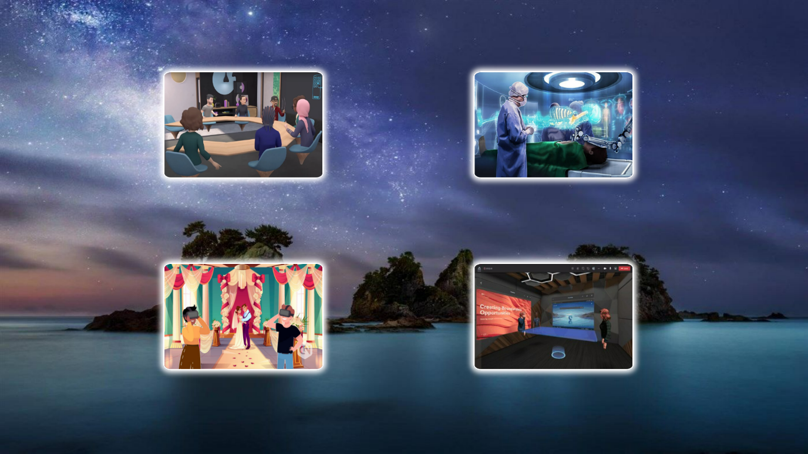

**political.html**

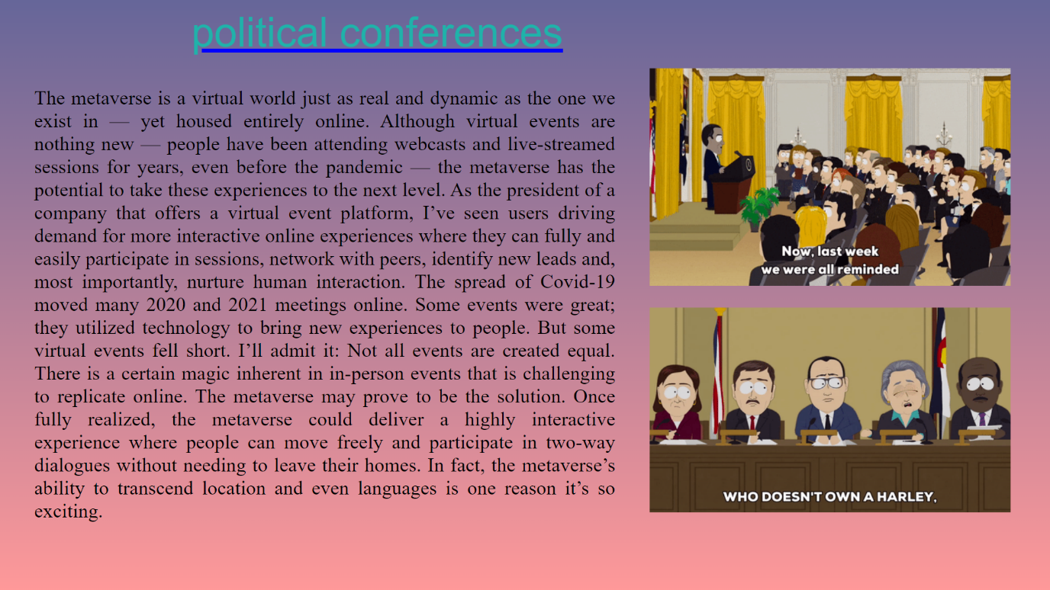  
 <html>

<head>

<title>political conferences </title>

</head>

<body style="background:linear-gradient(to bottom,#666699 0%, #ff9999 100%); overflow: hidden;">

<div style="z-index:1; position: absolute;top:100; left:950;width:1528;

height: 500;">

<img src ="D:\metaproject\images\giphy(2).gif" height="318" width="528">

</div>

<div style="z-index:2; position: absolute;top:450; left:950;width:1528;

height: 500;">

<img src ="D:\metaproject\images\bznu.gif" height="300" width="528">

</div>

<div style="z-index:3;position: absolute;left:280;top:13; font-size: 60px;

color:lightseagreen; text-decoration:underline; text-decoration-color:blue ;

font-family:sans-serif;">political conferences</div>

<div style="z-index:4;position: absolute;left:50;top:97;width:850; text-align: justify; font-size:29px; color:black;">

<p>The metaverse is a virtual world just as real and dynamic as the one we exist in — yet housed entirely online. Although virtual events are nothing new — people have been attending webcasts and live-streamed sessions for years, even before the pandemic — the metaverse has the potential to take these experiences to the next level. As the president of a company that offers a virtual event platform, I’ve seen users driving demand for more interactive online experiences where they can fully and easily participate in sessions, network with peers, identify new leads and, most importantly, nurture human interaction.

The spread of Covid-19 moved many 2020 and 2021 meetings online. Some events were great; they utilized technology to bring new experiences to people. But some virtual events fell short. I’ll admit it: Not all events are created equal. There is a certain magic inherent in in-person events that is challenging to replicate online.

The metaverse may prove to be the solution. Once fully realized, the metaverse could deliver a highly interactive experience where people can move freely and participate in two-way dialogues without needing to leave their homes. In fact, the metaverse’s ability to transcend location and even languages is one reason it’s so exciting.</p>

</div>

<a href="D:\metaproject\index tabs\Advantages of meta verse\Teleconference.html"><div style="position:fixed;z-index:6;bottom:0;left:0;width:200;height:100;"></div></a>

<a href="D:\metaproject\index tabs\Advantages of meta verse\Teleconference.html"><div style="position:fixed;z-index:6;bottom:0;left:650;width:200;height:100;"></div></a>

<a href="D:\metaproject\Naveen\medical.html">

<div style="position: absolute;z-index:10;right: 0;bottom: 0;height:100;width:200;">

</div></a>

</body>

</html>

**Medical.html**

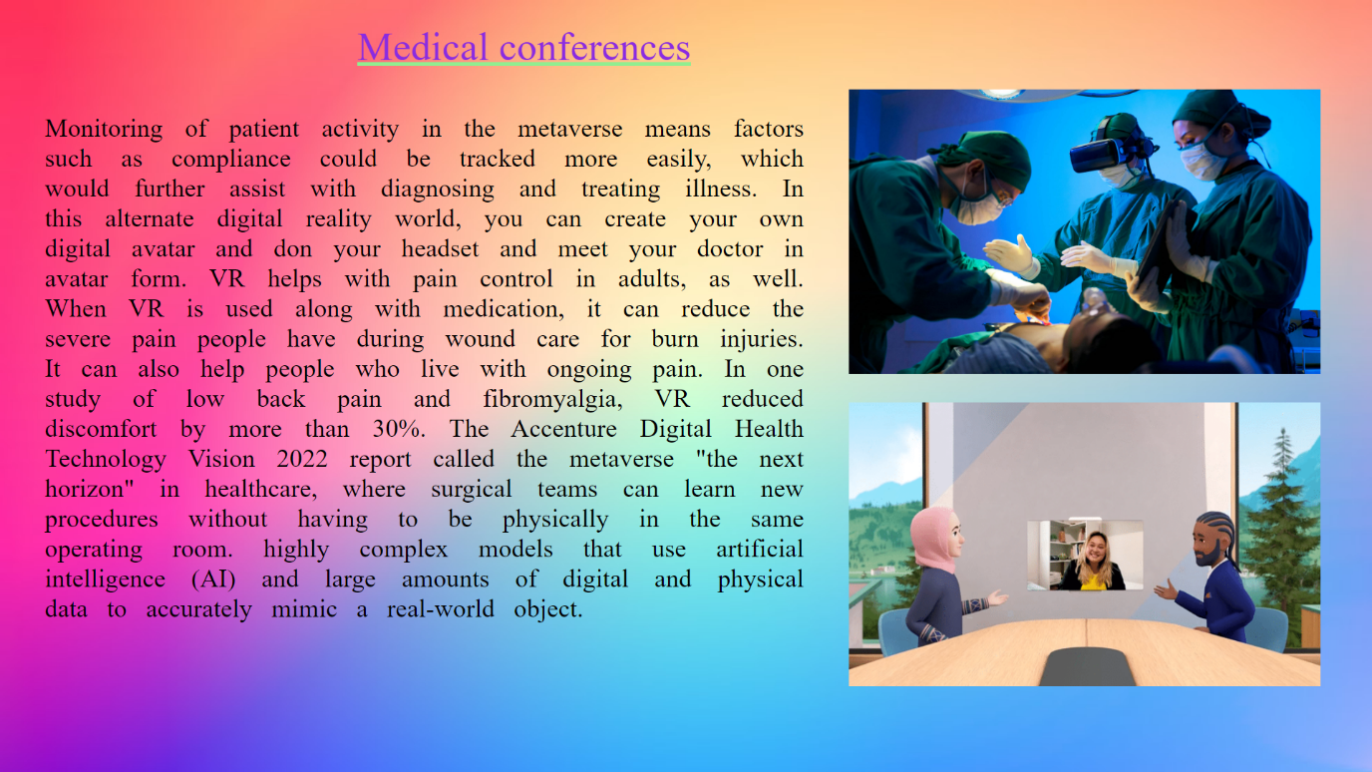

<html>

<head>

<title> medical conferences </title>

</head>

<body style="overflow: hidden;">

<div style="z-index:1; position: absolute;top:0; left:0;width:1528;

height: 500;">

<img src ="D:\metaproject\images\photo.jpeg" height="890" width="1550">

</div>

<div style="z-index:2; position: absolute;top:100; left:950;width:1528;

height: 500;">

<img src ="D:\metaproject\images\foto.jpg" height="318" width="528">

</div>

<div style="z-index:3; position: absolute;top:450; left:950;width:1528;

height: 500;">

<img src ="D:\metaproject\images\impact.gif" height="318" width="528"></div>

<div style="z-index:4;position: absolute;left:400;top:26 ;width: 990; text-align: justify; font-size: 45px; color:blueviolet; text-decoration: underline; text-decoration-color:lightgreen;"> Medical conferences </div>

<div style="z-index:5;position: absolute;left:50;top:97;width:850; text-align: justify; font-size:29px; color:black;word-spacing:14;">

<p>Monitoring of patient activity in the metaverse means factors such as compliance could be tracked more easily, which would further assist with diagnosing and treating illness. In this alternate digital reality world, you can create your own digital avatar and don your headset and meet your doctor in avatar form.

VR helps with pain control in adults, as well. When VR is used along with medication, it can reduce the severe pain people have during wound care for burn injuries. It can also help people who live with ongoing pain. In one study of low back pain and fibromyalgia, VR reduced discomfort by more than 30%.

The Accenture Digital Health Technology Vision 2022 report called the metaverse "the next horizon" in healthcare, where surgical teams can learn new procedures without having to be physically in the same operating room.

highly complex models that use artificial intelligence (AI) and large amounts of digital and physical data to accurately mimic a real-world object.

</p>

</div>

<a href="D:\metaproject\Naveen\political.html"><div style="position:fixed;z-index:6;bottom:0;left:0;width:200;height:100;"></div></a>

<a href="D:\metaproject\index tabs\Advantages of meta verse\Teleconference.html"><div style="position:fixed;z-index:6;bottom:0;left:650;width:200;height:100;"></div></a>

<a href="D:\metaproject\Naveen\marriages.html">

<div style="position: absolute;z-index:10;right: 0;bottom: 0;height:100;width:200;">

</div></a>

</body>

</html>

**Marriages.html**

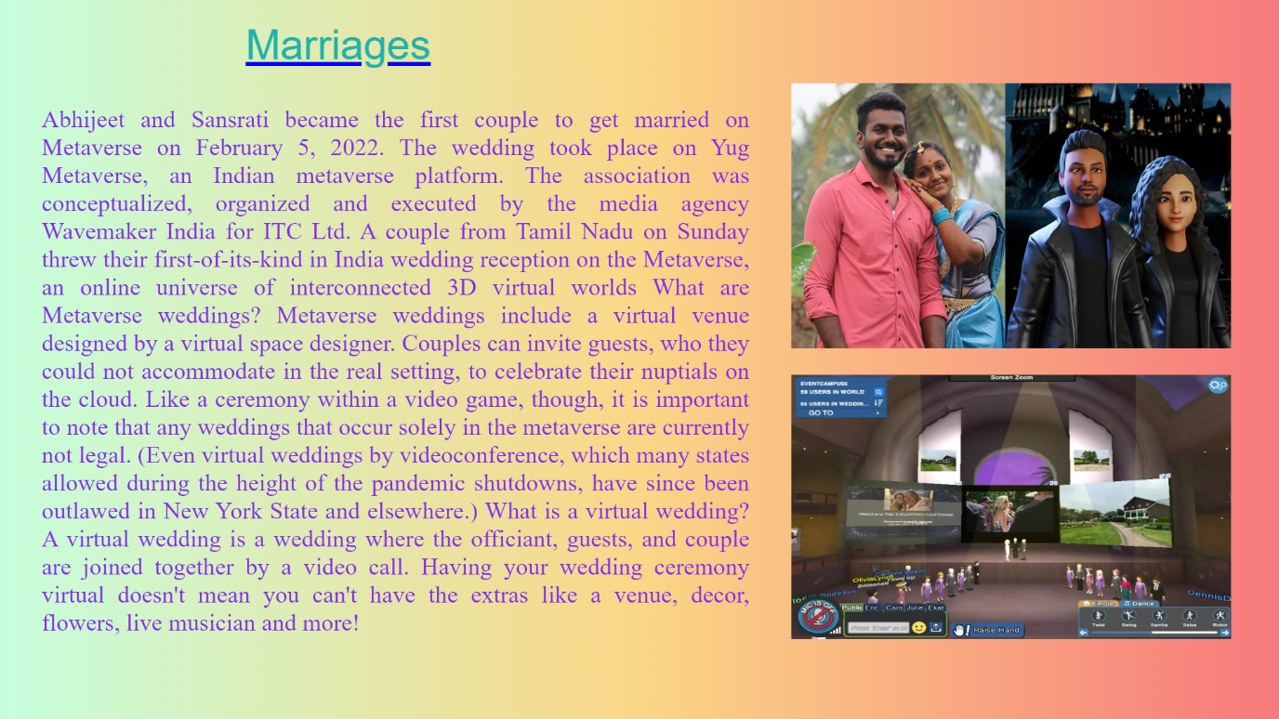

<html>

<head>

<title>marriages</title>

</head>

<body style="background:linear-gradient(to right, #c6ffdd,#fbd786,#f7797d); overflow: hidden;">

<div style="z-index:1; position: absolute;top:100; left:950;width:1528;

height: 500;">

<img src ="D:\metaproject\images\marriage1.jpg" height="318" width="528">

</div>

<div style="z-index:2; position: absolute;top:450; left:950;width:1528;

height: 500;">

<img src ="D:\metaproject\images\wedding.jpg" height="318" width="528">

</div>

<div style="z-index:3;position: absolute;left:295;top:25; font-size: 50px;

color:lightseagreen; text-decoration:underline; text-decoration-color:blue ;

font-family:sans-serif;">Marriages</div>

<div style="z-index:4;position: absolute;left:50;top:97;width:850; text-align: justify; font-size:29px; color:blueviolet;">

<p>Abhijeet and Sansrati became the first couple to get married on Metaverse on February 5, 2022. The wedding took place on Yug Metaverse, an Indian metaverse platform. The association was conceptualized, organized and executed by the media agency Wavemaker India for ITC Ltd.

A couple from Tamil Nadu on Sunday threw their first-of-its-kind in India wedding reception on the Metaverse, an online universe of interconnected 3D virtual worlds

What are Metaverse weddings? Metaverse weddings include a virtual venue designed by a virtual space designer. Couples can invite guests, who they could not accommodate in the real setting, to celebrate their nuptials on the cloud.

Like a ceremony within a video game, though, it is important to note that any weddings that occur solely in the metaverse are currently not legal. (Even virtual weddings by videoconference, which many states allowed during the height of the pandemic shutdowns, have since been outlawed in New York State and elsewhere.)

What is a virtual wedding? A virtual wedding is a wedding where the officiant, guests, and couple are joined together by a video call. Having your wedding ceremony virtual doesn't mean you can't have the extras like a venue, decor, flowers, live musician and more!</p>

</div>

<a href="D:\metaproject\Naveen\medical.html"><div style="position:fixed;z-index:6;bottom:0;left:0;width:200;height:100;"></div></a>

<a href="D:\metaproject\index tabs\Advantages of meta verse\Teleconference.html"><div style="position:fixed;z-index:6;bottom:0;left:650;width:200;height:100;"></div></a>

<a href="D:\metaproject\Naveen\3d video call.html">

<div style="position: absolute;z-index:10;right: 0;bottom: 0;height:100;width:200;">

</div></a>

</body>

</html>

**3d video call.html**

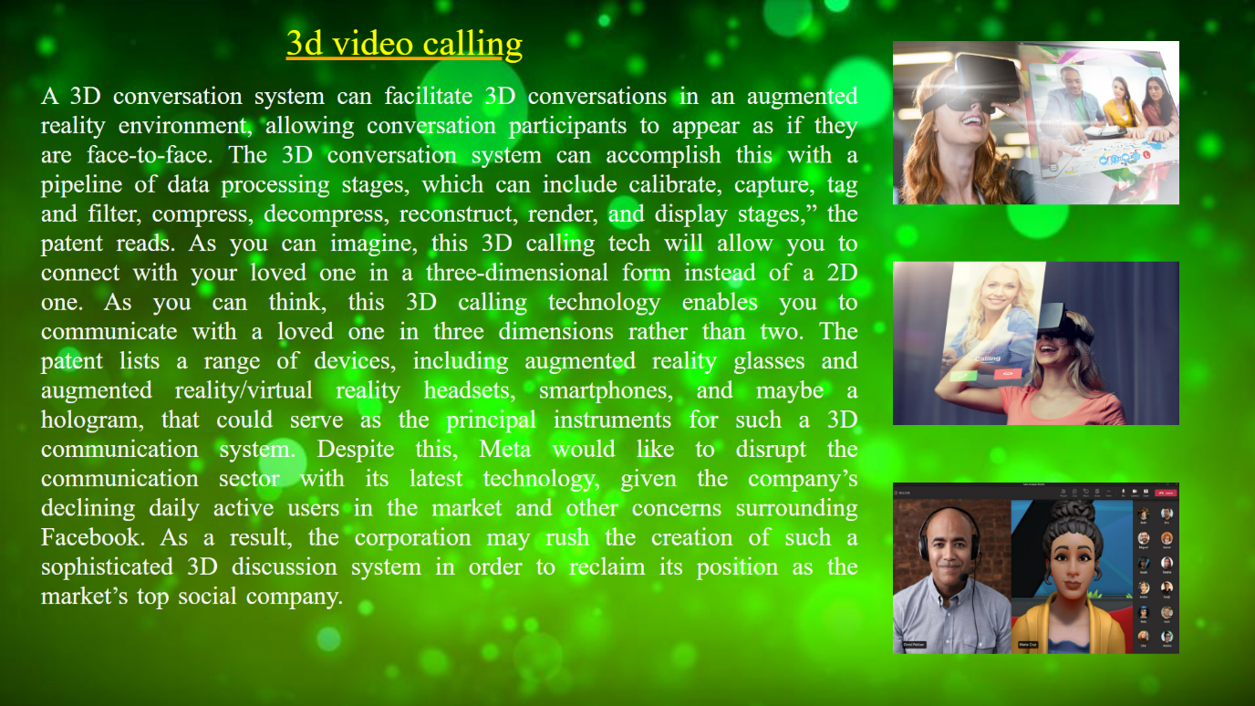

<html>

<head>

<title> 3d video calling </title>

</head>

<body style="overflow: hidden;">

<div style="z-index:1; position: absolute;top:0; left:0;width:1528;

height: 500;">

<img src ="D:\metaproject\images\bokeh.jpg" height="890" width="1550">

</div>

<div style="z-index:2; position: absolute;top:50; left:1093;width:1528;

height: 500;">

<img src ="D:\metaproject\images\composite.jpg" height="200" width="350">

</div>

<div style="z-index:3; position: absolute;top:320; left:1093;width:1528;

height: 500;">

<img src ="D:\metaproject\images\technology.jpg" height="200" width="350">

</div>

<div style="z-index:4; position: absolute;top:590; left:1093;width:1528;

height: 500;">

<img src ="D:\metaproject\images\477ff.jpg" height="210" width="350">

</div>

<div style="z-index:5 ;position: absolute;left:350;top:26 ;width: 990; text-align: justify; font-size: 45px; color:yellow; text-decoration: underline; text-decoration-color:orange;"> 3d video calling </div>

<div style="z-index:5;position: absolute;left:50;top:67;width:1000; text-align: justify; font-size:31px; color:whitesmoke; word-spacing: 3;">

<p> A 3D conversation system can facilitate 3D conversations in an augmented reality environment, allowing conversation participants to appear as if they are face-to-face. The 3D conversation system can accomplish this with a pipeline of data processing stages, which can include calibrate, capture, tag and filter, compress, decompress, reconstruct, render, and display stages,” the patent reads.

As you can imagine, this 3D calling tech will allow you to connect with your loved one in a three-dimensional form instead of a 2D one.

As you can think, this 3D calling technology enables you to communicate with a loved one in three dimensions rather than two. The patent lists a range of devices, including augmented reality glasses and augmented reality/virtual reality headsets, smartphones, and maybe a hologram, that could serve as the principal instruments for such a 3D communication system.

Despite this, Meta would like to disrupt the communication sector with its latest technology, given the company’s declining daily active users in the market and other concerns surrounding Facebook. As a result, the corporation may rush the creation of such a sophisticated 3D discussion system in order to reclaim its position as the market’s top social company. </p>

</div>

<a href="D:\metaproject\Naveen\marriages.html"><div style="position:fixed;z-index:6;bottom:0;left:0;width:200;height:100;"></div></a>

<a href="D:\metaproject\index tabs\Advantages of meta verse\Teleconference.html"><div style="position:fixed;z-index:6;bottom:0;left:650;width:200;height:100;"></div></a>

<a href="D:\metaproject\index tabs\Advantages of meta verse\Teleconference.html">

<div style="position: absolute;z-index:10;right: 0;bottom: 0;height:100;width:200;">

</div></a>

</body>

</html>

**Workplace.html**

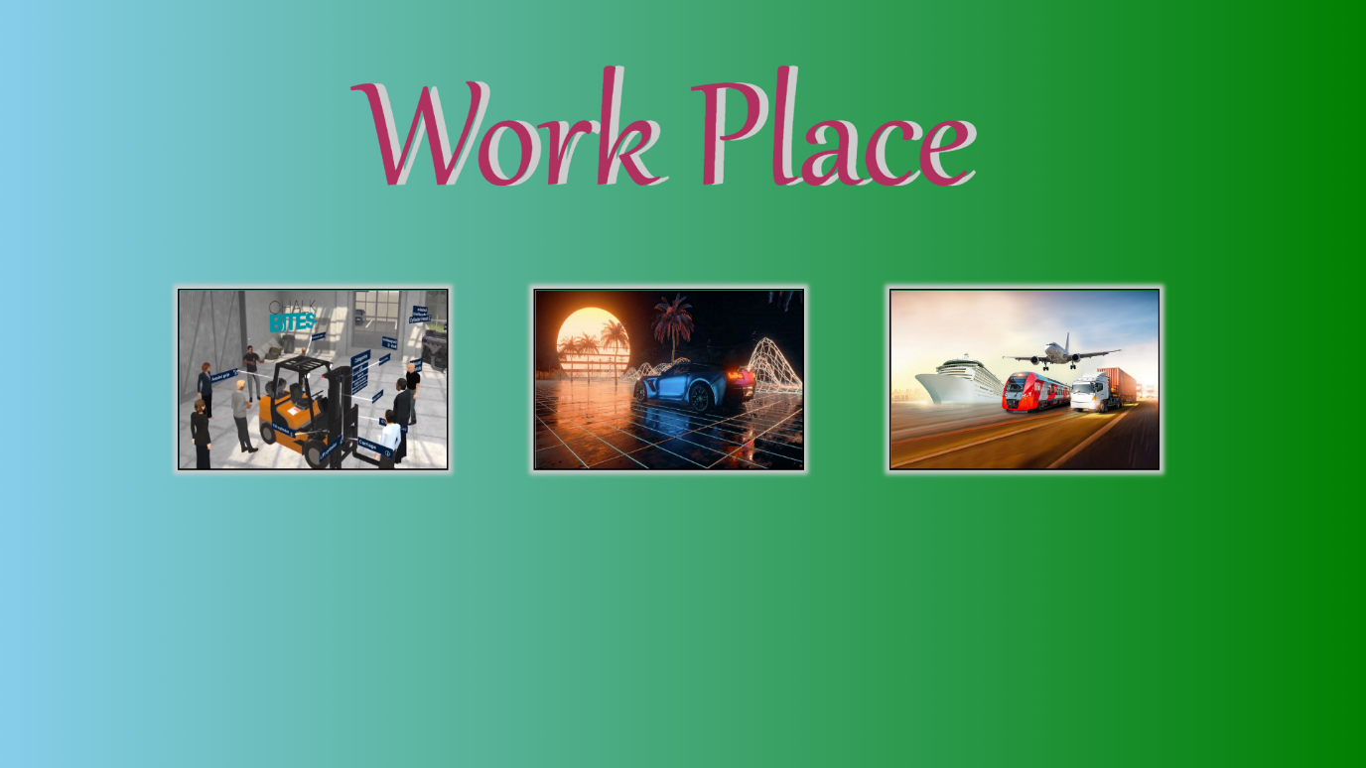

<html>

<head>

<title>jashuanim</title>

<script src="D:\metaproject\jq.js"></script>

<script language="javascript">

function fadeout2()

{

$("#medical2,#driving2,#transport2").fadeOut( 3000);

}

function medical1f()

{

document.getElementById("medical").style.animationPlayState= "running";

const myTimeOut=setTimeout(medical2f,1000)

function medical2f()

{

document.getElementById("medical2").style.animationPlayState= "running";

}

}

function transport1f()

{

document.getElementById("transport").style.animationPlayState= "running";

const myTimeOut=setTimeout(transport2f,1000)

function transport2f()

{

document.getElementById("transport2").style.animationPlayState= "running";

}

}

function driving1f()

{

document.getElementById("driving").style.animationPlayState= "running";

const myTimeOut=setTimeout(driving2f,1000)

function driving2f()

{

document.getElementById("driving2").style.animationPlayState= "running";

}

}

</script>

<style>

#medical

{

position: absolute; z-index: 4;top: 325;left: 200;width: 300;height: 200;

border-style: solid;box-shadow: 0px 0px 5px 5px #cccccc;border-width: 2px;

animation: rotatey 1s forwards ease-in paused alternate;

}

@keyframes rotatey

{

0%{ transform: rotateY(0deg);opacity: 1}

99%{transform: rotateY(90deg);opacity: 1}

100%{transform: rotateY(90deg);opacity: 0}

}

#medical2

{

top: 325;left: 200;width: 300;height: 200;opacity: 0;

border-style: solid;box-shadow: 0px 0px 5px 5px #cccccc;border-width: 2px;

position: absolute;z-index: 5;

animation: medical2z 4s forwards ease-out paused;

}

@keyframes medical2z

{

0%{top: 325;left: 200;width: 300;height: 200;opacity: 0;

transform:rotateY(270deg);z-index: 5;}

1%{top: 325;left: 200;width: 300;height: 200;opacity: 1;

transform:rotateY(270deg);z-index: 5;}

40%{top: 325;left: 200;width: 300;height: 200;opacity: 1;

transform: rotateY(360deg);z-index: 6}

100%{top: 20;left: 20;width: 1495;height: 825;opacity: 1;

transform: rotateY(360deg);z-index: 6}

}

#driving

{

border-style: solid;box-shadow: 0px 0px 5px 5px #cccccc;border-width: 2px;

position: absolute; z-index: 5;top: 325;left: 600;width: 300;height: 200;

animation: rotatey 1s forwards ease-in paused;

}

#driving2

{

border-style: solid;box-shadow: 0px 0px 5px 5px #cccccc;border-width: 2px;

top: 325;left: 600;width: 300;height: 200;opacity: 0;

position: absolute;z-index: 6;

animation: driving2z 4s forwards ease-out paused;

}

@keyframes driving2z

{

0%{top: 325;left: 600;width: 300;height: 200;opacity: 0;

transform:rotateY(270deg);z-index: 5}

1%{top: 325;left: 600;width: 300;height: 200;opacity: 1;

transform:rotateY(270deg);z-index: 5}

40%{top: 325;left: 600;width: 300;height: 200;opacity: 1;

transform: rotateY(360deg);z-index: 6}

100%{top: 20;left: 20;width: 1495;height: 825;opacity: 1;

transform: rotateY(360deg);z-index: 6}

}

#transport

{

border-style: solid;box-shadow: 0px 0px 5px 5px #cccccc;border-width: 2px;

position: absolute; z-index: 5;top: 325;left: 1000;width: 300;height: 200;

animation: rotatey 1s forwards ease-in paused;

}

#transport2

{

border-style: solid;box-shadow: 0px 0px 5px 5px #cccccc;border-width: 2px;

top: 325;left: 1000;width: 300;height: 200;opacity: 0;border-style: solid;

position: absolute;z-index: 5;border-width: 5;

animation: transport2z 4s forwards ease-out paused;

}

@keyframes transport2z

{

0%{top: 325;left: 1000;width: 300;height: 200;opacity: 0;

transform:rotateY(270deg);z-index: 5 }

1%{top: 325;left: 1000;width: 300;height: 200;opacity: 1;

transform:rotateY(270deg);z-index: 5}

40%{top: 325;left: 1000;width: 300;height: 200;opacity: 1;

transform: rotateY(360deg);z-index: 5}

100%{top: 20;left: 20;width: 1495;height: 825;opacity: 1;

transform: rotateY(360deg);z-index: 6}

}

</style>

</head>

<body style="background: linear-gradient(to right,skyblue,green);overflow:hidden;">

<p style="z-index:2;position:fixed;top:-200;left:400;width:1500;

text-shadow: 10px 0px 0px #cccccc; font-family:Gabriola;font-size:200;color:#B03060">Work Place</p>

<img src="D:\metaproject\images\remotework.jpg" id="medical">

<iframe src="D:\metaproject\Naveen\remote work.html" id="medical2"></iframe>

<div style="top: 325;left: 200;width: 300;height: 200;position: absolute;z-index: 5;" onmouseover="medical1f()"></div>

<img src="D:\metaproject\images\driving.jpg" id="driving">

<iframe src="D:\metaproject\Naveen\driving.html" id="driving2"></iframe>

<div style="top: 325;left: 600;width: 300;height: 200;position: absolute;z-index: 5;" onmouseover="driving1f()"></div>

<img src="D:\metaproject\images\transportation.jpg" id="transport">

<a href="D:\forhtml\transport.html" target="transportframe">

<iframe name="transportframe"

src="D:\metaproject\Naveen\Transportation.html" id="transport2"></iframe></a>

<div style="top: 325;left: 1000;width: 300;height: 200;position: absolute;z-index: 5;" onmouseover="transport1f()"></div>

<a href=""><div onclick="fadeout2();" style="top:100;left:1200;width:200;height:150;position:absolute;z-index:12;"></div></a>

<a href="D:\metaproject\index tabs\Advantages of meta verse\Teleconference.html"><div style="position:fixed;z-index:6;bottom:0;left:0;width:200;height:100;"></div></a>

<a href="D:\metaproject\Index2.html"><div style="position:fixed;z-index:6;bottom:0;left:650;width:200;height:100;"></div></a>

<a href="D:\metaproject\index tabs\Advantages of meta verse\games.html">

<div style="position: absolute;z-index:10;right: 0;bottom: 0;height:100;width:200;">

</div></a>

<a href="D:\metaproject\index tabs\Advantages of meta verse\Advantages.html"><div style="position:fixed;z-index:6;top:0;left:650;width:200;height:100;"></div></a>

</body></html>

**Remote work.html**

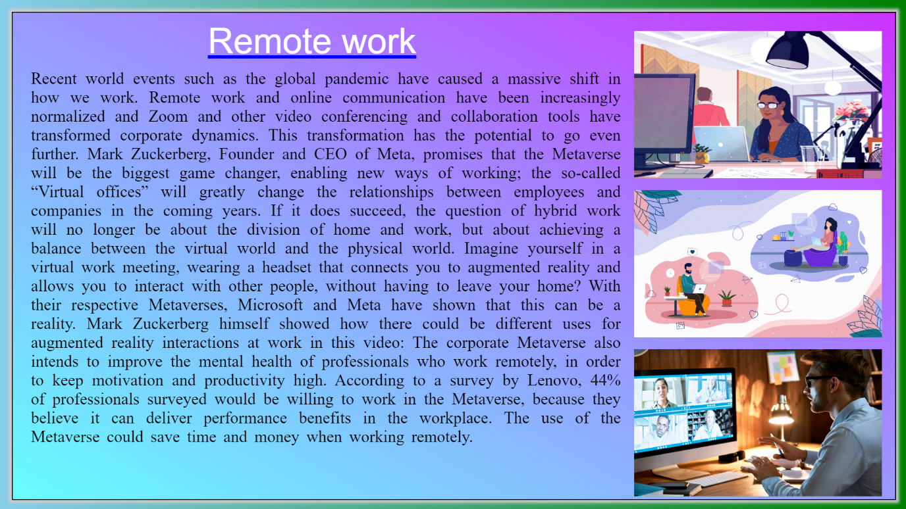

<html>

<head>

<title>remote work</title>

</head>

<body style="background:linear-gradient(to top right, #66ffff 0%, #cc33ff 100%); overflow: hidden;">

<div style="z-index:1; position: absolute;top:30; left:1053;width:1528;

height: 500;">

<img src ="D:\metaproject\images\deskworking.gif" height="250" width="420">

</div>

<div style="z-index:2; position: absolute;top:300; left:1053;width:1528;

height: 500;">

<img src ="D:\metaproject\images\taskade.gif" height="250" width="420">

</div>

<div style="z-index:3; position: absolute;top:570; left:1053;width:1528;

height: 500;">

<img src ="D:\metaproject\images\remote.jpeg" height="250" width="420">

</div>

<div style="z-index:3;position: absolute;left:330;top:13; font-size: 60px;

color: white; text-decoration:underline; text-decoration-color:blue ;

font-family:sans-serif;">Remote work </div>

<div style="z-index:4;position: absolute;left:30;top:67;width:1000; text-align: justify; font-size:28px;word-spacing: 5; color:black;">

<p>Recent world events such as the global pandemic have caused a massive shift in how we work. Remote work and online communication have been increasingly normalized and Zoom and other video conferencing and collaboration tools have transformed corporate dynamics. This transformation has the potential to go even further. Mark Zuckerberg, Founder and CEO of Meta, promises that the Metaverse will be the biggest game changer, enabling new ways of working; the so-called “Virtual offices” will greatly change the relationships between employees and companies in the coming years.

If it does succeed, the question of hybrid work will no longer be about the division of home and work, but about achieving a balance between the virtual world and the physical world.

Imagine yourself in a virtual work meeting, wearing a headset that connects you to augmented reality and allows you to interact with other people, without having to leave your home? With their respective Metaverses, Microsoft and Meta have shown that this can be a reality. Mark Zuckerberg himself showed how there could be different uses for augmented reality interactions at work in this video:

The corporate Metaverse also intends to improve the mental health of professionals who work remotely, in order to keep motivation and productivity high. According to a survey by Lenovo, 44% of professionals surveyed would be willing to work in the Metaverse, because they believe it can deliver performance benefits in the workplace.

The use of the Metaverse could save time and money when working remotely. </p>

</div>

</body>

</html>

**Driving.html**

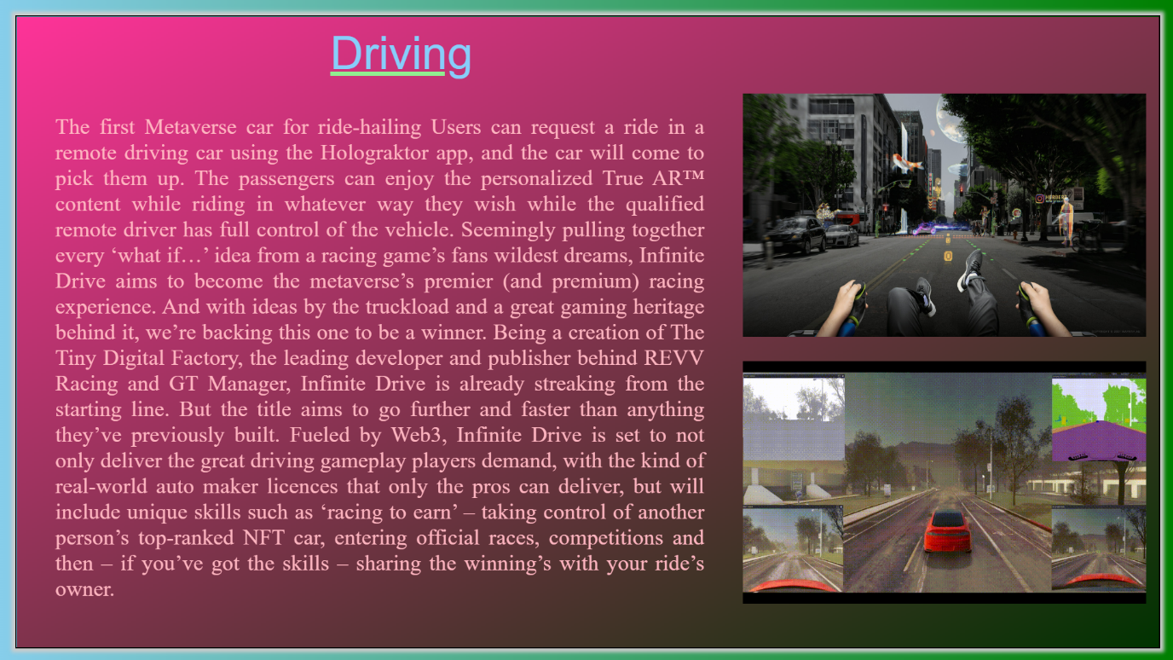

<html>

<head>

<title>remote work</title>

</head>

<body style="background:linear-gradient(to top right, #66ffff 0%, #cc33ff 100%); overflow: hidden;">

<div style="z-index:1; position: absolute;top:30; left:1053;width:1528;

height: 500;">

<img src ="D:\metaproject\images\deskworking.gif" height="250" width="420">

</div>

<div style="z-index:2; position: absolute;top:300; left:1053;width:1528;

height: 500;">

<img src ="D:\metaproject\images\taskade.gif" height="250" width="420">

</div>

<div style="z-index:3; position: absolute;top:570; left:1053;width:1528;

height: 500;">

<img src ="D:\metaproject\images\remote.jpeg" height="250" width="420">

</div>

<div style="z-index:3;position: absolute;left:330;top:13; font-size: 60px;

color: white; text-decoration:underline; text-decoration-color:blue ;

font-family:sans-serif;">Remote work </div>

<div style="z-index:4;position: absolute;left:30;top:67;width:1000; text-align: justify; font-size:28px;word-spacing: 5; color:black;">

<p>Recent world events such as the global pandemic have caused a massive shift in how we work. Remote work and online communication have been increasingly normalized and Zoom and other video conferencing and collaboration tools have transformed corporate dynamics. This transformation has the potential to go even further. Mark Zuckerberg, Founder and CEO of Meta, promises that the Metaverse will be the biggest game changer, enabling new ways of working; the so-called “Virtual offices” will greatly change the relationships between employees and companies in the coming years.

If it does succeed, the question of hybrid work will no longer be about the division of home and work, but about achieving a balance between the virtual world and the physical world.

Imagine yourself in a virtual work meeting, wearing a headset that connects you to augmented reality and allows you to interact with other people, without having to leave your home? With their respective Metaverses, Microsoft and Meta have shown that this can be a reality. Mark Zuckerberg himself showed how there could be different uses for augmented reality interactions at work in this video:

The corporate Metaverse also intends to improve the mental health of professionals who work remotely, in order to keep motivation and productivity high. According to a survey by Lenovo, 44% of professionals surveyed would be willing to work in the Metaverse, because they believe it can deliver performance benefits in the workplace.

The use of the Metaverse could save time and money when working remotely. </p>

</div>

</body>

</html>

**Transportation.html**

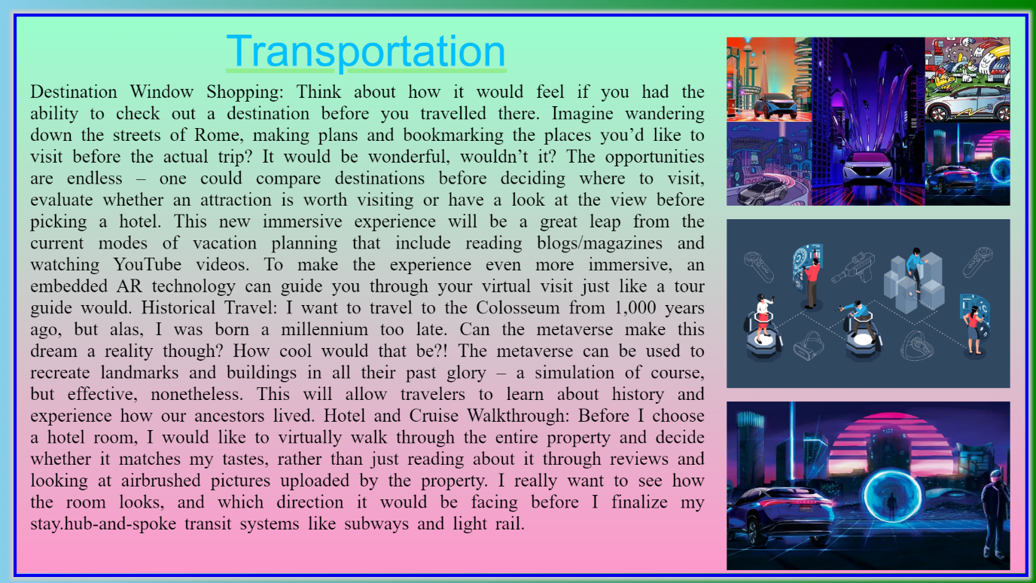

<html>

<head>

<title>transportation </title>

</head>

<body style="background:linear-gradient(to bottom, #99ffcc 0%, #ff99cc 100%);

overflow: hidden;">

<div style="z-index:1; position: absolute;top:30; left:1053;width:1528;

height: 500;">

<img src ="D:\metaproject\images/nissan.jpg" height="250" width="420">

</div>

<div style="z-index:2; position: absolute;top:300; left:1053;width:1528;

height: 500;">

<img src ="D:\metaproject\images/metav.png" height="250" width="420">

</div>

<div style="z-index:3; position: absolute;top:570; left:1053;width:1528;

height: 500;">

<img src ="D:\metaproject\images/down (2).jpeg" height="250" width="420">

</div>

<div style="z-index:4;position: absolute;left:310;top:13; font-size: 65px;

color:deepskyblue; text-decoration:underline; text-decoration-color:lightgreen;

font-family:sans-serif;"> Transportation </div>

<div style="z-index:5;position: absolute;left:20;top:67;width:1000; text-align: justify; font-size:28px;word-spacing: 5; color:black;">

<p> Destination Window Shopping: Think about how it would feel if you had the ability to check out a destination before you travelled there. Imagine wandering down the streets of Rome, making plans and bookmarking the places you’d like to visit before the actual trip? It would be wonderful, wouldn’t it? The opportunities are endless – one could compare destinations before deciding where to visit, evaluate whether an attraction is worth visiting or have a look at the view before picking a hotel. This new immersive experience will be a great leap from the current modes of vacation planning that include reading blogs/magazines and watching YouTube videos. To make the experience even more immersive, an embedded AR technology can guide you through your virtual visit just like a tour guide would.

Historical Travel: I want to travel to the Colosseum from 1,000 years ago, but alas, I was born a millennium too late. Can the metaverse make this dream a reality though? How cool would that be?! The metaverse can be used to recreate landmarks and buildings in all their past glory – a simulation of course, but effective, nonetheless. This will allow travelers to learn about history and experience how our ancestors lived.

Hotel and Cruise Walkthrough: Before I choose a hotel room, I would like to virtually walk through the entire property and decide whether it matches my tastes, rather than just reading about it through reviews and looking at airbrushed pictures uploaded by the property. I really want to see how the room looks, and which direction it would be facing before I finalize my stay.hub-and-spoke transit systems like subways and light rail.

</p>

</div>

</body>

</html>

**Games.html**

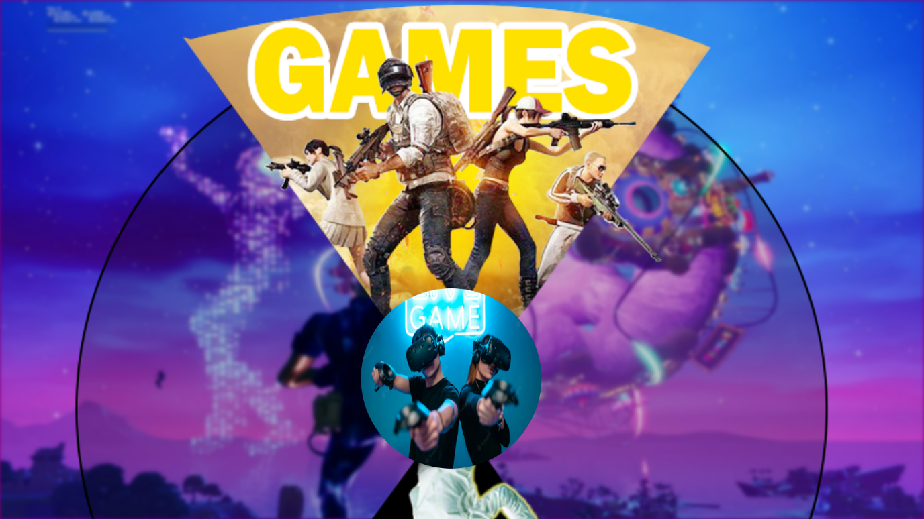

<html>

<head>

<title>games</title>

<script language="javascript">

function spin1()

{

document.getElementById("rotate1").style.animationPlayState="running";

const MyTimeOut=setTimeout(spin2,3460);

function spin2()

{

document.getElementById("rotate1").style.animationPlayState="paused";

}

}

</script>

<style>

#rotate1{

animation: spinningcircle 7s ease-out infinite forwards paused ;}

@keyframes spinningcircle {

0%{ transform:rotateZ(0deg);}

50%{transform: rotateZ(180deg);}

100%{transform: rotateZ(360deg);}

}

</style>

</head>

<body bgcolor="purple" style="overflow: hidden;">

<img style="z-index:-10;position: fixed;right:0;bottom:0;min-height: 100%;min-width: 100%;width: 100%;height: 100%;filter:blur(3px);"

src="D:\metaproject\images\entertainmentbg.jpg" >

<img style="border-radius:50%;position:absolute;top:480;left:600;z-index:3;"

width="300" height="300" src="D:\metaproject\images\games2.jpg"

onclick="spin1();">

<img id="rotate1" style="position: absolute;top:-150;left:-80;z-index:2;border-top: 50%;" width="1650" height="1650" usemap="#entmap"

src="D:\metaproject\images\gaming2.png">

<map name="entmap">

<area shape="rect" coords="0,0,1650,825" href="D:\metaproject\anil\My Gaming2.html">

<area shape="rect" coords="0,825,1650,1650" href="D:\metaproject\anil\Movies in meta.html">

</map>

<a href="D:\metaproject\index tabs\Advantages of meta verse\teleworking.html"><div style="position:fixed;z-index:6;bottom:0;left:0;width:200;height:100;"></div></a>

<a href="D:\metaproject\index tabs\Advantages of meta verse\Advantages.html"><div style="position:fixed;z-index:6;bottom:0;left:650;width:200;height:100;"></div></a>

<a href="D:\metaproject\index tabs\Advantages of meta verse\Others.html">

<div style="position: absolute;z-index:10;right: 0;bottom: 0;height:100;width:200;">

</div></a></body></html>

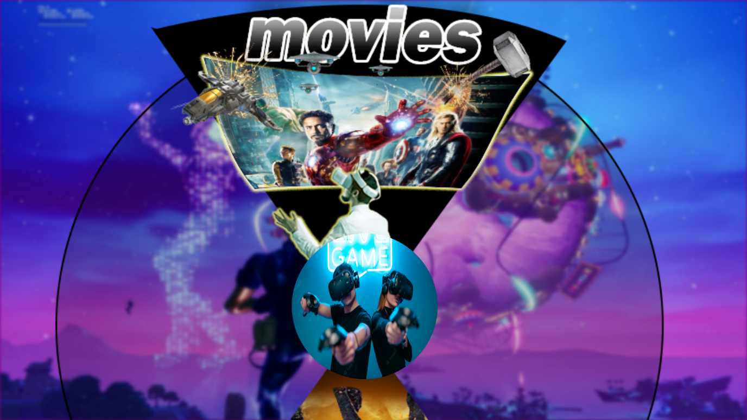

**My Gaming.html**

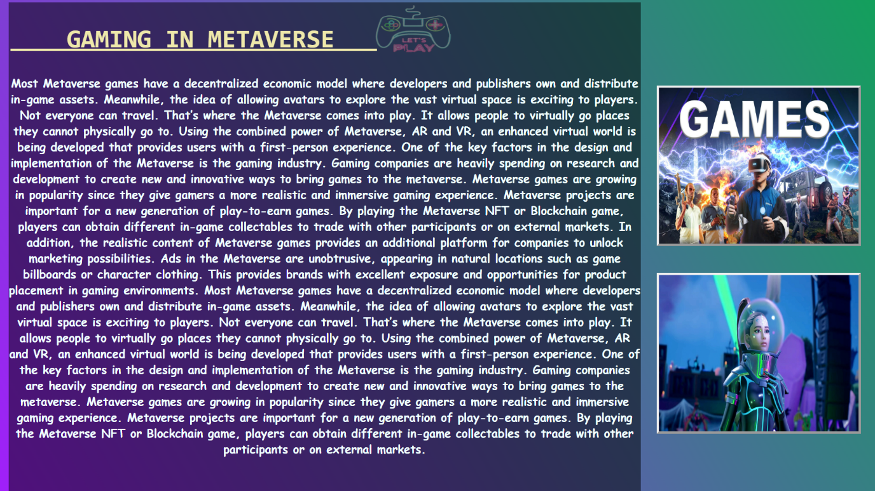

<html>

<head>

<title>Gaming in Meraverse</title>

<style>

#img1{

filter: blur(7px);

}

#h2{

position: relative;

top: 0;left:-230;

font-family:monospace;

color: palegoldenrod;

font-size: 45;

text-decoration: underline;

}

#img2{

border: 4px;

border-style: outset;

color: ghostwhite;

}

</style>

</head>

<body style="overflow:hidden;background: linear-gradient(60deg,#a120fa,#13a05c);">

<div style="z-index: 4;position: absolute; top:0; left:650;width: 1530;height: 990;">

<img src="D:\metaproject\images\pngtree-let-s-play-vector-realistic-neon-sign-of-video-vr-games-png-image_5991994.png" width="150"

height="100">

</div>

<div style="z-index: 4;position: absolute; top:150; left:1153;width: 1530;height: 990;">

<img id="img2" src="D:\metaproject\images\games3.jpg" width="350"

height="275">

</div>

<div style="z-index: 4;position: absolute; top:480; left:1153;width: 1530;height: 990;">

<img id="img2" src="D:\metaproject\images\1728-fortnite-ariana-grande-punchcard.jpg"height="275" width="350">

</div>

<div style="z-index:4;position:absolute;left:15;top:4; height: 900; width: 1110;background-image: url(D:/metaproject/infobg.png);

font-size: 20; color:azure; font-family:cursive ; text-align: center;">

<h2 id="h2">&nbsp;&nbsp;&nbsp;

GAMING IN METAVERSE&nbsp;&nbsp;&nbsp;

</h2>

<p> <b>

Most Metaverse games have a decentralized economic model where developers and publishers own and distribute in-game assets. Meanwhile, the idea of allowing avatars to explore the vast virtual space is exciting to players.

Not everyone can travel. That’s where the Metaverse comes into play. It allows people to virtually go places they cannot physically go to. Using the combined power of Metaverse, AR and VR, an enhanced virtual world is being developed that provides users with a first-person experience.

One of the key factors in the design and implementation of the Metaverse is the gaming industry. Gaming companies are heavily spending on research and development to create new and innovative ways to bring games to the metaverse.

Metaverse games are growing in popularity since they give gamers a more realistic and immersive gaming experience. Metaverse projects are important for a new generation of play-to-earn games. By playing the Metaverse NFT or Blockchain game, players can obtain different in-game collectables to trade with other participants or on external markets.

In addition, the realistic content of Metaverse games provides an additional platform for companies to unlock marketing possibilities. Ads in the Metaverse are unobtrusive, appearing in natural locations such as game billboards or character clothing. This provides brands with excellent exposure and opportunities for product placement in gaming environments.

Most Metaverse games have a decentralized economic model where developers and publishers own and distribute in-game assets. Meanwhile, the idea of allowing avatars to explore the vast virtual space is exciting to players.

Not everyone can travel. That’s where the Metaverse comes into play. It allows people to virtually go places they cannot physically go to. Using the combined power of Metaverse, AR and VR, an enhanced virtual world is being developed that provides users with a first-person experience.

One of the key factors in the design and implementation of the Metaverse is the gaming industry. Gaming companies are heavily spending on research and development to create new and innovative ways to bring games to the metaverse.

Metaverse games are growing in popularity since they give gamers a more realistic and immersive gaming experience. Metaverse projects are important for a new generation of play-to-earn games. By playing the Metaverse NFT or Blockchain game, players can obtain different in-game collectables to trade with other participants or on external markets.

</b>

</p>

</div>

<a href="D:\metaproject\index tabs\Advantages of meta verse\games.html"><div style="position:fixed;z-index:6;bottom:0;left:0;width:200;height:100;"></div></a>

<a href="D:\metaproject\index tabs\Advantages of meta verse\games.html"><div style="position:fixed;z-index:6;bottom:0;left:650;width:200;height:100;"></div></a>

<a href="D:\metaproject\anil\Movies in meta.html">

<div style="position: absolute;z-index:10;right: 0;bottom: 0;height:100;width:200;">

</div></a>

</body>

</html>

**Movies in meta.html**

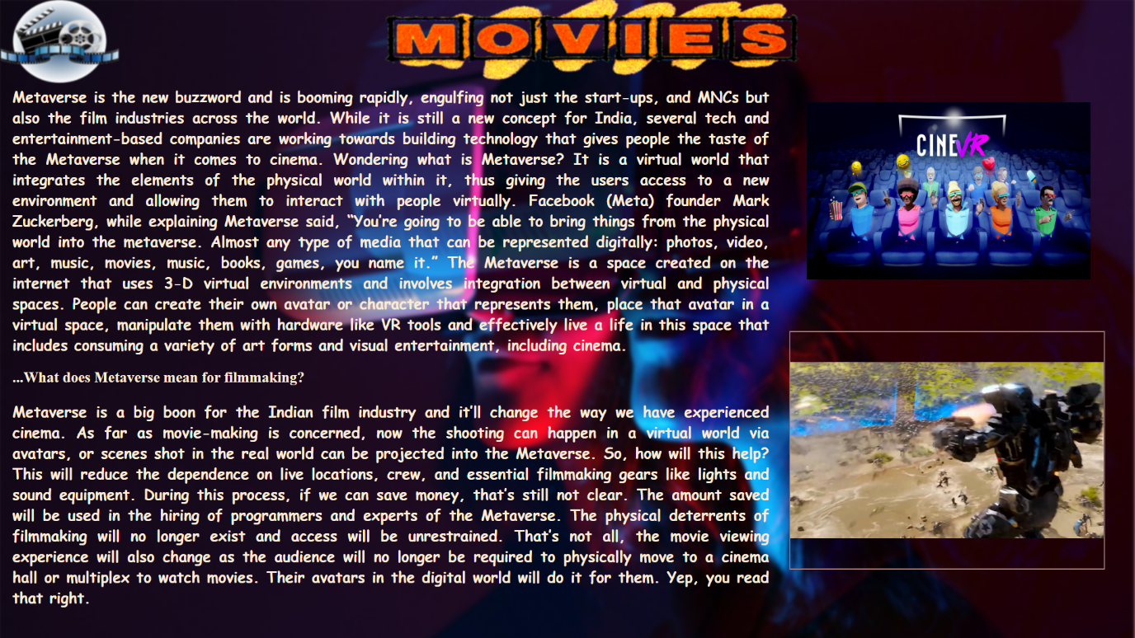

<html>

<head>

<title>Movies in Meraverse</title>

<style>

#img1{

filter: blur(3px);

}

#img2{

filter: blur(1px);

}

#h2{

font-family: inherit;

color: honeydew;

font-size: 48;

}

#h3{

font-family: serif;

font color: azure;

font-size: 25;

}

#img3{

border: 10px;

border-style: dotted;

border-color: ghostwhite;

}

</style>

</head>

<body style="overflow:hidden;">

<div style="z-index: 4;position: absolute; top:-5; left:-5;width: 1450;height: 1000;">

<img id="img1" src="D:\metaproject\images\heskett-december-2021-meta.jpg" height="1229" width="1926">

</div>

<div style="z-index: 4;position: absolute; top:0; left:1;width: 1530;height: 990;">

<img id="img2" src="D:\metaproject\images\pngkey.com-movie-night-png-671485.png"height="140" width="200">

<div style="z-index: 4;position: absolute; top:-5; left:650;width: 1530;height: 990;">

<img id="img2" src="D:\metaproject\images\pngaaa.com-2988926.png"height="140" width="700">

</div>

<div style="z-index:4;position:absolute;left:20;top:120; height: 700; width: 1280;

font-size: 25; color: antiquewhite; font-family:cursive; text-align: justify;">

<div style="z-index: 4;position: absolute; top:53; left:1344;width: 1530;height: 990;">

<img id="img4" src="D:\metaproject\images\XRMust_CINEVR.original.jpg" height="300" width="480">

</div>

<div style="z-index: 4;position: absolute; top:440; left:1314;width: 530;height: 400;border:groove 2px rosybrown; ">

<video controls muted autoplay loop="true" height="400;" width= "530">

<source src="D:\metaproject\images\thor entry2.mp4">

<video>

</div>

<p><b>

Metaverse is the new buzzword and is booming rapidly, engulfing not just the start-ups, and MNCs but also the film industries across the world. While it is still a new concept for India, several tech and entertainment-based companies are working towards building technology that gives people the taste of the Metaverse when it comes to cinema.

Wondering what is Metaverse? It is a virtual world that integrates the elements of the physical world within it, thus giving the users access to a new environment and allowing them to interact with people virtually.

Facebook (Meta) founder Mark Zuckerberg, while explaining Metaverse said, “You’re going to be able to bring things from the physical world into the metaverse. Almost any type of media that can be represented digitally: photos, video, art, music, movies, music, books, games, you name it.”

The Metaverse is a space created on the internet that uses 3-D virtual environments and involves integration between virtual and physical spaces. People can create their own avatar or character that represents them, place that avatar in a virtual space, manipulate them with hardware like VR tools and effectively live a life in this space that includes consuming a variety of art forms and visual entertainment, including cinema.</b>

</p><b>

<h1 id="h3">...What does Metaverse mean for filmmaking?</h1>

<p>

Metaverse is a big boon for the Indian film industry and it’ll change the way we have experienced cinema. As far as movie-making is concerned, now the shooting can happen in a virtual world via avatars, or scenes shot in the real world can be projected into the Metaverse. So, how will this help? This will reduce the dependence on live locations, crew, and essential filmmaking gears like lights and sound equipment. During this process, if we can save money, that’s still not clear. The amount saved will be used in the hiring of programmers and experts of the Metaverse. The physical deterrents of filmmaking will no longer exist and access will be unrestrained.

That’s not all, the movie viewing experience will also change as the audience will no longer be required to physically move to a cinema hall or multiplex to watch movies. Their avatars in the digital world will do it for them. Yep, you read that right.

</p>

</div>

</b></div>

</div>

<a href="D:\metaproject\anil\My Gaming2.html"><div style="position:fixed;z-index:6;bottom:0;left:0;width:200;height:100;"></div></a>

<a href="D:\metaproject\index tabs\Advantages of meta verse\games.html"><div style="position:fixed;z-index:6;bottom:0;left:650;width:200;height:100;"></div></a>

<a href="D:\metaproject\index tabs\Advantages of meta verse\games.html">

<div style="position: absolute;z-index:10;right: 0;bottom: 0;height:100;width:200;">

</div></a>

</body>

</html>

**Others.html**

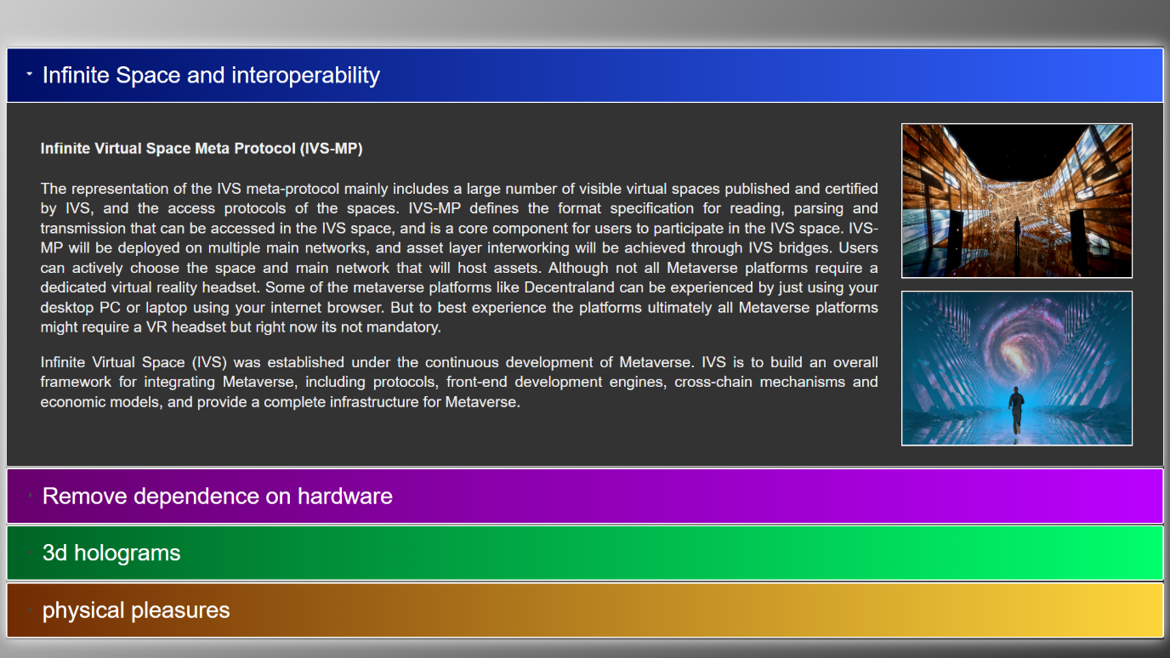

<html lang="en">

<head>

<title>jQuery UI Accordion - Default functionality</title>

<meta charset="utf-8">

<link href="D:\metaproject\jquery-ui-1.13.1\jquery-ui.min.css" rel="stylesheet" type="text/css"/>

<script src="D:\metaproject\jquery-ui-1.13.1\external\jquery\jquery.js" type="text/javascript"></script>

<script src="D:\metaproject\jquery-ui-1.13.1\jquery-ui.min.js" type="text/javascript">

</script>

<script>

$(function()

{

$( "#acc" ).accordion();

});

</script>

</head>

<body style="background:linear-gradient(125deg,#cccccc,#333333);">

<div id="acc" style="position: absolute;top: 60;width:1520;height:780;

box-shadow: 0px 0px 20px 0px #ffffff;">

<h3 style="background: linear-gradient(to right,#000F67,#3161FF);color:white;border-style:solid;border-width:2;border-color:white;font-size:30;">

Infinite Space and interoperability</h3>

<div style="background-color:#333333;color:#eeeeee;font-size:20;">

<div style="position: relative;top:0;left:0;height:200;width:1100;

text-align: justify;">

<h4> Infinite Virtual Space Meta Protocol (IVS-MP)</h4>

<p>

The representation of the IVS meta-protocol mainly includes a large number of visible virtual spaces published and certified by IVS, and the access protocols of the spaces. IVS-MP defines the format specification for reading, parsing and transmission that can be accessed in the IVS space, and is a core component for users to participate in the IVS space. IVS-MP will be deployed on multiple main networks, and asset layer interworking will be achieved through IVS bridges. Users can actively choose the space and main network that will host assets.

Although not all Metaverse platforms require a dedicated virtual reality headset. Some of the metaverse platforms like Decentraland can be experienced by just using your desktop PC or laptop using your internet browser. But to best experience the platforms ultimately all Metaverse platforms might require a VR headset but right now its not mandatory.

</p>

<p>Infinite Virtual Space (IVS) was established under the continuous development of Metaverse. IVS is to build an overall framework for integrating Metaverse, including protocols, front-end development engines, cross-chain mechanisms and economic models, and provide a complete infrastructure for Metaverse.</p>

</div>

<img style="position: relative;top:0;left: 1130;width: 300;height: 200;

border:double 2px #ffffff" src="D:\metaproject\images\infinite space.jpg" >

<img style="position: relative;top: -220;left: 821;border:double 2px #ffffff;

width:300;height:200;" src="D:\metaproject\images\infinite space2.jpg" >

</div>

<h3 style="background: linear-gradient(to right,#67006D,#BA00FF);color:white;border-style:solid;border-width:2;border-color:white;font-size:30;">

Remove dependence on hardware</h3>

<div style="background-color:#333333;color:#eeeeee;font-size:20;">

<div style="position: relative;top:0;left:310;height:200;width:1100;

text-align: justify;">

<p>Your laptop is an obvious choice, but a few other vital pieces of equipment might be easy to forget. Be sure to pack the following:

Projector and replacement bulb<br>

Mouse and mouse pad<br>

Remote (the ones with the built-in laser pointer are nice)<br>

Microphone<br>

Headphones (if you use them)<br>

Appropriate cables, including a dual mini plug if you use a boom box for sound (#9)<br>

Video adapter (many projectors want VGA)<br> if your laptop doesn’t output VGA

Most conference facilities will supply some or all of these items, but working with your own equipment has its advantages: You’ll be more at ease with your own equipment and you’ll be able to quickly troubleshoot most problems. Also consider the addition of a portable screen. A blank wall works in a pinch, but it isn’t the best way to present yourself, your product, or your company.<br>

<br>

We don't need all equipment while presenting in metaverse

</p>

</div>

<img style="position: relative;top:0;left: -20;width: 300;height: 200;

border:double 2px #ffffff" src="D:\metaproject\images\infinite space2.jpg" >

<img style="position: relative;top: -220;left: -330;border:double 2px #ffffff;

width:300;height:200;" src="D:\metaproject\images\hardware.jpg" >

</div>

<h3 style="background: linear-gradient(to right,#006426,#00FF6C);color:white;border-style:solid;border-width:2;border-color:white;font-size:30;">

3d holograms</h3>

<div style="background-color:#333333;color:#eeeeee;font-size:21;">

<div style="position: relative;top:0;left:0;height:200;width:1100;

text-align: justify;">

<p>We can say that a hologram is the encoded version of a lightfield. Or that it is a special kind of photography that can encode completely how light scatters around an object, so that not only the intensity of light (like a classical photography), but all the properties of the light rays that come from that object are recorded into it.

Let me make an imaginary example to explain this better. Imagine that you take a photo of something with a special holographic camera, for instance, a beautiful flower garden. Then you take this picture, that is 2D, and looking at it, it is like you always had a 2D window through the 3D garden wherever you are. It is a flat picture, but looking through it from whatever point of view you can really feel all the colors, the reflections, the depth cues, the parallax, of the garden you have taken the photo to. A permanent window to that garden. This is what a hologram can be.

</p>After this explanation, I think you already got one of the reasons why holograms matter. Our VR headsets are a window towards a 3D world, too, but they have just simple stereoscopy and no possibility of focusing on objects at different depths. If we could have a holographic display inside them, we could see reality in a new way, with complete depth perception and focus, parallax, etc… That would be incredibly realistic.

</p>

</div>

<img style="position: relative;top:0;left: 1130;width: 300;height: 200;

border:double 2px #ffffff" src= "D:\metaproject\images\3D hologram3.jpg">

<img style="position: relative;top: -220;left: 821;border:double 2px #ffffff;

width:300;height:200;" src="D:\metaproject\images\3d hologram.jpg" >

</div>

<h3 style="background: linear-gradient(to right,#712C03,#FDD63C);color:white;border-style:solid;border-width:2;border-color:white;font-size:30;">

physical pleasures</h3>

<div style="background-color:#333333;color:#eeeeee;font-size:21;">

<div style="position: relative;top:0;left:310;height:200;width:1100;

text-align: justify;">

<p>They're able to do this using haptic technology. Essentially, it works with the use of a thin array of transducers that are integrated to the belly of the VR headset (an Oculus Quest 2) which directs ultrasound energy to different parts of the mouth.

The study has been published in Future Interfaces Group. In an example, researchers reveal how it would essentially work. For instance, when playing a horror game in VR or metaverse, the tech could simulate the feeling of a spider brushing across the lips, or feel some liquid actually falling into the mouth.

The tech is also able to simulate the motions experienced while brushing teeth, smoking, feeling rain, sipping a drink and even a kiss.

</p>

<p>Researchers explain in their paper, “Proximity of the mouth to the headset offers a significant opportunity to enable on- and in-mouth haptic effects, without needing to run wires or wear an extra accessory. We developed a thin, compact, beamforming array of ultrasonic transducers, which can render haptic effects onto the mouth.”

They added, “Importantly, all components are integrated into the headset, meaning the user does not need to wear an additional accessory or place any external infrastructure in their room.”

It’ll be interesting to see what more levels of feeling we could soon get to experience in the metaverse and if it could ever come even remotely close to the real deal.

</p>

</div>

<img style="position: relative;top:0;left: -20;width: 300;height: 200;

border:double 2px #ffffff" src="D:\metaproject\images\kiss.jpg" >

<img style="position: relative;top: -220;left: -330;border:double 2px #ffffff;

width:300;height:200;" src="D:\metaproject\images\kiss3.jpg" >

</div>

</div>

<a href="D:\metaproject\index tabs\Advantages of meta verse\games.html"><div style="position:fixed;z-index:6;bottom:0;left:0;width:200;height:100;"></div></a>

<a href="D:\metaproject\index tabs\Advantages of meta verse\Advantages.html"><div style="position:fixed;z-index:6;bottom:0;left:650;width:200;height:100;"></div></a>

<a href="D:\metaproject\index tabs\Advantages of meta verse\Advantages.html">

<div style="position: absolute;z-index:10;right: 0;bottom: 0;height:100;width:200;">

</div></a>

</body>

</html>

**Disadvantages.html**

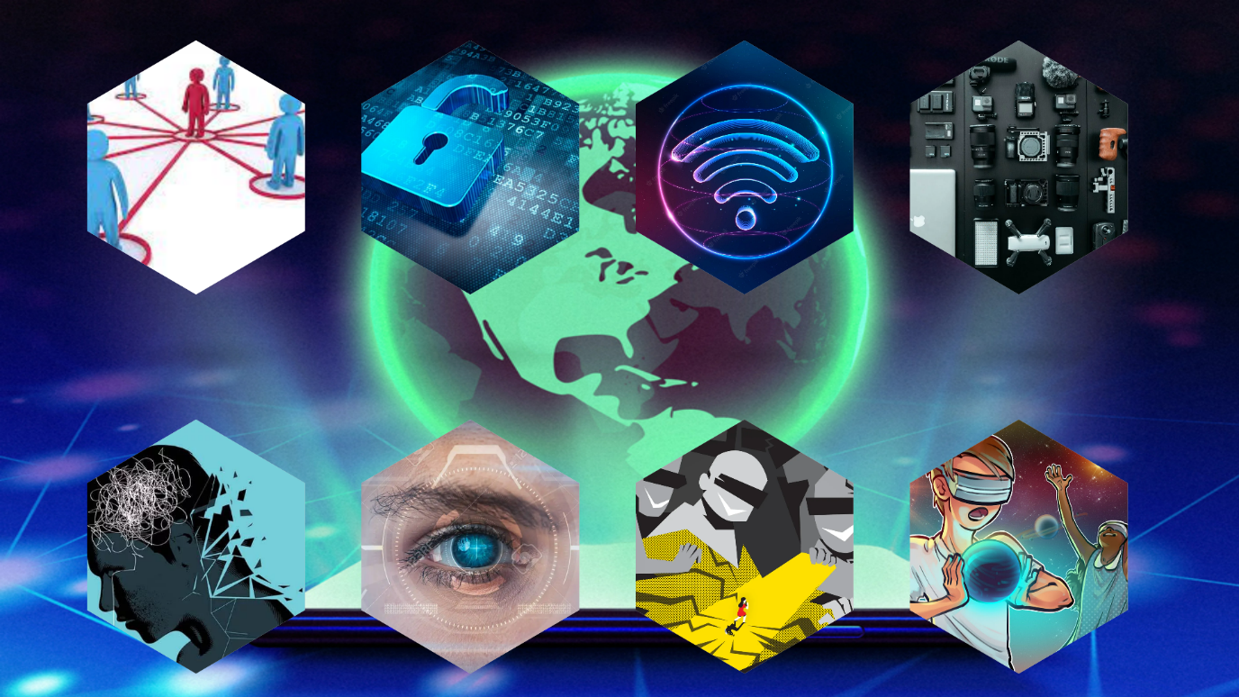

<!DOCTYPE html>

<html lang="en">

<head>

<meta charset="UTF-8">

<meta name="viewport" content="width=device-width, initial-scale=1.0">

<title>Responsive Hexagon Card Hover Effect</title>

<style type="text/css">

*{

margin: 0; padding: 0;

box-sizing: border-box;

font-family: sans-serif;

}

body{

display: flex; justify-content: center;

align-items: center; min-width: 100vh;

}

.container{

position: relative; display: flex;

justify-content: center;

align-items: center;

flex-wrap: wrap;

}

.container .hexagon::before{

content: ''; position: absolute;

bottom: -70px;

width: 100%;

height: 60px;

background: radial-gradient(rgba(0,0,0,0.16), transparent, transparent);

border-radius: 50%;

transition: 0.5s;

}

.container .hexagon:hover::before{

opacity: 0.8;

transform: scale(0.8);

}

.container .hexagon{

position: relative;

width: 300px;

height: 350px;

margin: 50px 20px 70px;

}

.container .hexagon .hexagon-shape{

position: absolute;

top: 0;

left: 0;

width: 90%;

height: 90%;

background: #ccc;

clip-path: polygon(0 25%, 50% 0, 100% 25%, 100% 75%, 50% 100%, 0 75%);

transition: 0.5s;

}

.container .hexagon:hover .hexagon-shape{

transform: translateY(-30px);

}

.container .hexagon .hexagon-shape img{

position: absolute;

top: 0;

bottom: 0;

width: 100%;

height: 100%;

object-fit: cover;

}

.container .hexagon .hexagon-shape .content{

position: absolute;

top: 0; left: 0;

width: 100%; height: 100%;

display: flex;

align-items: center;

justify-content: center;

padding: 20px;

text-align: center;

color: #oooooo;

background: linear-gradient(45deg, #ccc, rgba(3,255,244,0.5));

opacity: 0;

transition: 0.5s;

}

.container .hexagon:hover .hexagon-shape .content{

opacity: 1;

}

</style>

<body style="overflow:hidden;">

<font color="black">

<div style="position: absolute;left: -10;top: 90;">

<img src="D:\metaproject\images\3D hologram3.jpg" width="1537" height="870"></div>

<div class="container">

<div class="hexagon">

<div class="hexagon-shape">

<img src="D:\metaproject\images\social impact.jfif" alt="">

<div class="content">

<div>

<h2>Social Impact</h2>

<p>While metaverse could make you experience any environment, the disconnect from the real world could seriously impact our mental health. The same could be seen in a more aggressive form with a whole virtual world.</p>

</div>

</div>

</div>

</div>

<div class="hexagon">

<div class="hexagon-shape">

<img src="D:\metaproject\images\privacy issues.jpg" >

<div class="content">

<div>

<h2>Privacy</h2>

<p>As most of our personal and professional lives are spent online, our data has gradually become a commodity for many marketing companies. The advent of intrusive technologies has already raised our privacy concerns. Now the larger question is: how will metaverse control someone’s privacy.</p>

</div>

</div>

</div>

</div>

<div class="hexagon">

<div class="hexagon-shape">

<img src="D:\metaproject\images\internetconnection.jpg" >

<div class="content">

<div>

<h2>Internet</h2>

<p>For the Metaverse, we recommend a minimum of 1 Gbps (1000 Mbps) for both upstream and downstream traffic. If you are only using the Metaverse to view content, you may be able to get away with less bandwidth.</p>

</div>

</div>

</div>

</div>

<div class="hexagon">

<div class="hexagon-shape">

<img src="D:\metaproject\images\equipmentovr.jpg" >

<div class="content">

<div>

<h2>Requires technology</h2>

<p>Not everyone may be able to afford the tech to experience metaverse since it does use pretty high-level equipment for an ultimate VR experience. The metaverse may directly impact and increase the socio-economic disparity. </p>

</div>

</div>

</div>

</div>

<a href="D:\metaproject\index tabs\Advantages of meta verse\Advantages.html">

<div class="hexagon">

<div class="hexagon-shape">

<img src="D:\metaproject\images\mental issues.webp">

<div class="content">

<div>

<h2>psychological issues</h2>

<p> 1.Attention deficit hyperactivity disorder

2.Eating disorders

3.Anxiety, phobias and post-traumatic stress disorder

4.Autism

5.Alzheimer's disease

6.Stress and pain management</p>

</div>

</div>

</div>

</div></a>

<div class="hexagon">

<div class="hexagon-shape">

<img src="D:\metaproject\images\eye disablity.webp">

<div class="content">

<div>

<h2>Eye Disability</h2>

<p>Blind and visually impaired users will need screen reading capabilities along with seamless audio description. One challenge will be that the metaverse, by its very nature, is intended to be a visually richer world than what we have today. This will pose further complexities for blind and low vision users.</p>

</div>

</div>

</div>

</div>

<div class="hexagon">

<div class="hexagon-shape">

<img src="D:\metaproject\images\virualcrime.jpg">

<div class="content">

<div>

<h2>Virtual Crime</h2>

<p> Most recently, the virtual worlds were in the news when a group of male virtual avatars molested a woman’s virtual avatar. This falls in a very grey area with the current criminal regulations. People often use social media to create fake identities as well. Even in the metaverse, this problem is bound to prevail.</p>

</div>

</div>

</div>

</div>

<a href="D:\metaproject\Naveen\aligation and critcs.html"><div class="hexagon">

<div class="hexagon-shape">

<img src="D:\metaproject\images\minors.jfif">

<div class="content">

<div>

<h2>Adverse impact on minors</h2>

<p> It may be extremely difficult to keep children away from this futuristic tech. Therefore, it becomes imperative to protect the children from the harmful impact of the metaverse.</p>

</div>

</div>

</div>

</div></a>

</div>

</body>

</font>

</html>

**Aligation and critics.html**

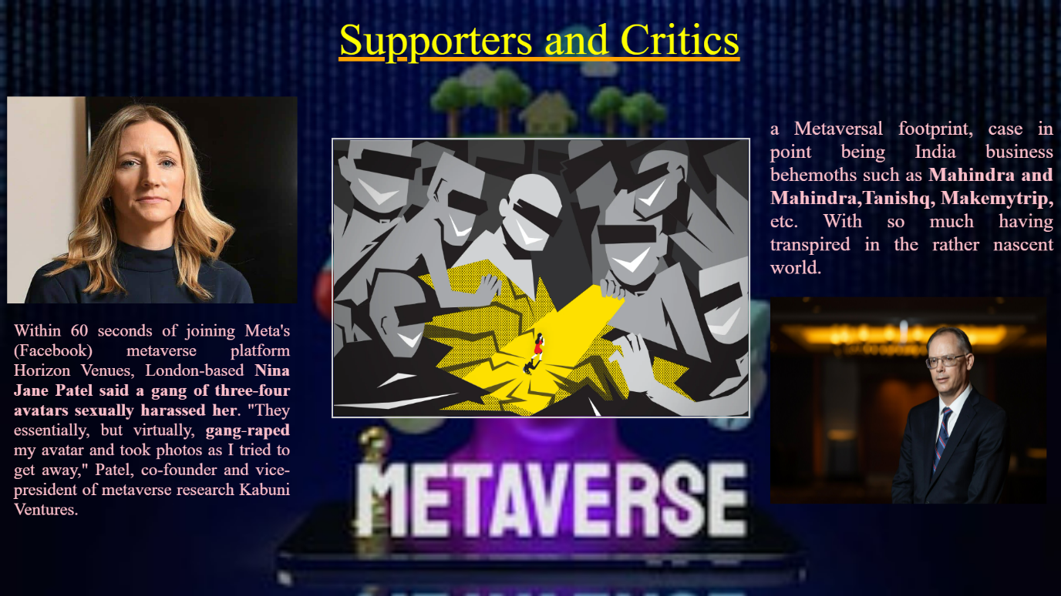

<html>

<head>

<title> Suppoters and critism </title>

</head>

<body style="overflow:hidden;">

<div style="z-index:1; position: absolute;top:0; left:0;width:1528;

height: 500;">

<img src ="D:\metaproject\images\meeta.jpg" height="870" width="1558">

</div>

<img style="position: fixed;z-index: 2;top:200;left:480;height:400;width:600;

border:solid 3px #cccccc"

src="D:\metaproject\images\virualcrime.jpg">

<div style="z-index:2; position: absolute;top:140; left:10 ;width:1528;

height: 500;">

<img src ="D:\metaproject\images\patel.jpeg" height="300" width="420">

</div>

</div>

<div style="z-index:3;position: absolute;left:490;top:20 ;width: 990; text-align: justify; font-size: 65px; color:yellow; text-decoration: underline; text-decoration-color:orange;">Supporters and Critics </div>

<div style="z-index:5;position: absolute;left:20;top:440;width:400; text-align: justify; font-size:25px; color:pink;">

<p>

Within 60 seconds of joining Meta's (Facebook) metaverse platform Horizon Venues, London-based<b> Nina Jane Patel said a gang of three-four avatars sexually harassed her</b>. "They essentially, but virtually,<b> gang-raped</b> my avatar and took photos as I tried to get away," Patel, co-founder and vice-president of metaverse research Kabuni Ventures.</p></div>

<div style="z-index:6; position: absolute;top:430; left:1115;width:1528;

height: 500;">

<img src ="D:\metaproject\images\professor.jpg" height="300" width="400">

</div>

<div style="z-index:5;position: absolute;left:1115;top:140;width:410; text-align: justify; font-size:29px; color:pink;">

<p>a Metaversal footprint, case in point being India business behemoths such as <b>Mahindra and Mahindra,Tanishq, Makemytrip,</b> etc. With so much having transpired in the rather nascent world.

</p>

</div>

<a href="D:\metaproject\index tabs\disadvantages.html"><div style="position:fixed;z-index:6;bottom:0;left:0;width:200;height:100;"></div></a>

<a href="D:\metaproject\Index2.html"><div style="position:fixed;z-index:6;bottom:0;left:650;width:200;height:100;"></div></a>

<a href="D:\metaproject\index tabs\overview.html"> <div style="position: absolute;z-index:10;right: 0;bottom: 0;height:100;width:200;"> </div></a>

</div>

</body>

</html>

**Overview.html**

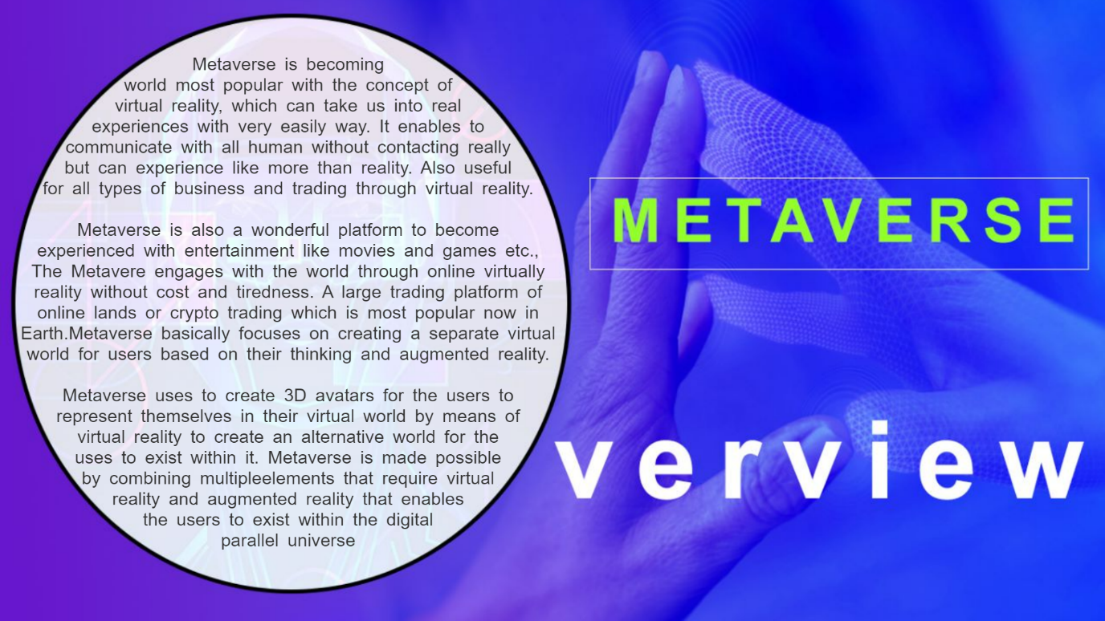

<html>

<head>

<title>overview</title>

<script src="D:\metaproject\jq.js"></script>

<script language="javascript">

function text1fadeIn(){

$("#text1").fadeIn(1000);

}

function text2fadeIn(){

$("#text2").fadeIn(1000);

}

function text1fadeOut(){

$("#text1").fadeOut(1000);

}

function text2fadeOut(){

$("#text2").fadeOut(1000);

}

function step1(){

text1fadeOut();

text2fadeIn();

}

function step2(){

text2fadeOut();

text1fadeIn();

}

var a=0;

function fadetog(){

if(a==0)

{

a=1;

step1();

}

else

{

a=0;

step2();

}

}

</script>

</head>

<body>

<img style="z-index: 0;position: fixed;right:0;bottom:0;min-height: 100%;

min-width: 100%;" src="D:\metaproject\images\overview.jpeg">

<div style="z-index:2;position:fixed;top:50;left:18;height:700;width:765;" onclick="fadetog()"></div>

<p style="z-index:1;position:fixed;top:50;left:18;height:700;width:765;text-align: center;color:#333333;font-family: arial;

font-size:25px;word-spacing: 5px;" id="text1" >

Metaverse is becoming <br>world most popular with the concept of<Br> virtual reality, which can take us into real <br>experiences with very easily way. It enables to <br>communicate with all human without contacting really <Br>but can experience like more than reality

.

Also useful<Br> for all types of business and trading through virtual reality. <br><br>Metaverse is also a wonderful platform to become <Br>experienced with entertainment like movies and games etc., <Br>

The Metavere engages with the world through online virtually reality without cost and tiredness. A large trading platform of online lands or crypto trading which is most popular now in Earth.Metaverse basically focuses on creating a separate virtual world for users based on their thinking and augmented reality.<br><br> Metaverse uses to create 3D avatars for the users to <br>represent themselves in their virtual world by means of<br> virtual reality to create an alternative world for the<br> uses to exist within it.

Metaverse is made possible <br> by combining multipleelements that require virtual <br>reality and augmented reality that enables<br> the users to exist within the digital<br> parallel universe<br> </p>

<p style="z-index:1;position:fixed;top:50;left:18;height:700;width:765;text-align: center;color:#333333;font-family: arial;display: none;

font-size:23px;word-spacing: 5px;" id="text2">

and do whatever they want like<br> studying, playing, attending meetings and <br>concerts, even traveling, etc.

Metaverse is<br> applicable to buying virtual 3D goods for our avatars,<br> playing online immersive games, using E-commerce<br> platforms to try the product in the Metaverse before even<br> actually ordering it, and buying cryptocurrency tokens.<br>

Metaverse is made possible by using Virtual reality devices that support theusers to take them to a 3D environment. It also makes use of the various motion tracking sensors that are attached to the user’s hands to be able to interact with the virtual objects in the Metaverse.<br><span style="text-decoration: underline;text-decoration-color: royalblue;color:brown;">Metaverse Ecosystem</span><br>

The Metaverse ecosystem is basically a self imaginary experience for the users which allows them to interact with two people using the metaverse technology. The metaverse ecosystem basically deals with the creation of online virtual reality rooms where the userswill share their thoughts and ideas and communicate with each other on the metaverse in virtual reality. For example – Roblox allows its <br>users to create online rooms while playing games for<br> interaction with the users within the Roblox ecosystem<br> of the game. This creates an immersive ecosystem<br> for the users to pursue and create the characters<br> and stories for the interaction between the<br> users and their avatars.</p>

<a href="D:\metaproject\Naveen\aligation and critcs.html"><div style="position:fixed;z-index:6;bottom:0;left:0;width:200;height:100;"></div></a>

<a href="D:\metaproject\Index2.html"><div style="position:fixed;z-index:6;bottom:0;left:650;width:200;height:100;"></div></a>

<a href="D:\metaproject\index tabs\conclusion.html"> <div style="position: absolute;z-index:10;right: 0;bottom: 0;height:100;width:200;"> </div></a>

</body>

</html>

**Conclusion.html**

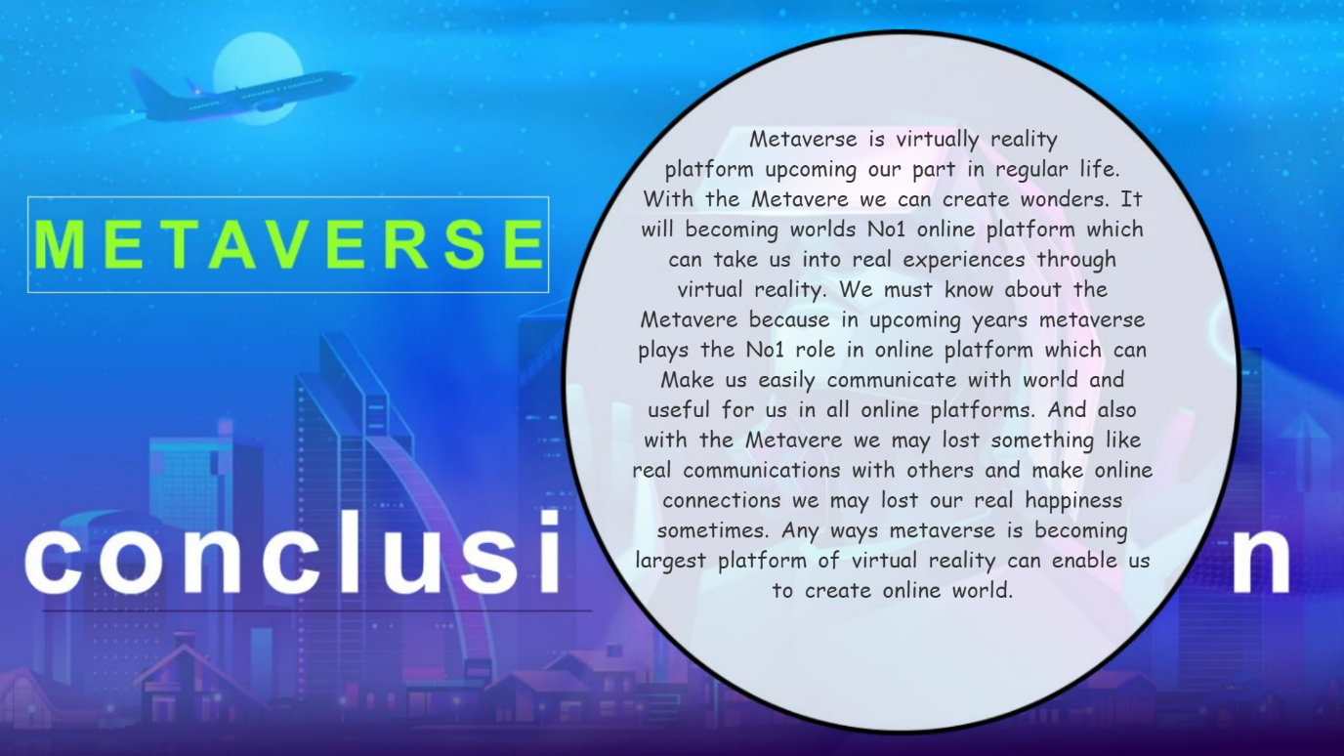

<html>

<head>

<title>overview</title>

</head>

<body>

<img style="z-index: 0;position: fixed;right:0;bottom:0;min-height: 100%;

min-width: 100%;" src="D:\metaproject\images\conclusionbg.jpeg">

<div style="z-index:1;position:fixed;top:140;left:720;width:600;height:600;text-align: center;font-size:25px;color:#333333;font-family:cursive;word-wrap: break-word;word-spacing:5px"> &nbsp;&nbsp;Metaverse is virtually reality <br>platform upcoming our part in regular life. <Br>With the Metavere we can create wonders. It will becoming worlds No1 online platform which can take us into real experiences through virtual reality.

We must know about the Metavere because in upcoming years metaverse plays the No1 role in online platform which can

Make us easily communicate with world and useful for us in all online platforms.

And also with the Metavere we may lost something like real communications with others and make online connections we may lost our real happiness sometimes.

Any ways metaverse is becoming largest platform of virtual reality can enable us to create online world.

</div>

<a href="D:\metaproject\index tabs\overview.html"><div style="position:fixed;z-index:6;bottom:0;left:0;width:200;height:100;"></div></a>

<a href="D:\metaproject\Index2.html"><div style="position:fixed;z-index:6;bottom:0;left:650;width:200;height:100;"></div></a>

<a href="D:\metaproject\aravind\thankyou.html"> <div style="position: absolute;z-index:10;right: 0;bottom: 0;height:100;width:200;"> </div></a></body></html>

**Thankyou.html**

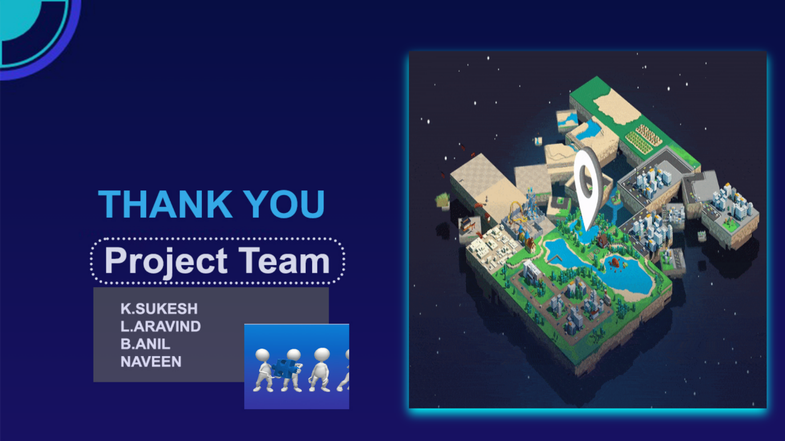

<html>

<head>

<title>overview</title>

</head>

<body>

<img style="z-index: 0;position: fixed;left:0;top:0;min-height: 100%;

min-width: 100%;" src="D:\metaproject\images\thankyou.jpeg">

<a href="D:\metaproject\index tabs\conclusion.html"><div style="position:fixed;z-index:6;bottom:0;left:0;width:200;height:100;"></div></a>

<a href="D:\metaproject\Index2.html"><div style="position:fixed;z-index:6;bottom:0;left:650;width:200;height:100;"></div></a>

<a href="D:\metaproject\Homepage.html"> <div style="position: absolute;z-index:10;right: 0;bottom: 0;height:100;width:200;"> </div></a>

</body>

</html>